

New Zealand Diploma in System Administration Level 6

# **IAC601: Infrastructure as Code**

# Assessment/Aromatawai - Assessment 1 Version 1 Credits 12

# Practical Assessment



|  |  |  |  |
| --- | --- | --- | --- |
|  | Submission | FER1 | FER2 |
| Result | Click or tap here to enter text. | Click or tap here to enter text. | Click or tap here to enter text. |
| Date | Click or tap to enter a date. | Click or tap to enter a date. | Click or tap to enter a date. |
| Assessor’s Signature |  |  |  |

|  |  |
| --- | --- |
| Student Name | Hui(Spark) ZHENG |
| Student ID | AEU3000774 |
| Student Signature | Spark |
| Assessor | Click or tap here to enter text. |

# Assessor’s Feedback

|  |
| --- |
| Submission |
| Click or tap here to enter text. |

|  |
| --- |
| FER1 |
| Click or tap here to enter text. |

|  |
| --- |
| FER2 |
| Click or tap here to enter text. |

# Assessment Instructions and Guidelines for Submission **Kōrero Whakamārama**

## Task Completion

* + All tasks must be completed to receive a mark. Submissions with incomplete or missing tasks will be marked as Incomplete**.**
  + Any storage media (flash drive, disk, etc.) submitted must be virus free. Media containing malware or content that cannot be run directly will marked as a Fail.
  + Assignments will be judged based on completeness, correctness and clarity. Please refer to the assessment schedule for more details.

## Format

* + All written submissions must:
  + Be formatted in size 11 Arial font;
  + Have 1.15 line spacing**;**
  + Include a title page with the candidate’s name, class and Aspire2 student ID clearly printed.
  + All pages and printouts must include the candidate’s Aspire2 student ID in the footer.
  + You may need to attach the task cover sheet found on Canvas to the front of the final submission of your task (Please confirm with your tutor).

## Authenticity and Referencing

* + By submitting your assignment, you agree to the Aspire2 Education policy on ‘Academic Dishonesty and Plagiarism’. Assignments completed using unfair means or plagiarised material will receive a FAIL grade.
  + You must acknowledge the source of information you have used in your work. When you refer to another writer’s ideas or a website in your assignment, whether you paraphrase or use a direct quotation, you must give the source.
  + Reference your work by providing a reference list, APA 7 referencing and in-text citations where relevant.

## Submission

* + Written submissions must include a signed and printed copy of the completed assessment with all supporting documentation as outlined in the assessment before the due date provided.
  + All written work will be submitted via Turnitin in your Canvas LMS course unless otherwise specified.

## Due Date

* + Refer to your Canvas LMS course for specific due dates

## Competency-based Assessment Resubmission and Re-enrolment

* + Students will have an opportunity to provide further evidence twice.
  + To be eligible for a FER the student must make a reasonable attempt at the questions/tasks in the assessment.
  + Reasonable is to be defined as a response that at the very least attempts to address the question/task.
  + Where the student does not make a reasonable attempt at ALL questions/tasks they will not achieve and will be required to re-enrol in the paper.
  + A fee of $250 is payable for the second FER.
  + The need for further evidence from the students will be noted on the assessment as “FER” and dated.
  + When the further evidence is deemed adequate the “FER” notation will be crossed out, initialled and dated.
  + If a student is still deemed not yet competent after the second FER they will be required to re-enrol in the paper. A fee will apply for re-enrolment and details will be available in the Programme Handbook, and students will be informed of them at the start of the program.
  + Additional FER’s are at the discretion of the Head of Faculty.

# Reconsideration of Assessments and Appeals

* Students have the right to a reconsideration of assessment or appeal if they believe an assessment has been incorrectly marked or graded.
* The request for reconsideration must be made in writing to the Head of Faculty within five (5) working days of the return of the assessment. A fee of $40 per assessment applies.
* Students must be informed that, as a result of the reconsideration of assessment, their result may be unchanged, raised or lowered.
* The reconsidered result will be recorded as the final result. Students retain the right to appeal this result.

# Feedback

* + You may request feedback from your lecturer to verify the accuracy of your marks.
  + Any feedback and grading results will be available in the Canvas LMS within the timeframe specified by your Programme Handbook.

# Assessment Criteria

|  |
| --- |
| Course Aims |
| In this course, learners will gain the knowledge and skills to automate the configuration and deployment of applications and services using Infrastructure as Code. |

|  |
| --- |
| Graduate Profile Outcome (GPO) |
| GPO 1 (2 Credits) – Plan and use services, technologies, and tools to automate the deployment and management of devices, applications, and infrastructure by way of scripts to automate standard system procedures.  GPO 2 (5 Credits) – Implement, configure, and deploy a range of services in the cloud, including infrastructure as code, billing and cost management, to meet organizational requirements.  GPO 5 (3 Credits) – Apply professional and ethical practices with integrity to meet the industry wide expectations of a responsible IT professional, in accordance with legal, regulatory, and organizational requirements.  GPO 6 (2 Credits) – Apply communication, information design, teamwork, personal and interpersonal skills to enhance working effectiveness, efficiency, and quality outcomes in a variety of situations in an organizational environment. |

|  |
| --- |
| Learning Outcomes/Tīpako |
| 1. Plan, create and execute scripted commands to automate the deployment of applications on a desktop computer and for services in the cloud (7 credits). 2. Analyse and apply industry (legal and regulatory) and organizational requirements for the automated deployment process (3 credits). 3. Apply information design and version control to document a process or workflow and scripts used to a professional standard (2 credits). |

|  |  |
| --- | --- |
| Task Mapping/Mahere Mahi | Learning Outcome/Tipako |
| Part 1 | |
| 1.1 Planning for pre-deployment process | LO1, LO3 |
| 2.1 Industry, legal and regulatory requirements | LO2 |
| 3.1 Plan, design and create a deployment script | LO1 |
| 4.1 Pre- and post-deployment implementation on a new client machine | LO1 |
| 5.1 GitHub repository with version control | LO3 |
| 6.1 Documentation with information design and version control | LO3 |
| Part 2 | |
| 1.1 Plan and design of cloud environment | LO1, LO3 |
| 2.1 Analysis and evaluation of legal and regulatory requirements | LO2 |
| 3.1 Script design and development | LO1 |
| 4.1 Deployment Services on Azure Platform and Testing | LO1 |
| 5.1 GitHub repository | LO3 |
| 6.1 Documentation | LO3 |

# Student Undertaking

I have read and understood the assessment instructions given above. I understand that I will be given zero marks and will be reported to the disciplinary committee if I am found cheating or engaging in any academic misconduct.

**Student Name:** Hui(Spark) ZHENG

|  |  |
| --- | --- |
| Student Signature: |  |

**Date:** 31/08/2024

# Introduction/Prompt

# Part 1 – Silent Deployment of Operating System and Applications for Media Labs

## Scenario

Media Labs is currently undergoing significant growth and expansion and as part of their expansion plan, they are establishing a new testing team. This team will be responsible for thoroughly testing the products developed by the company to ensure their quality.Initially, the plan is to have a testing team consisting of 5 to 10 testers, with future plans to expand it further.

To support the operations of this testing team, the organization has invested in new client machines.As the Systems Administrator, your task is to set up these new client machines using an automated system procedure approach. This process requires silent deployment to configure the machines with Windows 11 and ensure that all necessary applications are installed using PowerShell, with the Microsoft Deployment Toolkit (MDT) interface.The applications to be installed on the client machines include:

* Web browser:
  + Either Google Chrome or Mozilla Firefox.
  + Version: Latest stable release.
* VLC Media Player:
  + Version: Latest stable release.
* Adobe Acrobat Reader:
  + Version: Latest stable release.

The installations will be performed from a Windows Server that already has the Active Directory Domain Services (ADDS), Dynamic Host Configuration Protocol (DHCP) and Domain Name System (DNS) roles configured.

Your role as the System Administrator is crucial in ensuring the seamless setup of these client machines, which will enable the testing team to carry out their responsibilities effectively and contribute to the company’s success during this period of growth and beyond.

## Task Instructions

### Task 1: Planning for Pre-Deployment Processes

#### Task 1.1

Before commencing the deployment process, you are required to install the Microsoft Deployment Toolkit (MDT) and prepare the deployment environment.

Outline all procedures of establishing the server environment for automated deployment via MDT using PowerShell script and MDT installation. Provide a screenshot of the MDT installation process with a step by step explanation.

### Task 2: Analysis and Evaluation of Legal and Regulatory Requirements

#### Task 2.1

Analyse and evaluate the legal, and regulatory requirements that Media Lab needs to adhere to in automating the deployment process. You are required to apply and implement at least one specific requirement for each in this project.

Document the implementation strategies and clearly illustrate how you apply each in the deployment process.

### Task 3: Plan, Design and Create a Deployment script

#### Task 3.1

You are required to configure MDT, install and configure WDS, automate the deployment of Windows 11 OS and installation of applications. Complete all the following tasks to plan, design and create the script for deployment:

1. Prepare a PowerShell script to deploy Windows 11 and applications installation with MDT and WDS. The script should include the following tasks:
   * Configure MDT settings, create Bootstrap.ini and CustomSettings.ini for silently deploying Windows 11 OS to the client machine.
   * Import applications in MDT and utilize appropriate command-line instructions for deploying them silently to client machines.
   * Install and configure Windows Deployment Services (WDS) on the server.
   * The script must include instructions for silent installation and configuration for OS and applications without user intervention.
2. Submit the script and make sure to screenshot and document all key steps.

### Task 4: Pre- and Post-Deployment Implementation for a new client machine.

#### Task 4.1

You are now ready to start the deployment of the script on a new client machine. Plan and document the pre- and post-deployment procedures needed to deploy the OS and required applications on the new client machine according to the given requirements.

* Deploy the script prepared in Task 3.1 to deploy the OS and applications.
* Screenshot and document all key steps in the process, including any testing and/or troubleshooting undertaken if you encounter issues during the script deployment.

### Task 5: Version Control with Git/GitHub Repository

You are required to commit the script prepared in Task 3 and Task 4, and the documentation to the Git/GitHub repository to manage the version control of the scripts and documentation.

#### Task 5.1

You are required to upload all the documents and scripts created onto Git/GitHub to effectively manage version control and monitor any modifications made to the scripts and documentation.Your tasks are to:

* Create a Git/GitHub repository.
* Commit the scripts and documentation to the GitHub repository multiple times with meaningful messages.
* Make sure to screenshot and document all key steps.

### Task 6: Documentation

#### Task 6.1

Create documentation for the entire deployment process, including any modification to the scripts, issues encountered and their resolutions using information design and documentation standards.

# Part 2 Automated Deployment of Cloud Services for Media Labs

## Scenario

Media Labs is a medium-sized fast-growing interactive media development company that specializes in creating innovative solutions for its clients. The organization is undertaking a strategic move to the Azure cloud platform to enhance cost efficiency and scalability in response to increasing service demands.The transition will be executed in several stages with the first project focusing on deploying specific cloud services for a pilot test.

Your role, as assigned by the organization is to automate the deployment of these services on Azure using Terraform and ensure compliance with industry standards and regulations. Here are the deployment requirements:

1. Virtual Machine (VM):

* Configuration – Provision a Window Server 2022 datacentre VM with the following specifications:
  + VM Size: Standard B1s
  + CPU: 1 core
  + Memory: 1GB
  + Storage: B1s
* Networking: Assigned with a public IP address and is accessible via Remote Desktop Protocol (RDP) from specific IP ranges.

1. Database services – Azure Database for MySQL.

* Database Engine Version: MySQL 8.0.
* Compute Generation: Gen5.

You are tasked with planning, creating, and executing scripted commands to automate the deployment of the above services on the Azure platform using Terraform. This automation will streamline the setup process, ensuring consistency and efficiency. Additionally, you must adhere to the legal, and regulatory requirements to maintain security and compliance standards. As part of your responsibility, you have to document the entire deployment process to a professional standard to facilitate future reference and troubleshooting.

## Task Instructions

### Task 1: Planning and Design of Cloud Infrastructure

#### Task 1.1

Plan and design the cloud environment that includes all the necessary resources needed to run the desired services based on the organization's needs. Present this plan using clear and organized visual, such as diagrams and charts, to effectively showcase how the cloud infrastructure will look and function.

### Task 2: Analysis and Evaluation of Legal and Regulatory Requirements

#### Task 2.1

Analyse and evaluate the legal and regulatory requirements Media Labs must conform to in order to maintain security and compliance standards in automating the deployment process to the Azure platform. Apply and illustrate the implementation of at least one specific requirement for each.

Document the implementation strategy and illustrate clearly how you apply it to address specific requirements.

### Task 3: Scripts Design and Development

#### Task 3.1 Azure Platform Deployment

You are required to design and create the script to deploy the services on the Azure platform. The script created needs to be committed to GitHub with proper version control management.

1. Create deployment scripts to automate the setup of services including the installation and configuration of Virtual Machine, Azure SQL Databases, software dependencies and configure environment variables according to the following naming.
   1. Azure Virtual Machine:

* Resource Group Name: YournameIAC-rg (e.g., AbhiIAC-rg)
* Network Interface Name: YournameIAC-nic
* Network Security Group Name: YournameIAC.nsg
* Public IP Address Name: YournameIAC-public-ip
* Virtual Network Name: YournameIAC.vnet
* Virtual Machine Name: YournameIAC.vm
* Server: Windows Server 2022 Datacenter Azure Edition
* OS Disk: Standard HDD
* Virtual Machine Size: Standard B1s
  1. Azure SQL Database:
* Use the same resource group, Network Interface Cards (NIC), and Virtual Network (VNET)
* Create DNS zone = “YournameIAC.mysql.database.azure.com” (Example: AbhiIAC.mysql.database.azure.com)
* Create Subnet = “Subnet-yourname”
* Server name = “Yourname-mysqlfs-iac601” (Example: Abhi-mysqlfs-iac601)
* Backup Retention days: 7
* SKU (service Level) of MySql flexible server: “GP_Standard_D2ds_v4”

1. Submit the script to GitHub and document it. Make sure to screenshot and document all the key steps involved.

### Task 4: Deployment Services to the Azure Platform and Testing

#### Task 4.1

You are going to deploy the services to the Azure platform with the script created in Task 3.1.You are required to carry out all the needed procedures for pre- and post-deployment.

* Illustrate the pre- and post-deployment process with screenshots.
* Deploy the services according to the organization's requirements by executing the deployment scripts created in Task 3.1.
* Test the deployed services on the Azure Platform to confirm their functionality by using remote desktop access for the Azure VM and utilizing MySQL Workbench to interact with Azure MySQL Database.
* Troubleshoot any issues encountered during deployment.
* Make sure to screenshot and document all key steps before, during and after the deployment processes.

### Task 5: GitHub Repository

#### Task 5.1

You are required to upload all the documents and scripts created onto Git/GitHub with the Git/GitHub account created in Part 1 to effectively manage version control and monitor any modifications to the scripts and documentation. Your tasks are to:

* Upload documents and scripts in Git/GitHub.
* Commit the scripts and documentation to the GitHub repository multiple times.
* Make sure to screenshot and document all key steps.

### Task 6: Documentation

#### Task 6.1

Create documentation for the entire deployment process, including any modification to the scripts, issues encountered and their resolutions using information design and documentation standards.

# Evidence and Judgement Statements

|  |  |
| --- | --- |
| Learning Outcome: | 1. Plan, create and execute scripted commands to automate the deployment of applications on a desktop computer and for services in the cloud. 2. Analyse and apply industry (legal and regulatory) and organizational requirements for the automated deployment process. 3. Apply information design and version control to document a process or workflow and scripts used to a professional standard. |
| Documentation: | The documentation must include the scripts and screenshots for the entire deployment process, including any modification made to the scripts, implementation, testing and troubleshooting issues encountered, and their resolutions using information design and documentation standards. |

| Task | Task Description | Evidence Criteria | Judgement |
| --- | --- | --- | --- |
| **Part 1** | | | |
| **1.1** | Before commencing the deployment process, you are required to install the Microsoft Deployment Toolkit (MDT) and prepare the deployment environment.  Outline all procedures of establishing the server environment for automated deployment via MDT using PowerShell script and MDT installation. Provide a screenshot of the MDT installation process with a stepwise explanation. | * The student outlines all steps involved to set up the server environment and install Microsoft Deployment Toolkit using PowerShell. * The student provides clear and relevant screenshots accompanied by an explanation to illustrate the installation process. * The student ensures all configurations, scripts, or commands used are appropriate for silent and automated deployment. | * The student provided a complete illustration of all steps involved to set up the deployment tools and preparing the deployment environment. * The student provided all the screenshots and presented them in a structured manner. |
| **2.1** | Analyse and evaluate the legal, and regulatory requirements that Media Lab needs to adhere to in automating the deployment process. You are required to apply and implement at least one specific requirement for each in this project.  Document the implementation strategies and clearly illustrate how you apply each in the deployment process. | * The student analyses and evaluates at least three legal and regulatory requirements related to automating the deployment process. * The student applies and implements at least one specific requirement for legal compliance. * The student applies and implements at least one specific requirement for regulatory compliance. * The student documents the implementation strategy for each to illustrate how you apply each requirement in the deployment process. | * The student analysed and evaluated legal and regulated requirements. * The student provided at least one of each legal and regulatory requirement related to the automating processes. * The students document the strategy of applying each of them during the deployment process. |
| **3.1** | You are required to configure MDT, install and configure WDS, automate the deployment of Windows 11 OS and installation of applications. Complete all the following tasks to plan, design and create the script for deployment:   1. Prepare a PowerShell script to deploy Windows 11 and applications installation with MDT and WDS. The script should include the following tasks:    * Configure MDT settings, create Bootstrap.ini and CustomSettings.ini for silently deploying Windows 11 OS to the client machine.    * Import applications in MDT and utilize appropriate command-line instructions for deploying them silently to client machines.    * Install and configure Windows Deployment Services (WDS) on the server.    * The script must include instructions for silent installation and configuration for OS and applications without user intervention. 2. Submit the script and make sure to screenshot and document all key steps. | * The student configures MDT and creates all .ini files to enable silently deploying of Windows 11 OS and applications on the new client machines. * The student imports all applications to MDT to perform silent installation using PowerShell. * The student provides a PowerShell deployment script that performs all the required tasks accordingly. * The student documents and submit the script according to the design principles. * The student submits the script to GitHub. | * The student provided a PowerShell script and all .ini. files to perform all the specified tasks accordingly. * The script provided is well-presented and submitted to GitHub. |
| **4.1** | You are now ready to start the deployment of the script on a new client machine. Plan and document the pre- and post-deployment procedures needed to deploy the OS and required applications on the new client machine according to the requirements given successfully.  Deploy the script prepared in Task 3.1 to deploy the OS and applications.  Test and troubleshoot if you encountered any issues during the pre-and post-deployment.  Capture the screenshot and document all key steps in the whole process. | * The student plan and document all the pre-and post-deployment procedures that need to be carried out to deploy the OS and required applications on the client machine successfully. * The student provides evidence of deploying the script prepared in Task 3.1, demonstrating that the OS and the required applications are successfully deployed on the client machine. * The student provides evidence of testing and troubleshooting activities, detailing any encountered issues during the pre-and post-deployment stages. * The student captures clear screenshots of each critical step throughout the deployment process, providing visual documentation to support their actions. * The student provides documentation detailing all key steps, including any alterations or modifications made during deployment. | * The student provided both pre- and post-deployment procedures that were carried out in order to ensure successful deployment of the OS and applications on the new client machine. * The student deployed the script from Task 3.1 and successfully deployed the OS and applications. * The student conducted testing to ensure the OS and applications were functioning. * The student troubleshot to identify and resolve any technical issues encountered during the deployment process. * The student submitted screenshots and complete documentation to illustrate the entire deployment process. |
| **5.1** | **GitHub Repository**  Create a GitHub repository.  Commit the scripts and documentation to the GitHub repository multiple times.  Make sure to screenshot and document all key steps. | * The student creates a GitHub repository. * The student submits the scripts and documentation to the Git/GitHub repository. * The student performs at least two commits at different stages of the development process, showcasing the progress made. * The student maintains a well-organized and up-to-date repository structure. * The screenshot provided for the submission to Git/GitHub repository. | * The student has created a GitHub repository. * The student has submitted the scripts and documentation to the Git/GitHub repository according to the requirements given. * The student has implemented version control for the script and documentation. * Screenshots have been provided for tasks. |
| **6.1** | Create documentation for the entire deployment process, including any modification made to the scripts, issues encountered, and their resolutions using information design and documentation standards. | * Student submits appropriate documentation of task completion for Tasks 1–5. | * Documentation provided must include all items mentioned in the Documentation table above. |

| Task | Task Description | Evidence Criteria | Judgement |
| --- | --- | --- | --- |
| **Part 2** | | | |
| **1.1** | Plan and design the cloud environment that includes all the necessary resources needed to run the desired services based on the organization's needs.  Present this plan using clear and organized visuals such as diagrams and charts to effectively showcase how the cloud infrastructure will look and function. | * The student provides all necessary resources required for the desired services on the Azure platform. * The student shows the relationships and interdependencies between various resources in the cloud environment. * The student’s plan aligned with the aspect of security, compliance, regulations and adherence to industry standards and the organization’s goals. | * The student provided all needed resources required to set up the services on the Azure platform. * The provided visuals effectively and coherently represent the planned cloud infrastructure. * The designed cloud environment is not only functional but also reflects considerations for security, compliance, and efficiency. * The student's plan aligned with the organization's goals and industry best practices. |
| **2.1** | Analyse and evaluate the legal, and regulatory requirements that Media Lab needs to adhere to maintain security and compliance standards in automating the deployment process to the Azure platform. Apply and illustrate the implementation of at least one specific requirement for each.  Document the implementation strategy and illustrate clearly how you apply it to address specific requirements. | * The student provides analysis and evaluation of at least three legal and regulatory requirements related to automating the deployment process to the Azure platform. * The student illustrates the application and implementation of at least one specific requirement for each of the legal and regulatory guidelines, explaining its significance and impact. | * The student analysed and evaluated legal and regulated requirements. * The student provided at least one of each legal and regulatory requirement related to the automating processes. * The students document the strategy of applying each of them during the deployment process. |
| **3.1** | Azure Platform Deployment:   1. Create deployment scripts to automate the setup of services including the installation and configuration of Virtual Machine, Azure SQL Databases, software dependencies and configure environment variables according to the following:    1. Azure Virtual Machine:  * Resource Group Name: *Yourname*IAC-rg (e.g., AbhiIAC-rg) * Network Interface Name: *Yourname*IAC-nic * Network Security Group Name: *Yourname*IAC.nsg * Public IP Address Name: *Yourname*IAC-public-ip * Virtual Network Name: *Yourname*IAC.vnet * Virtual Machine Name: *Yourname*IAC.vm * Server: Windows Server 2022 Datacenter Azure Edition * OS Disk: Standard HDD * Virtual Machine Size: Standard B1s   1. Azure SQL Database: * Use the same resource group, Network Interface Cards (NIC), and Virtual Network (VNET). * Create DNS zone= “*Yourname*IAC.mysql.database.azure.com” (Example: AbhiIAC.mysql.database.azure.com) * Create Subnet= “Subnet-youname” * Server name = “*Yourname*-mysqlfs-iac601” (Example: Abhi-mysqlfs-iac601) * Backup Retention days: 7 * SKU (service Level) of MySQL flexible server: “GP_Standard_D2ds_v4”  1. Submit the script and make sure to screenshot and document all the key steps. | * The student designs and creates a deployment script that automates the setup and configuration of the Azure Virtual Machine with the mentioned specifications, naming conventions, and additional requirements. * The student produces a deployment script that automates the setup of the Azure SQL Database with the defined configurations, naming conventions, and required parameters. * The student submits the script to GitHub. * The student submits the script as part of documentation. | * The student created and submitted the script prepared to set up both services on the Azure Platform. * The student submitted the script to GitHub. * Screenshot provided for the key processes. |
| **4.1** | You are going to deploy the services to the Azure platform with the script created in Task 3.1. You are required to carry out all the needed procedures for pre- and post-deployment.   * Illustrate the pre- and post-deployment process with screenshots. * Deploy the services according to the organization's requirements by executing the deployment scripts created in Task 3.1. * Test the deployed services on the Azure Platform to confirm their functionality by using remote desktop access for the Azure VM and utilizing MySQL Workbench to interact with Azure MySQL Database. * Troubleshoot any issues encountered during deployment. * Make sure to screenshot and document all key steps before, during, and after the deployment processes. | * The student outlines and illustrates the pre-and post-deployment with screenshots. * The student executes the deployment scripts from Task 3.1 to deploy with services deployed according to organizational requirements. * The student tests the functionality of the deployed Azure services. * The student troubleshoots any technical issues encountered during the deployment process. * The student provides screenshots for all the key steps before, during and after the deployment process. | * The student outlined and carried out all the procedures for pre-and post-deployment. * The student executed the script from Task 3.1 and tested the functionality of the services after deployment. * The student troubleshot the technical issues and ensured the services are working on the Azure platform. * The student provided the screen shots of all the key processes. provided to illustrate the key process. |
| **5.1** | Your tasks are to:   * Upload documents and scripts in Git/GitHub. * Commit the scripts and documentation to the GitHub repository multiple times with meaningful messages. * Make sure to screenshot and document all key steps. | * The student submits the scripts and documentation to the Git/GitHub repository. * The student performs at least two commits at different stages of the development process, showcasing the progress made. * The student maintains a well-organized and up-to-date repository structure. * The screenshot provided for the submission to Git/GitHub repository. | * The student has submitted the scripts and documentation to the Git/GitHub repository according to the requirements given. * The student has implemented version control for the script and documentation. * Screenshots have been provided for tasks. |
| **6.1** | Create documentation for the entire deployment process, including any modification made to the scripts, issues encountered, and their resolutions using information design and documentation standards. | * Student submits appropriate documentation of task completion for Tasks 1–5. | * Documentation provided must include all items mentioned in the Documentation table above. |

Contents

Part 1 22

Task 1: Planning for Pre-Deployment Processes 22

Task 2: Analysis and Evaluation of Legal and Regulatory Requirements 27

Task 3: Plan, Design and Create a Deployment Script 28

Task 4: Pre- and Post-Deployment Implementation for a new client machine 43

Task 5: Version Control with GitHub Repository 51

Part 2 55

Task 1: Planning and Design of Cloud Infrastructure 55

Task 2: Analysis and Evaluation of Legal and Regulatory Requirements 57

Task 3: Scripts Design and Development 58

Task 4: Deployment Services to the Azure Platform and Testing 67

Task 5: GitHub Repository 80

References 83

# Part 1

## Task 1: Planning for Pre-Deployment Processes

1. **Prepare a Windows Server that already has the ADDS, DHCP and DNS roles configured.**

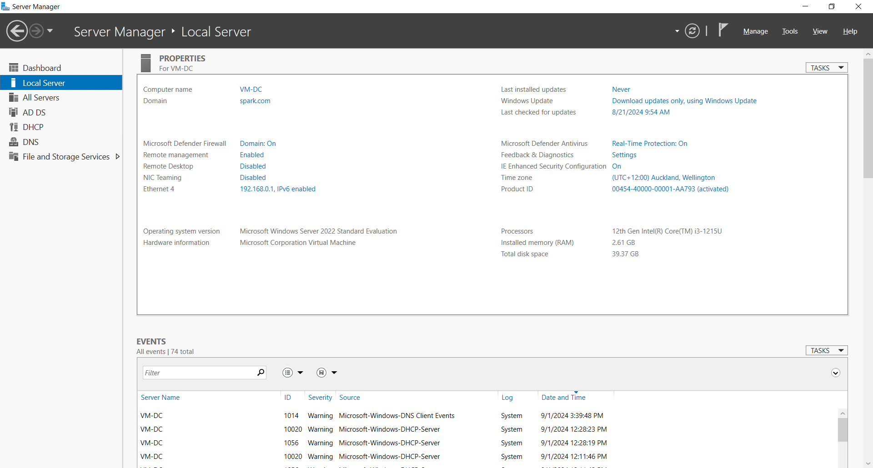

1. **Install MDT with PowerShell Script**

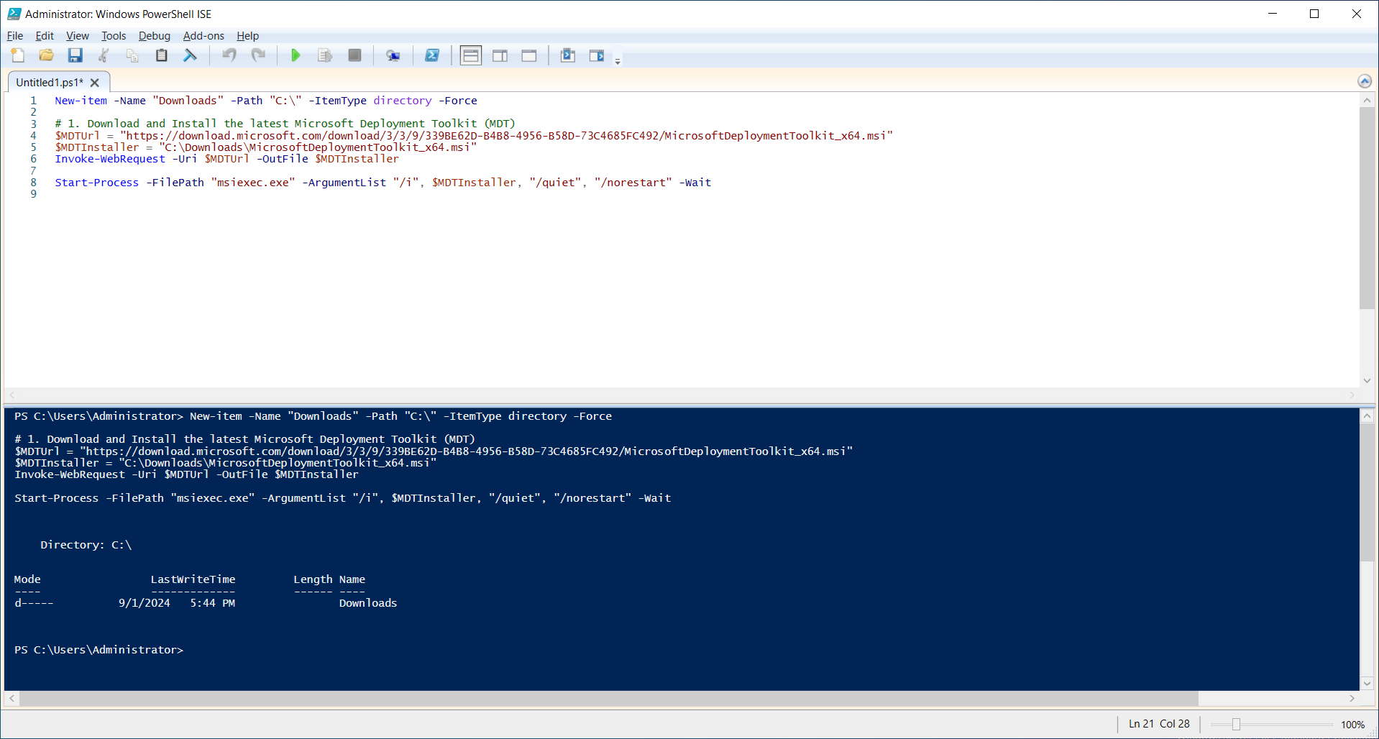

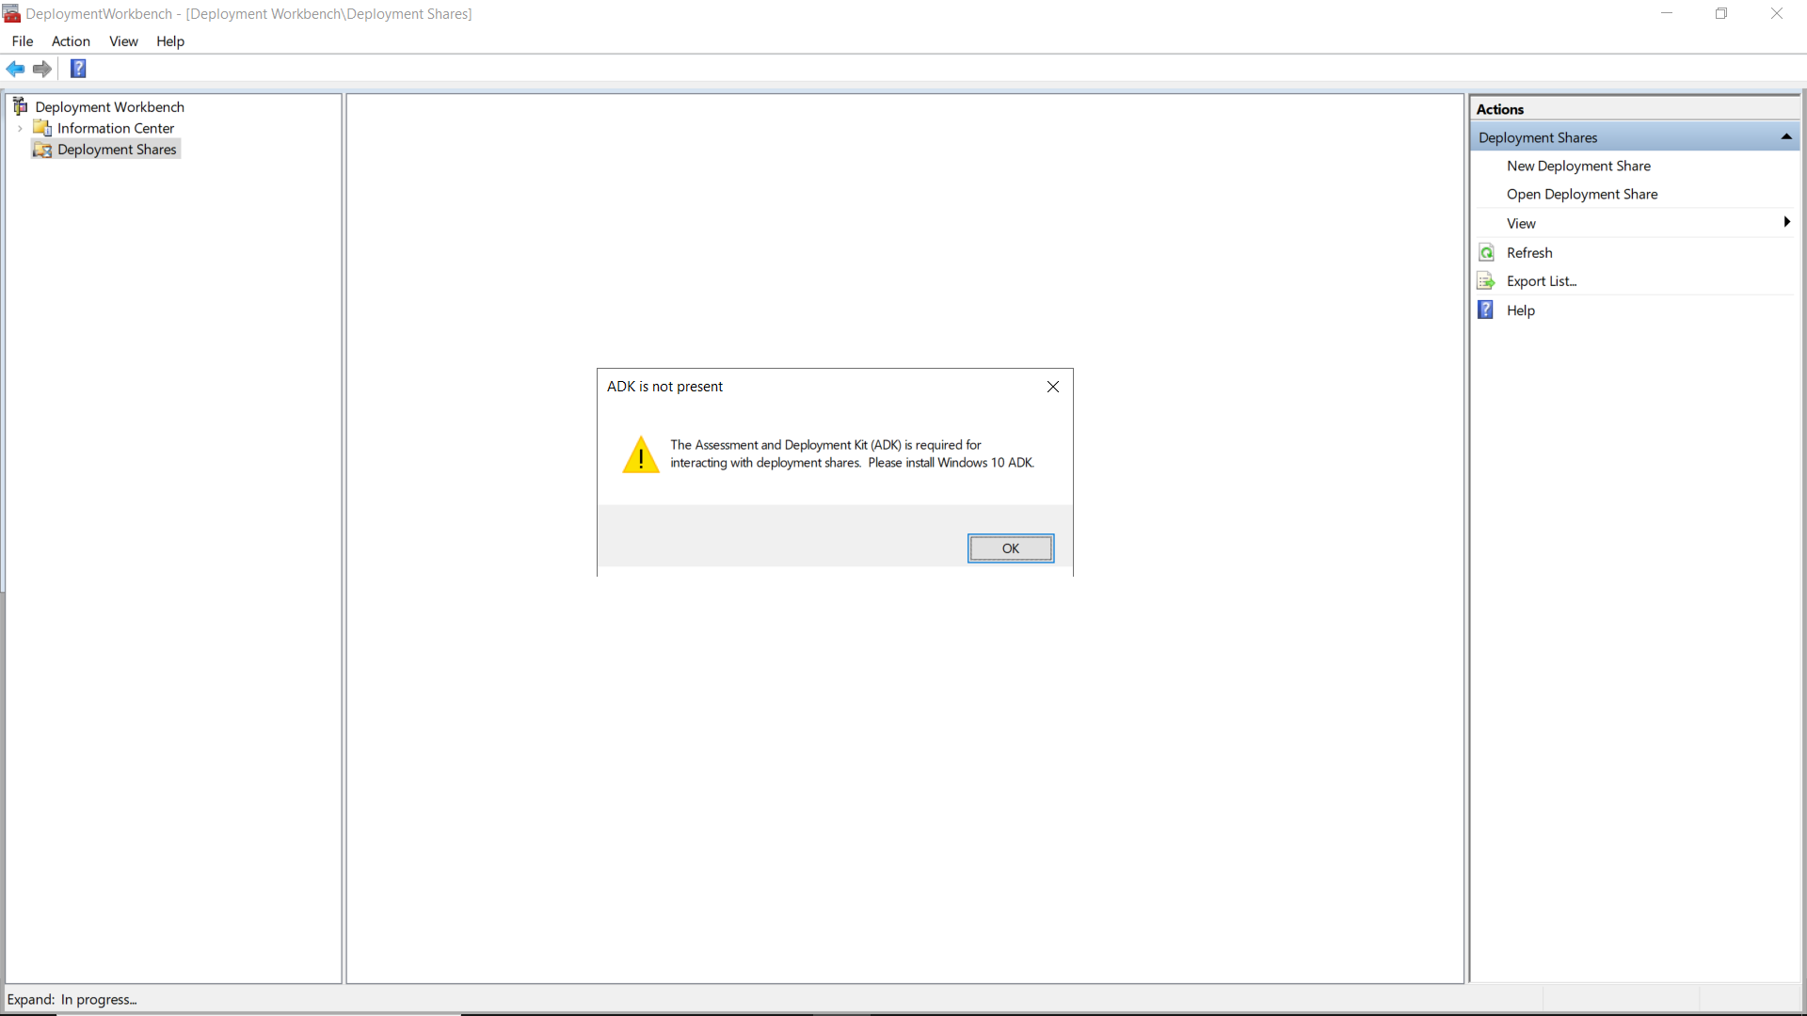

1. **Install Windows SDK**

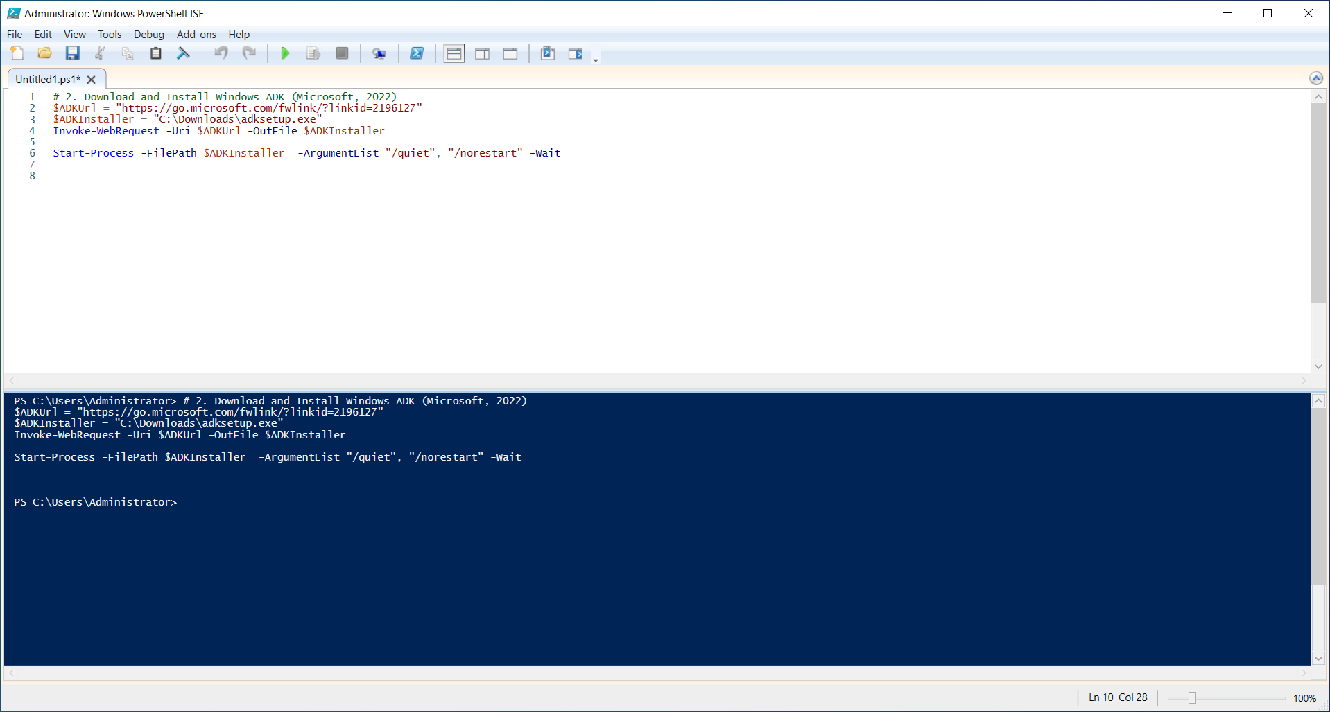

1. **Install Windows PE add-on for the Windows ADK**

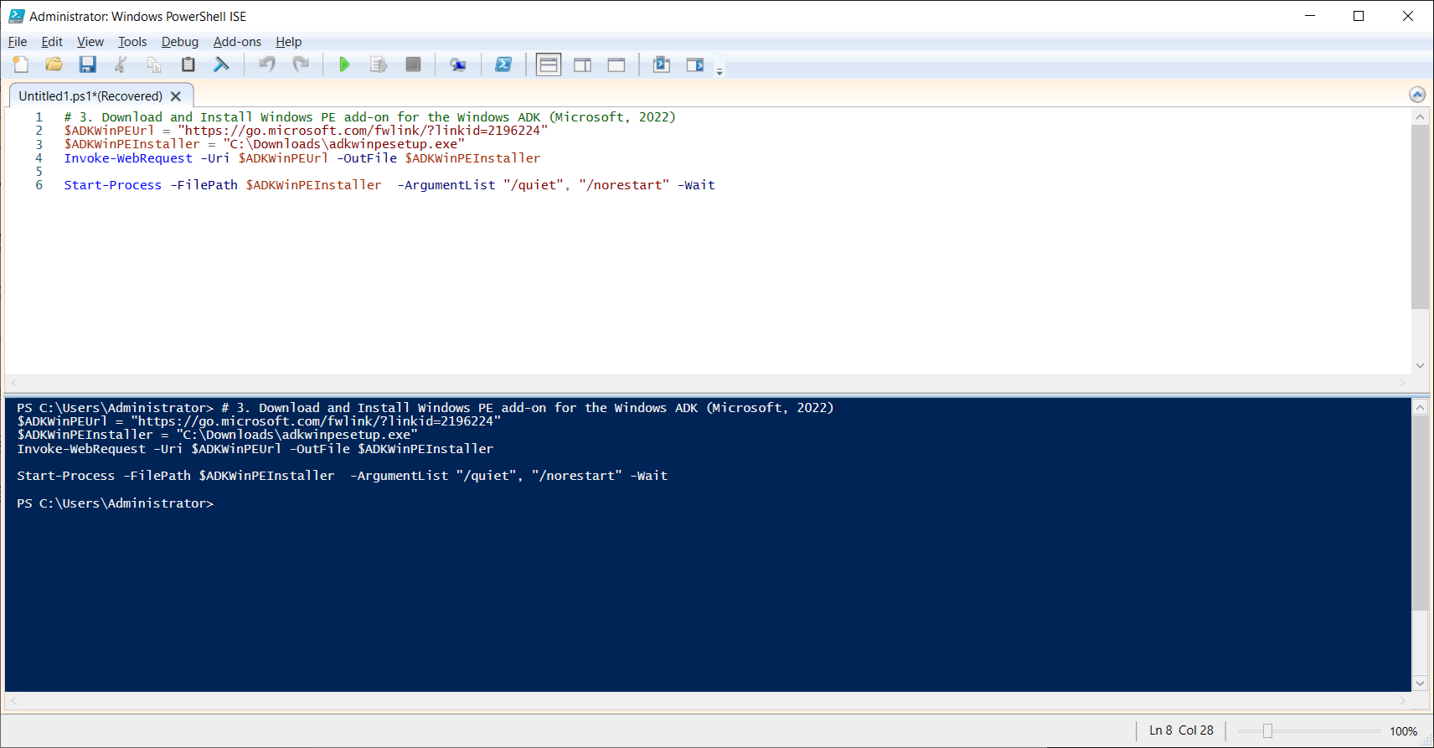

1. **Check installation in Control Panel list:**

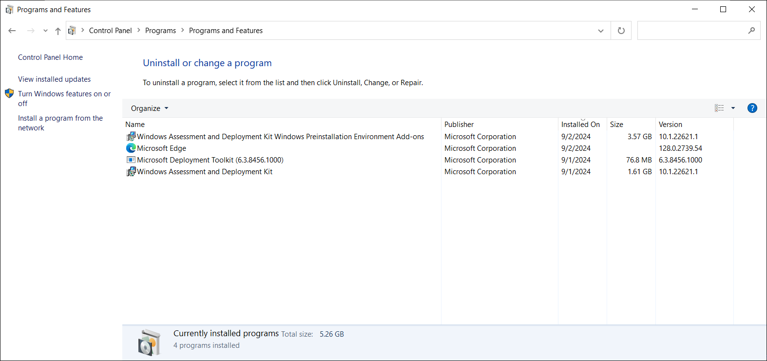

1. **Check MDT after Windows SDK and PE add-on installed.**

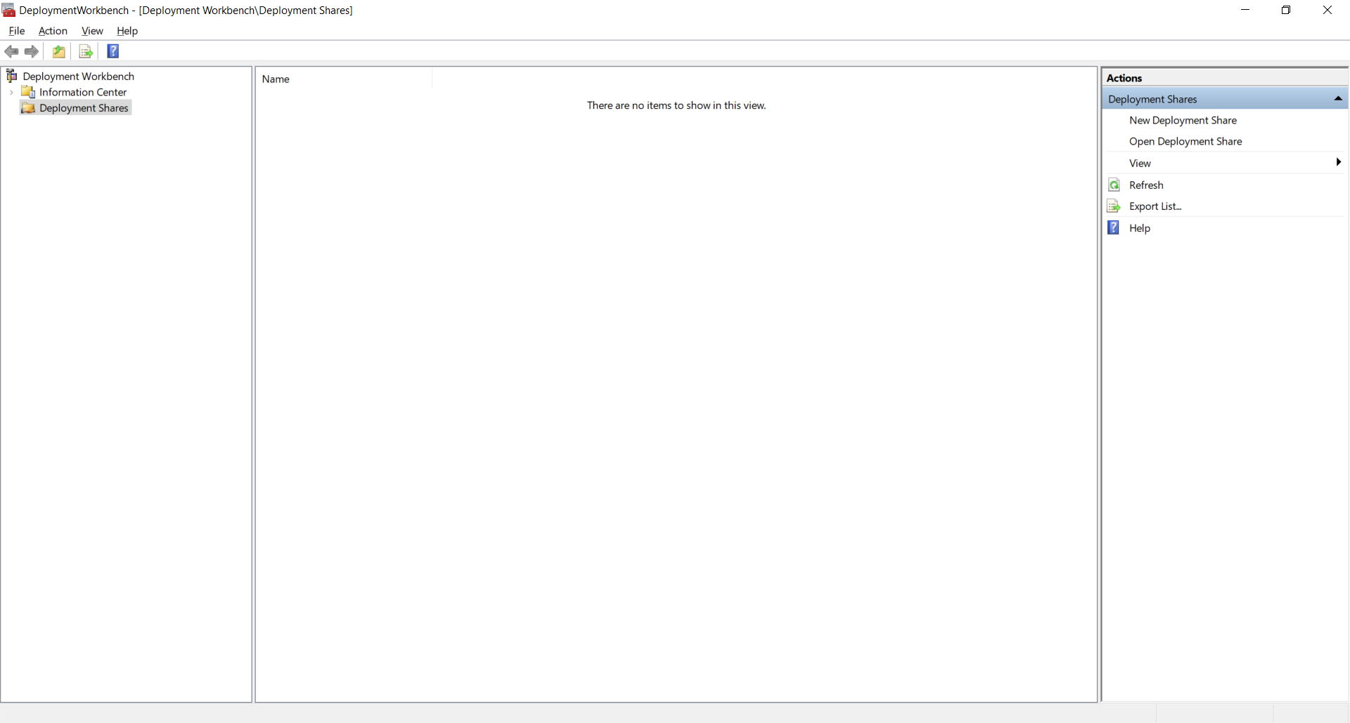

1. **Download Windows 11 image and mount it to the Server**

* Link of download Windows 11 (Microsoft, n.d.)

<https://go.microsoft.com/fwlink/?linkid=2171764>

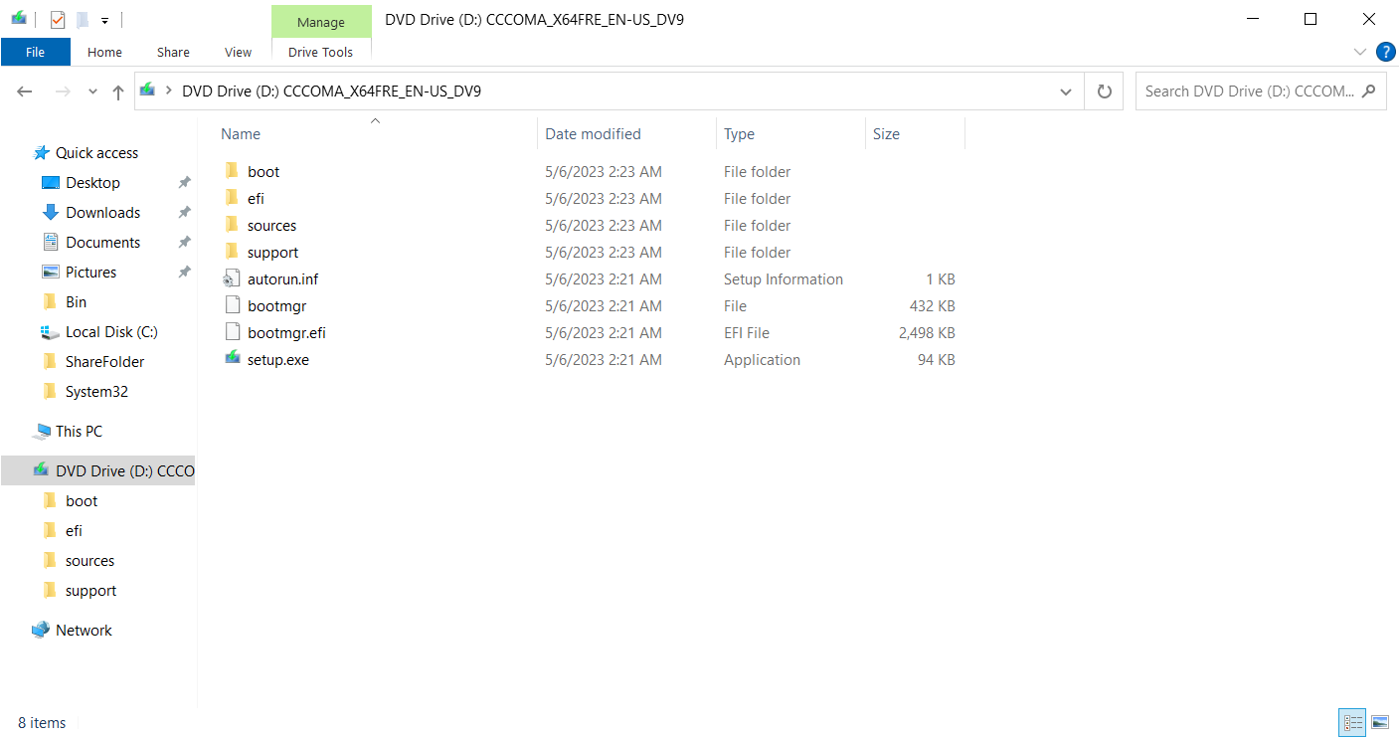

1. **Download Applications: Google Chrome, VLC and Adobe Acrobat Reader.**

* Link of download Google Chrome:

https://dl.google.com/tag/s/appguid%3D%7B8A69D345-D564-463C-AFF1-A69D9E530F96%7D%26iid%3D%7B8760FC7E-F333-738A-2267-71EB73676E42%7D%26lang%3Den%26browser%3D5%26usagestats%3D0%26appname%3DGoogle%2520Chrome%26needsadmin%3Dtrue%26ap%3Dx64-stable-statsdef_0%26brand%3DGCEA/dl/chrome/install/googlechromestandaloneenterprise64.msi

* Link of download VLC (VideoLAN, n.d.):

https://get.videolan.org/vlc/3.0.17.4/win32/vlc-3.0.17.4-win32.exe

* Link of download Adobe Acrobat Reader (Adobe, n.d.):

https://get.adobe.com/reader/enterprise/.

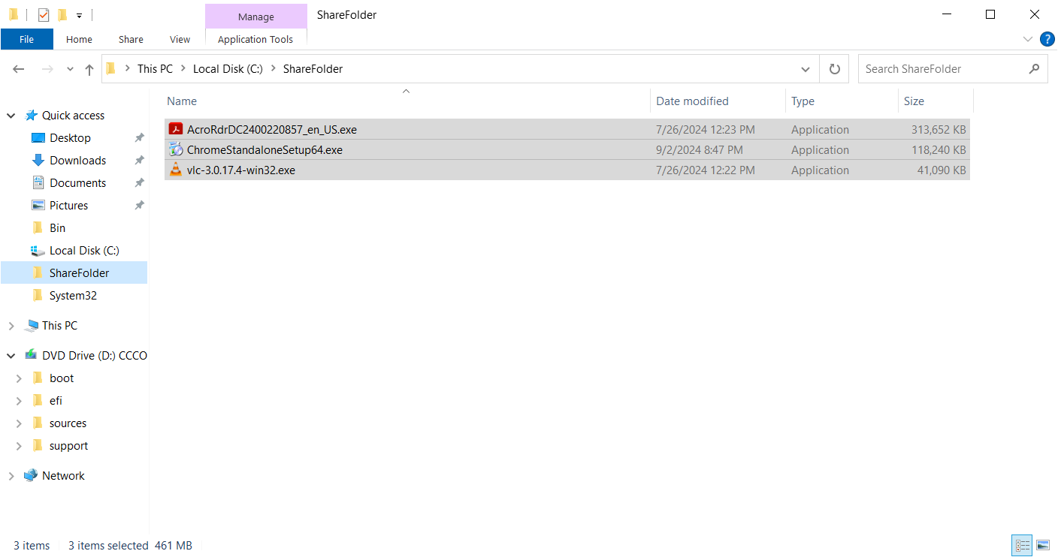

## Task 2: Analysis and Evaluation of Legal and Regulatory Requirements

There are several primary legal and regulatory requirements in New Zealand, including Privacy Act 2020(Privacy Act 2020. 2024), Copyright Act 1994(Copyright Act 1994. 2023), Fair Trading Act 1986(Fair Trading Act 1986. 2024), Health Information Privacy Code 2020(Health Information Privacy Code 2020. 2022), and New Zealand Information Security Manual (New Zealand Information Security Manual. 2024), etc.

To use Microsoft Deployment Toolkit (MDT) to deploy Windows 11 and applications automatically involves those legal and regulatory requirements listed above. These requirements ensure that the deployment process is compliance with software licenses, data protection, and security regulations.

1. **Software license compliance.** 
   * + - During the implementation, to ensure all software installed, including Windows 11, Google Chrome, VLC Media Player, and Adobe Acrobat Reader, is properly licensed for use by Media Labs under Copyright Act 1994 and Fair Trading Act 1986.
       - For Media Labs, licenses are confirmed before deployment. A record of all software licenses, proof of purchase and download links is maintained and the usage and installation of software on each client machine is documented to demonstrate compliance.
2. **Data protection and privacy.** 
   * + - Under Privacy Act 2020 and Health Information Privacy Code 2020, it includes ensuring that no personal data is unlawfully processed during the deployment, and appropriate measures are in place to secure any personal data that may be involved.
       - During deployment, all personal data is minimized, protected, and only used for the necessary purposes, and data is encrypted and is not leaked or improperly accessed. MDT and deployment scripts is configured to anonymize to avoid storing any user-specific data in deployment logs or capturing user data during the deployment process.
3. **Security and compliance standards.** 
   * + - Under New Zealand Information Security Manual, deployment processes should include measures that align with these standards, like secure transmission of data and maintaining system integrity, protecting against cybersecurity with security patches and updates to prevent vulnerabilities, managing firewall rules, ensuring security policies are enforced, and managing system settings to prevent unauthorized changes.
       - During deployment, PowerShell script is configured to update Windows 11 and all other applications with the latest patches to avoid vulnerabilities.

## Task 3: Plan, Design and Create a Deployment Script

**1. Add MDT snap-in to support PowerShell cmdlets.**

Add-PSSnapin Microsoft.BDD.PSSnapIn

Import-Module "C:\Program Files\Microsoft Deployment Toolkit\bin\MicrosoftDeploymentToolkit.psd1"

$deploymentShare = "C:\DeploymentShare"

$mdtPath = "$deploymentShare\Control"

$networkPath = "\\VM-DC\DeploymentShare"

**2. Create a new share folder for the deployment**

New-Item $deploymentShare -Type directory -Force

New-SmbShare -Name DeploymentShare -Path $deploymentShare -FullAccess Administrators

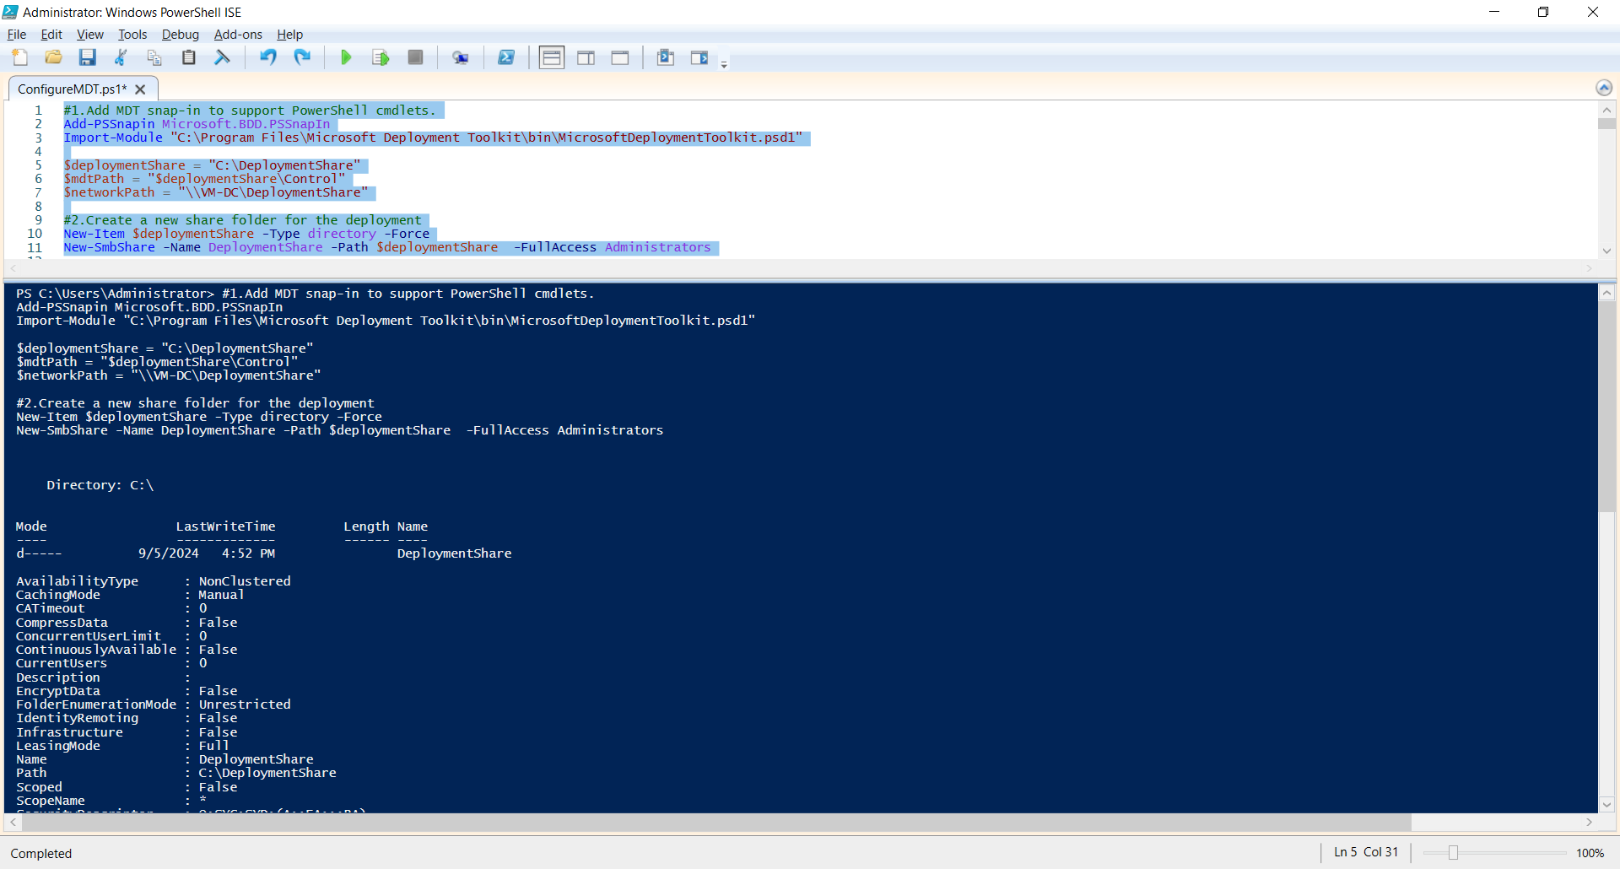

**3. Initilize the deployment folder as a persistent drive named "DS001"**

#Import-Module "C:\Program Files\Microsoft Deployment Toolkit\bin\MicrosoftDeploymentToolkit.psd1"

new-PSDrive -Name "DS001" -PSProvider "MDTProvider" -Root "C:\DeploymentShare" -Description "MDT Deployment Share" -Force -Verbose | add-MDTPersistentDrive -Verbose

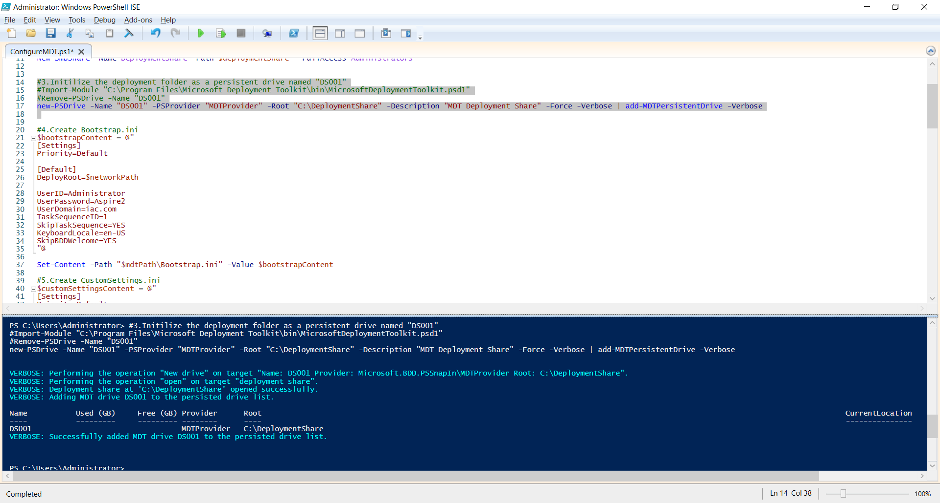

**4. Create Bootstrap.ini**

$bootstrapContent = @"

[Settings]

Priority=Default

[Default]

DeployRoot=$networkPath

UserID=Administrator

UserPassword=Aspire2

UserDomain=iac.com

TaskSequenceID=1

SkipTaskSequence=YES

KeyboardLocale=en-US

SkipBDDWelcome=YES

"@

Set-Content -Path "$mdtPath\Bootstrap.ini" -Value $bootstrapContent

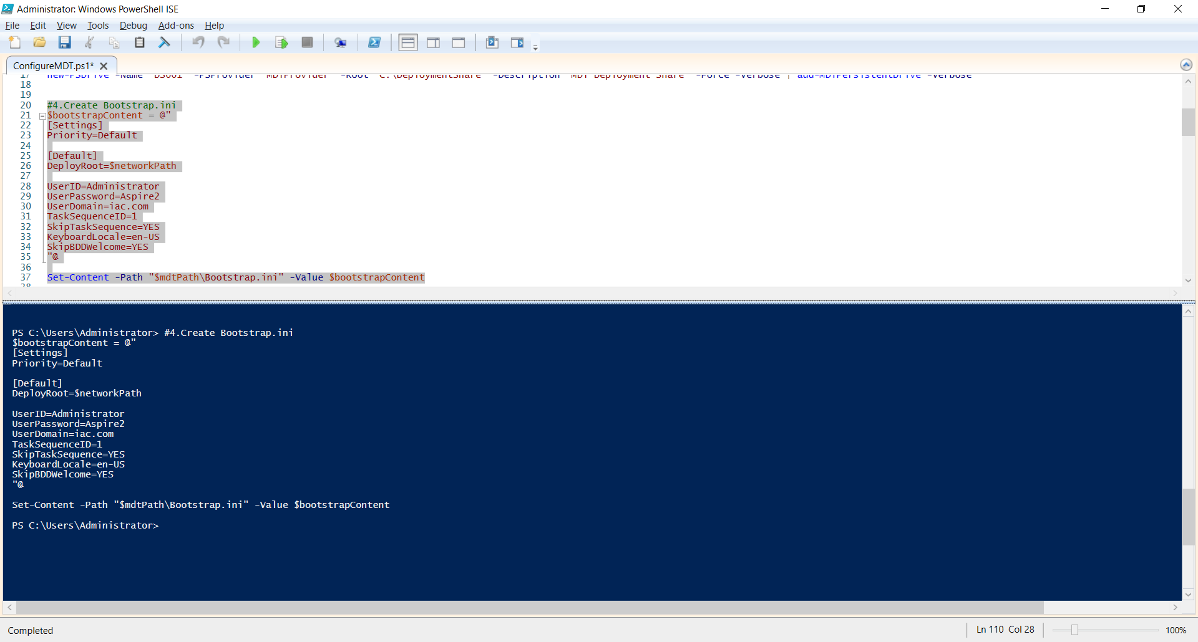

**5. Create CustomSettings.ini**

$customSettingsContent = @"

[Settings]

Priority=Default

Properties=MyCustomProperty

[Default]

OSInstall=Y

SkipCapture=YES

SkipAdminPassword=YES

SkipProductKey=YES

SkipComputerBackup=YES

SkipBitLocker=YES

SkipBDDWelcome=YES

SkipUserData=YES

SkipTimeZone=YES

SkipLocaleSelection=YES

SkipComputerName=YES

SkipSummary=YES

SkipDomainMembership=YES

SkipApplications=YES

KeyboardLocale=en-US

TimeZoneName=New Zealand StandardTime

EventService=http://Deployment:9800

"@

Set-Content -Path "$mdtPath\CustomSettings.ini" -Value $customSettingsContent

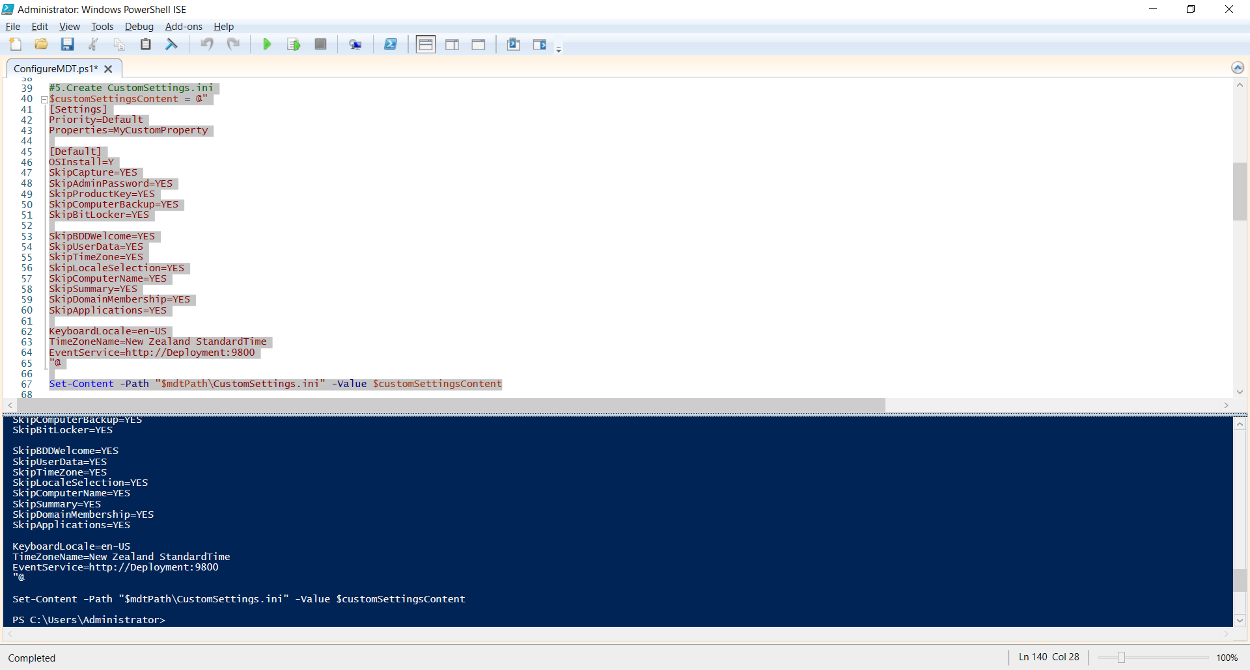

**6. Import Applications (Chrome, VLC and Acrobat Reader) into MDT**

Restore-MDTPersistentDrive -Verbose

Get-PSDrive -PSProvider Microsoft.BDD.PSSnapIn\MDTProvider

Import-MDTApplication -Name "Google Chrome" -Path "DS001:\Applications" -ApplicationSourcePath "C:\ShareFolder\Chrome" -DestinationFolder Chrome -WorkingDirectory ".\Applications\Chrome" -CommandLine "ChromeStandaloneSetup64.exe /silent /install" -ShortName Chrome

Import-MDTApplication -Name "VLC Media Player" -Path "DS001:\Applications" -ApplicationSourcePath "C:\ShareFolder\VLC" -DestinationFolder VLC -WorkingDirectory ".\Applications\VLC" -CommandLine "vlc-3.0.17.4-win32.exe /L=1033 /S" -ShortName VLC

Import-MDTApplication -Name "Adobe Acrobat Reader" -Path "DS001:\Applications" -ApplicationSourcePath "C:\ShareFolder\AcroRdr" -DestinationFolder AcroRdr -WorkingDirectory ".\Applications\AcroRdr" -CommandLine "AcroRdrDC2400220857_en_US.exe /sAll /rs /msi EULA_ACCEPT=YES" -ShortName AcroRdr

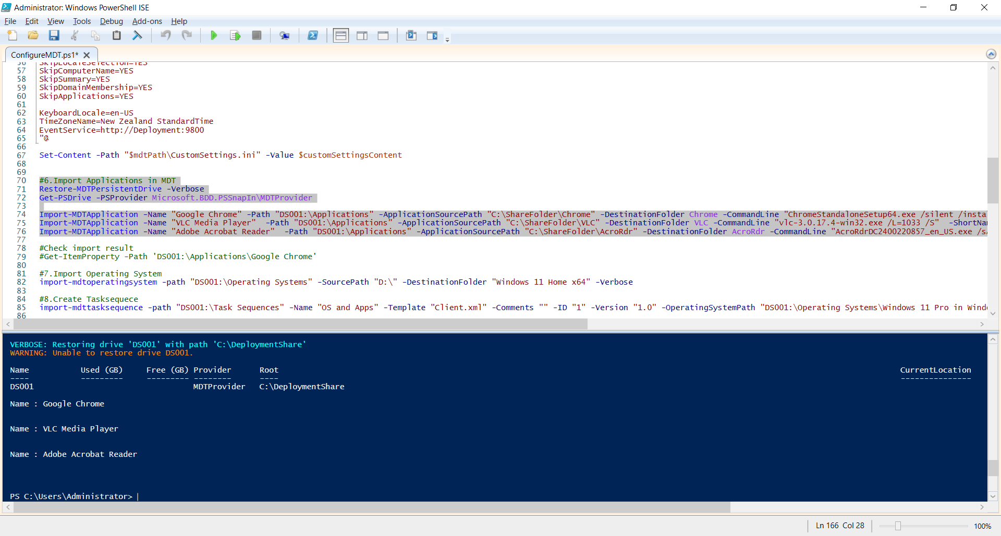

**Check imported applications on the MDT management console:**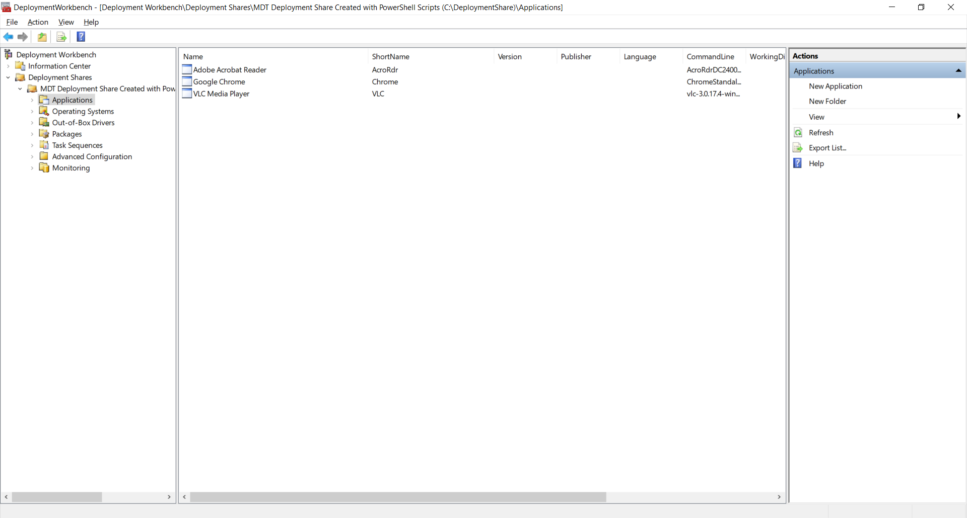

**7. Import Operating System**

import-mdtoperatingsystem -path "DS001:\Operating Systems" -SourcePath "D:\" -DestinationFolder "Windows 11 Home x64" -Verbose

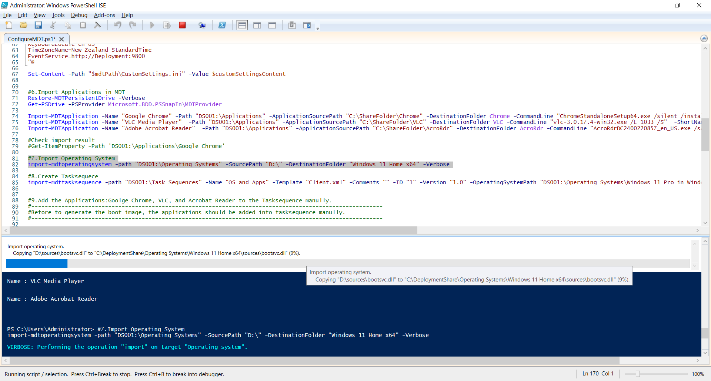

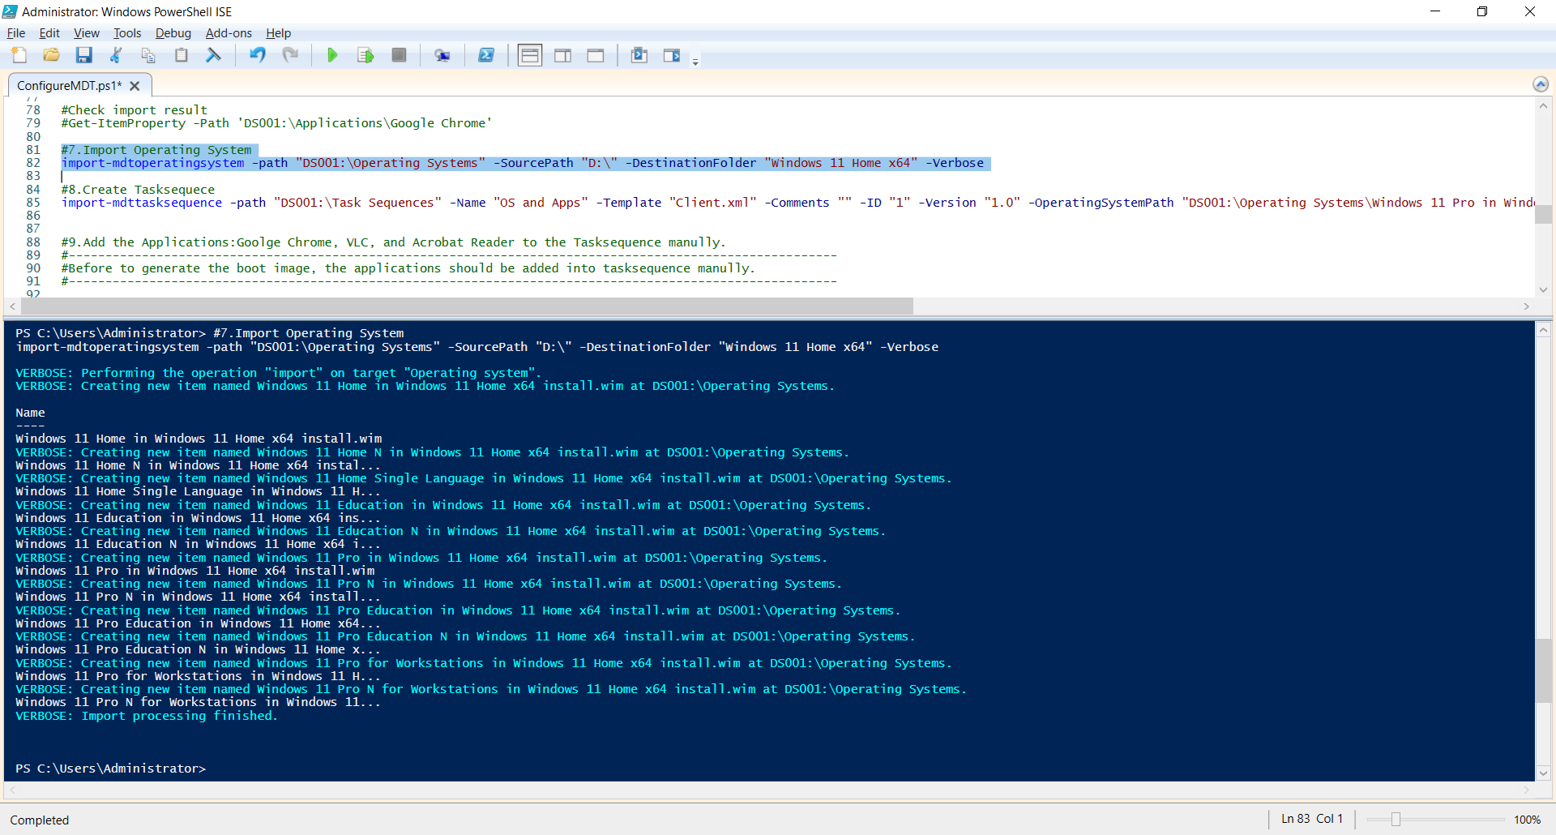

**Check imported Windows 11 on the MDT management Console.**

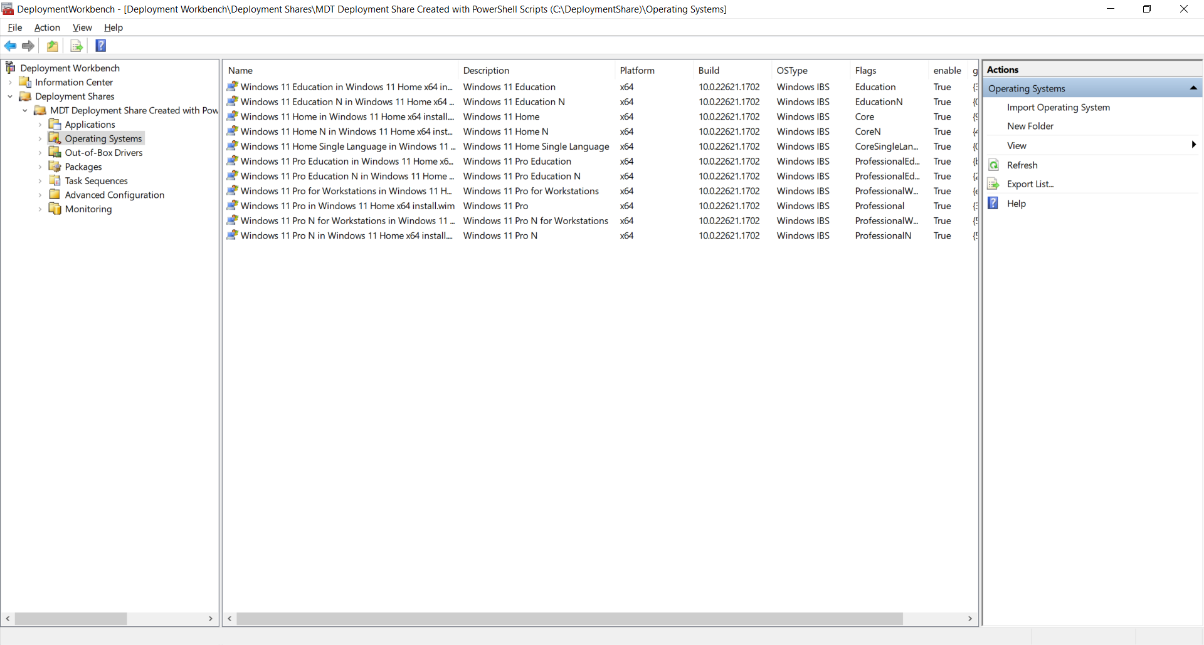

**8. Create Tasksequece**

import-mdttasksequence -path "DS001:\Task Sequences" -Name "OS and Apps" -Template "Client.xml" -Comments "" -ID "1" -Version "1.0" -OperatingSystemPath "DS001:\Operating Systems\Windows 11 Pro in Windows 11 Home x64 install.wim" -FullName "Windows User" -OrgName "Media Labs" -HomePage "about:blank" -Verbose

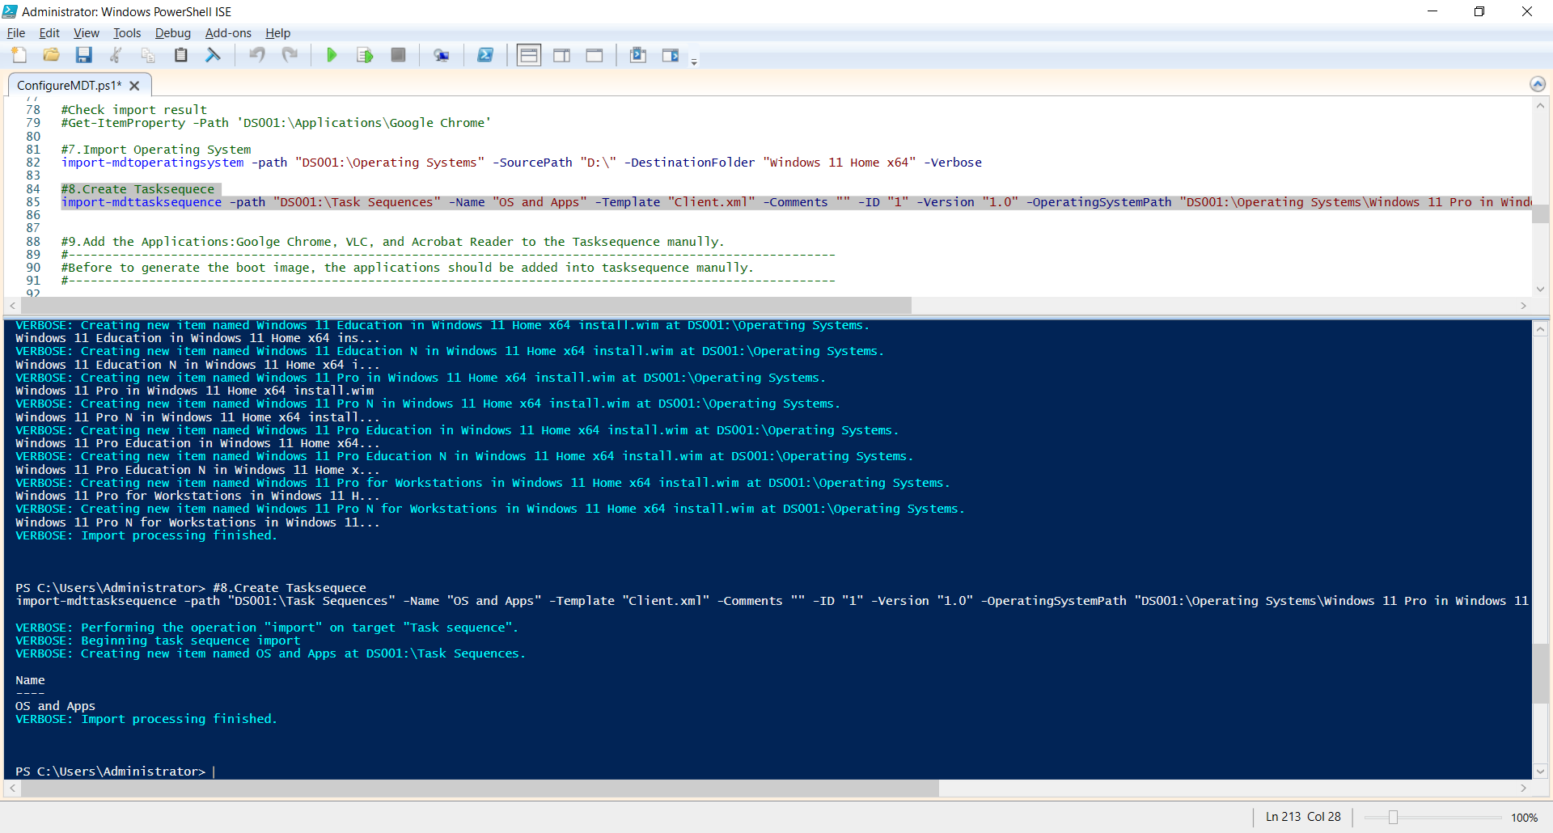

**9. Add the Applications: Google Chrome, VLC, and Acrobat Reader to the Tasksequence manually.**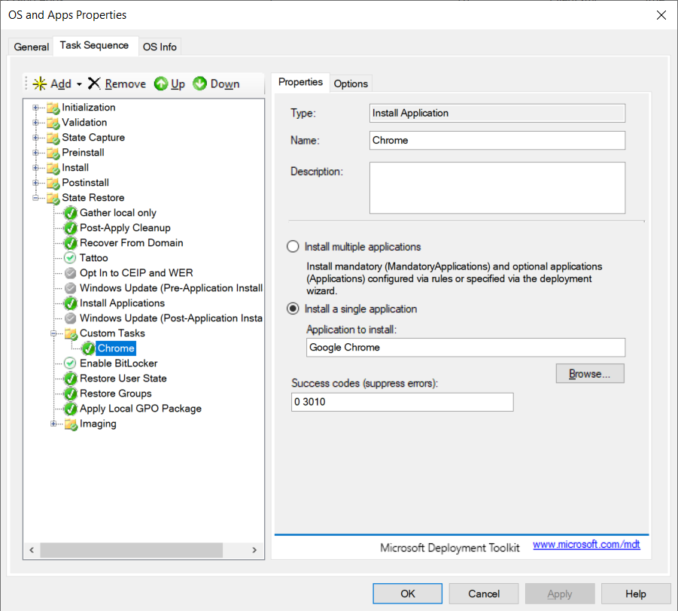

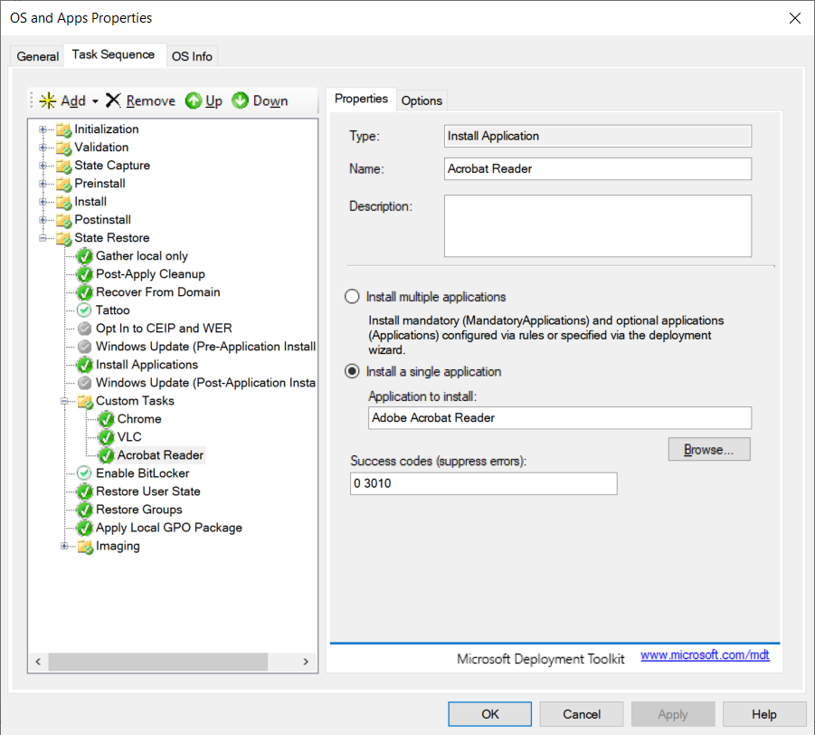

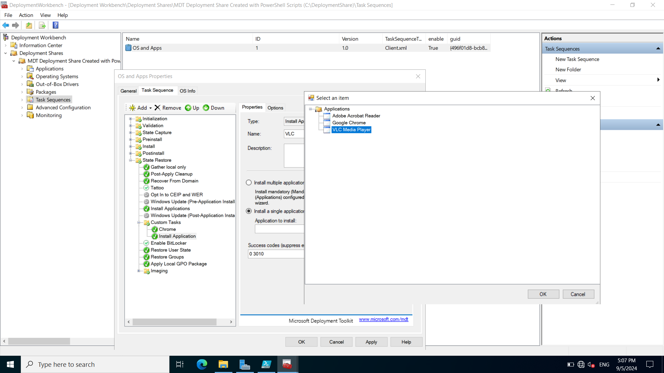

**10. Generate the boot image**

#Since Windows 11 will be installed on X64 machines and x86 image will not be generated.

Set-ItemProperty -Path "DS001:" -Name "SupportX86" -value $false -Force -Verbose

#Generate the boot image.

Update-MDTDeploymentShare -Path "DS001:" -Force -Verbose

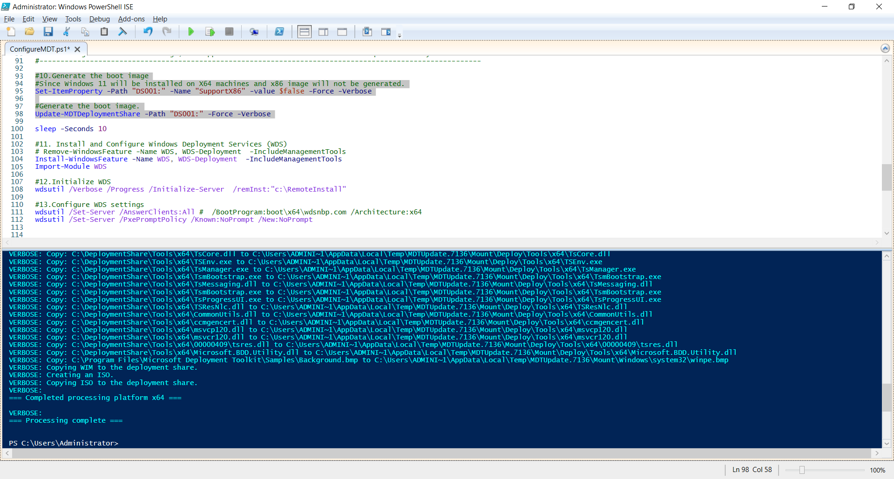

**11. Install and Configure Windows Deployment Services (WDS)**

Install-WindowsFeature -Name WDS -IncludeManagementTools

Import-Module WDS

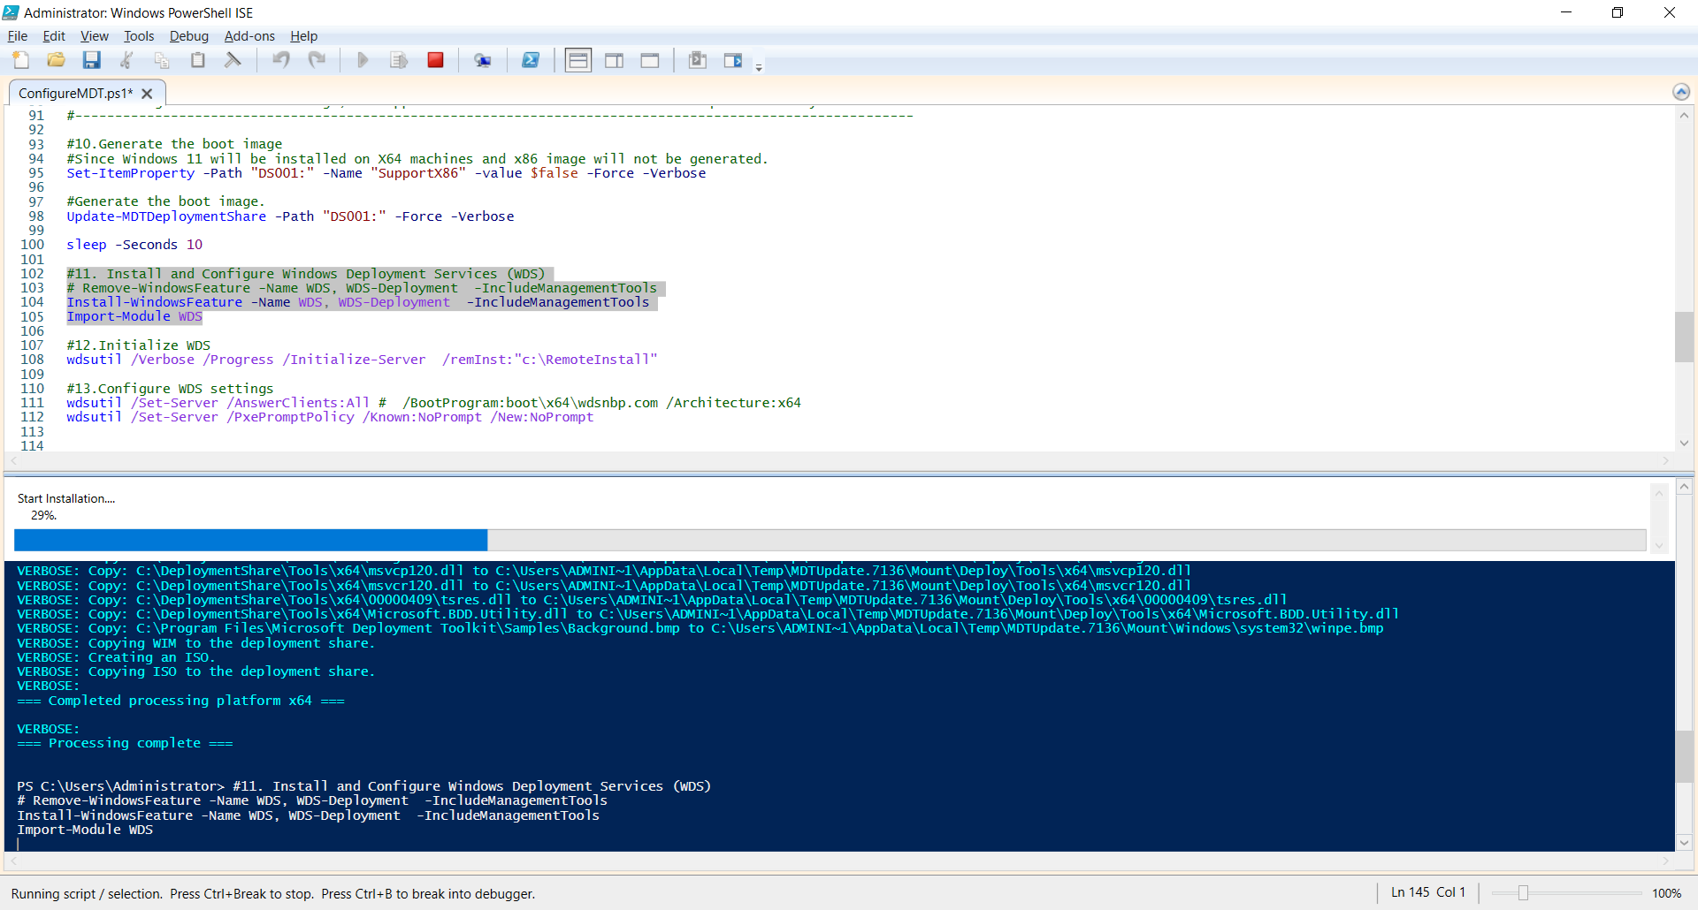

**12. Initialize WDS**

wdsutil /Verbose /Progress /Initialize-Server /remInst:"c:\RemoteInstall"

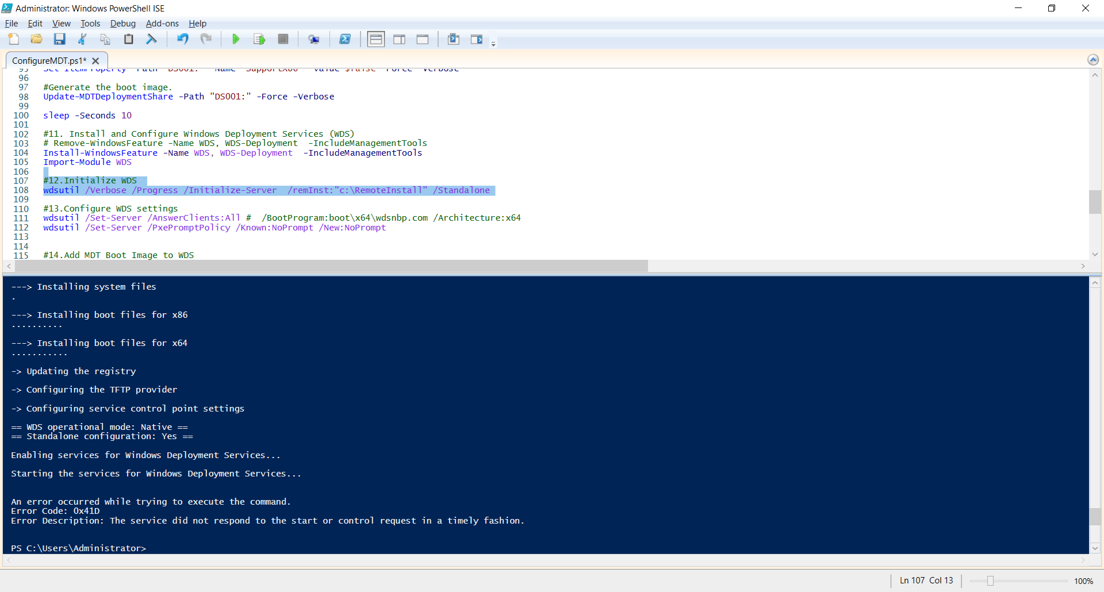

**13. Configure WDS settings**

wdsutil /Set-Server /AnswerClients:All

wdsutil /Set-Server /PxePromptPolicy /Known:NoPrompt /New:NoPrompt

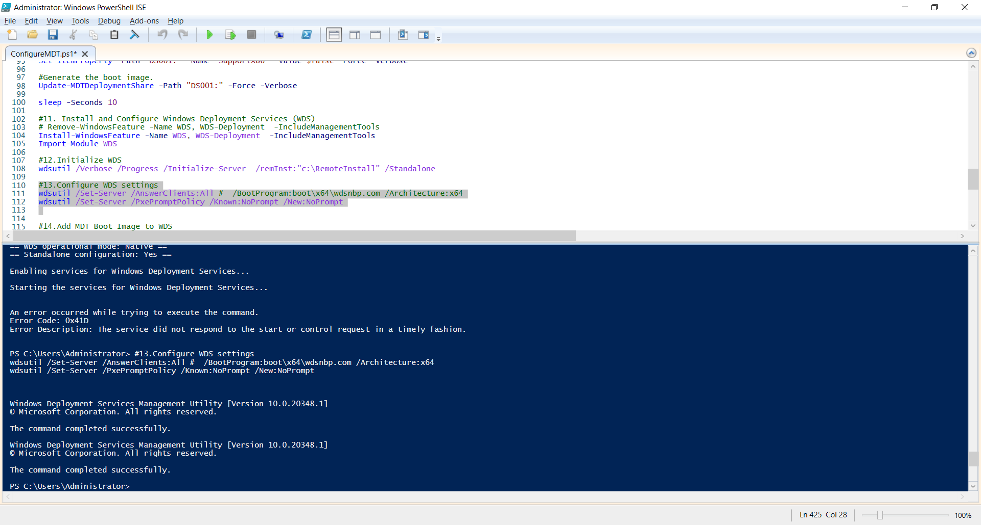

**14. Start Windows Deployment Service**

wdsutil /verbose /start-Server

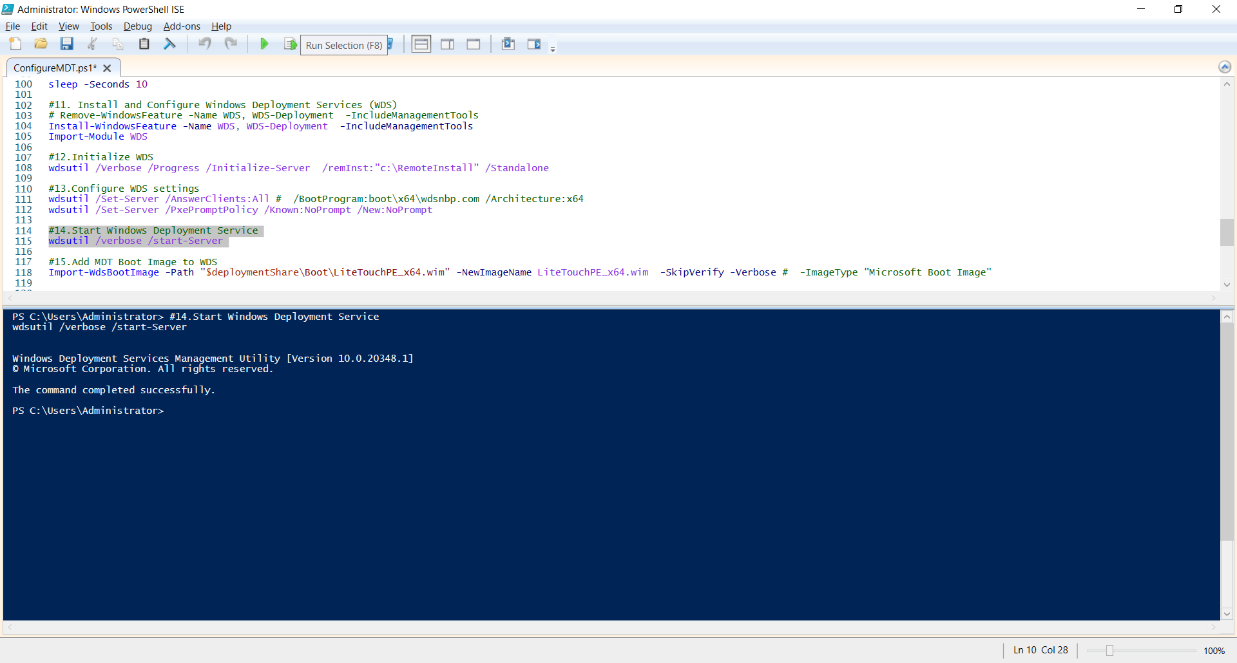

**15. Add MDT Boot Image to WDS**

Import-WdsBootImage -Path "$deploymentShare\Boot\LiteTouchPE_x64.wim" -NewImageName LiteTouchPE_x64.wim -SkipVerify -Verbose # -ImageType "Microsoft Boot Image"

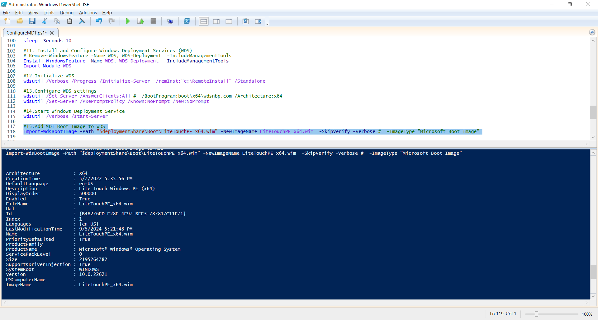

## Task 4: Pre- and Post-Deployment Implementation for a new client machine

**1 . Set parameters for the client virtual machine**

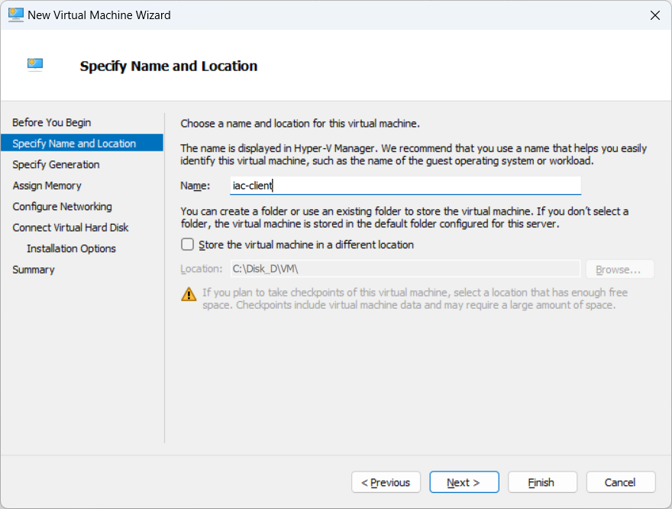

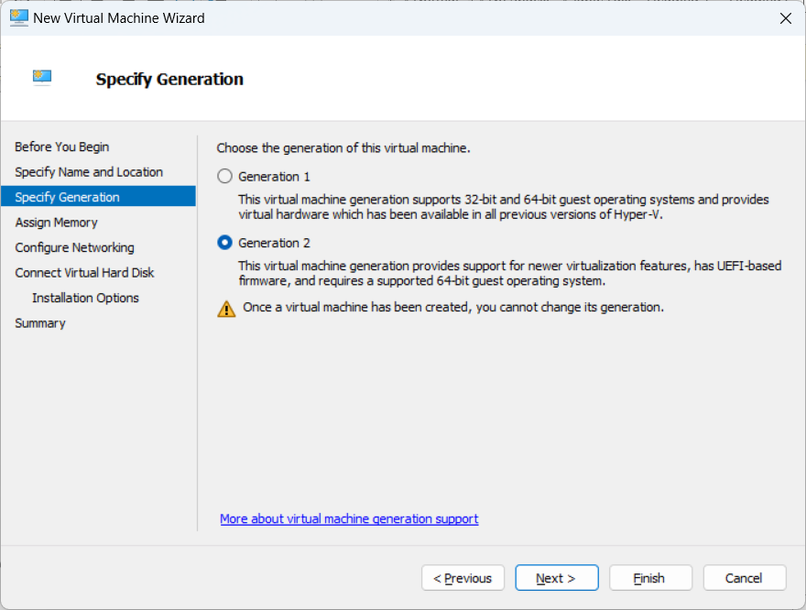

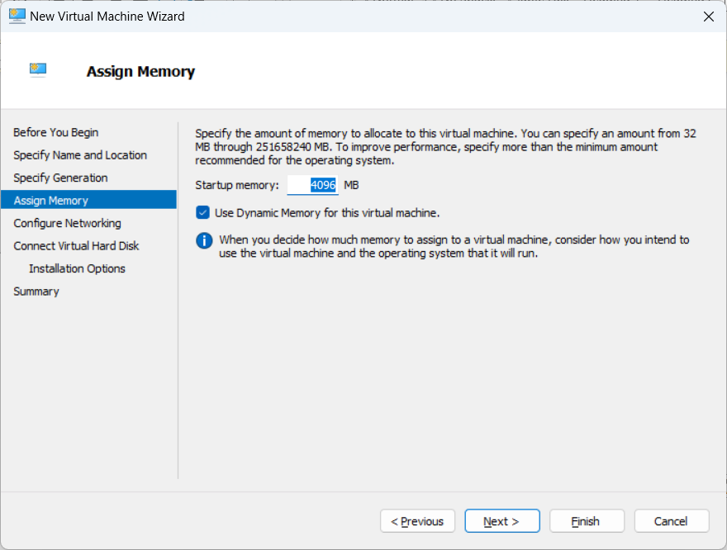

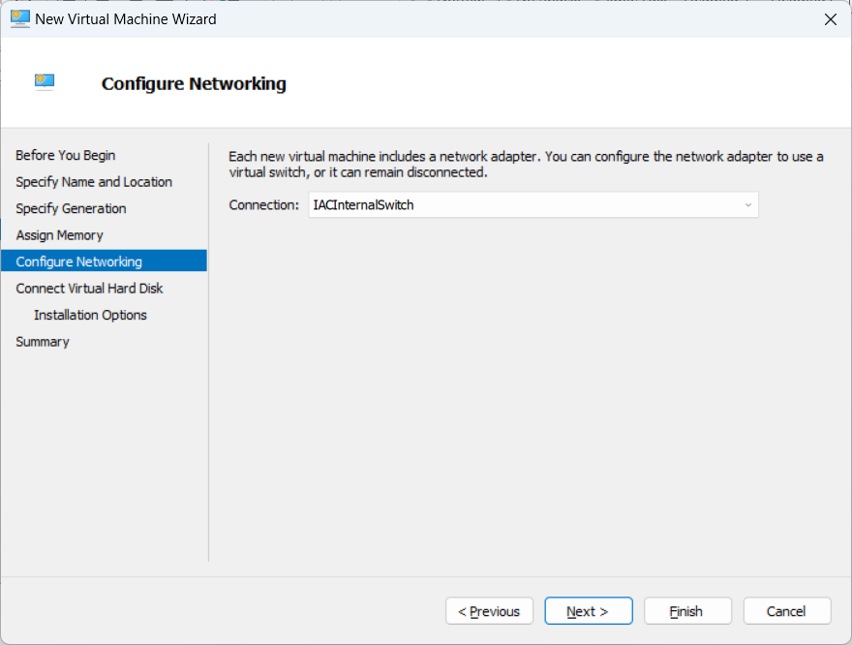

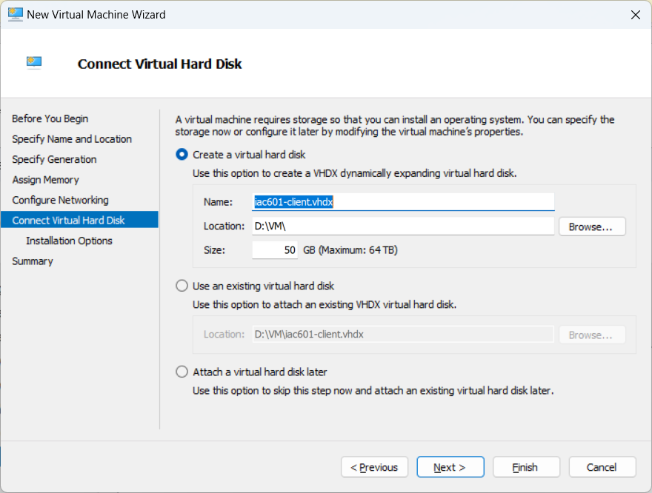

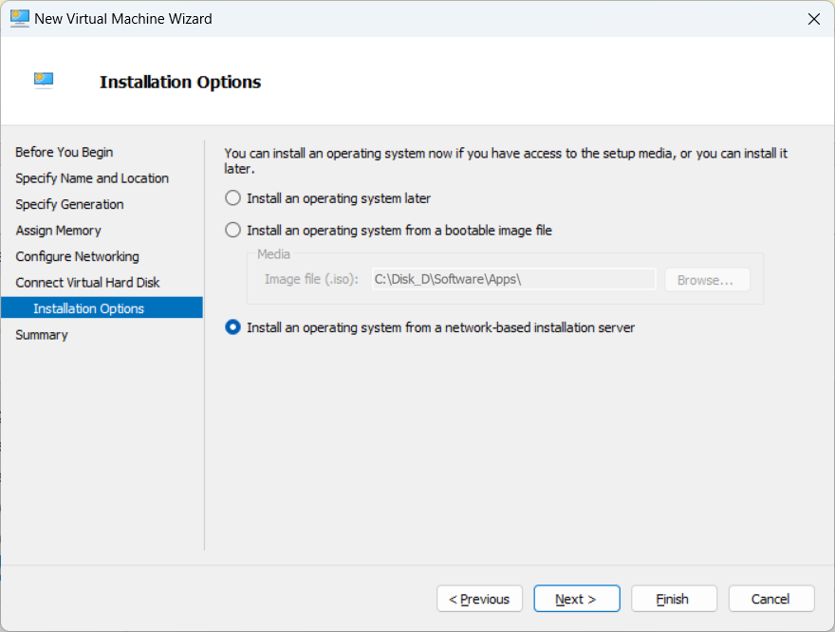

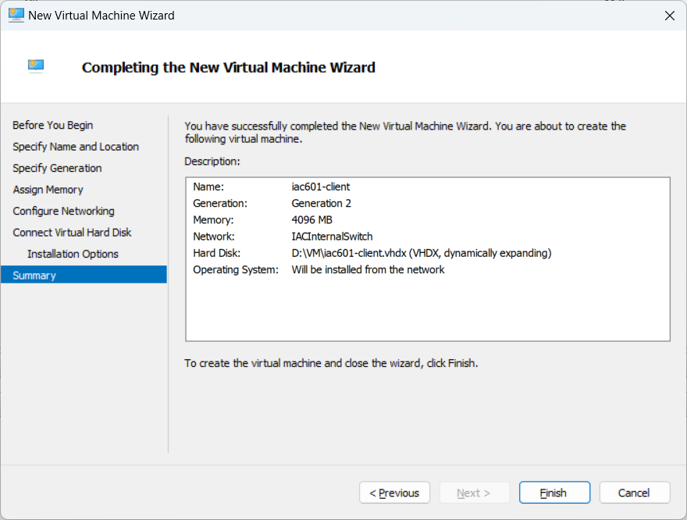

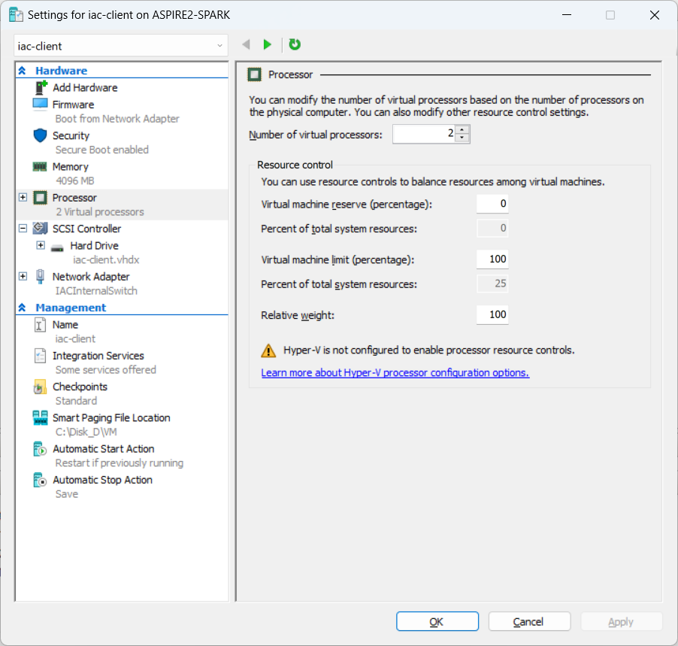

**2. Turn on the client machine and Windows Deployment is starting automatically.**

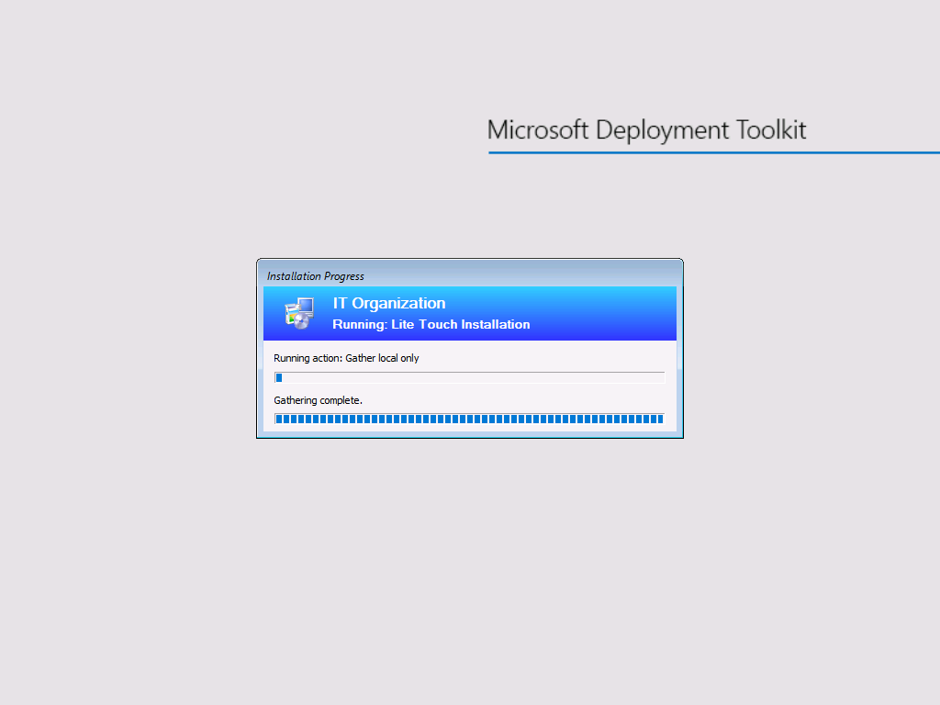

**3. Windows 11 Pro is installing.**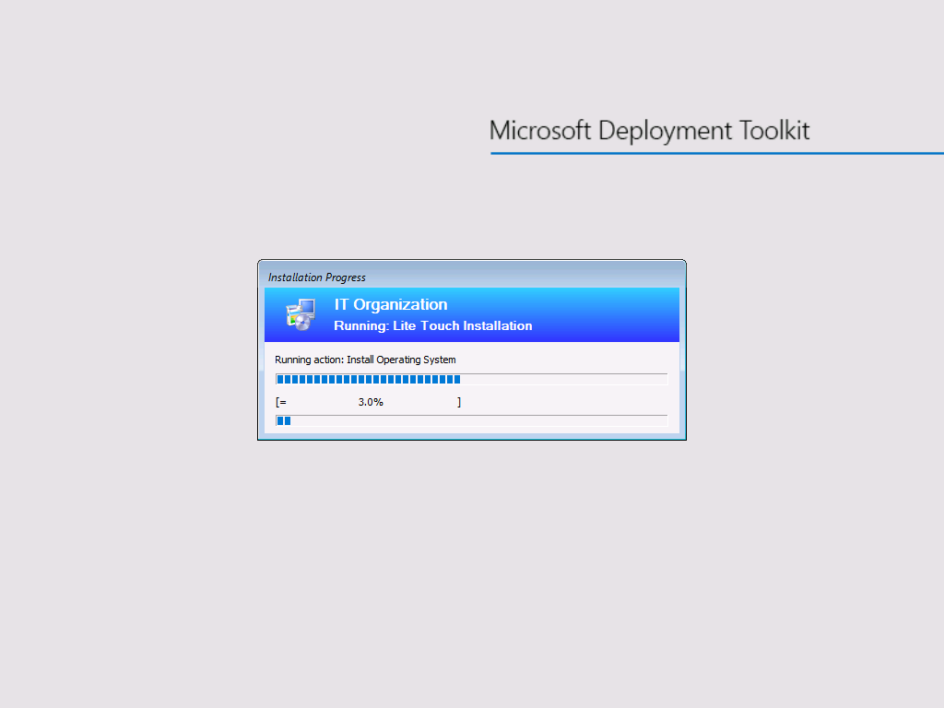

**4. Windows 11 Pro is installed automatically.**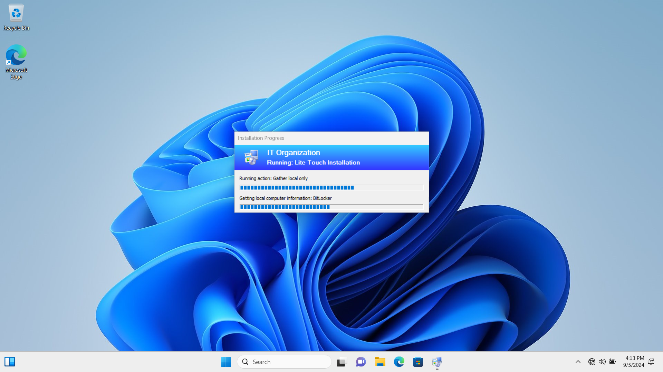

**5. Google Chrome is installing.**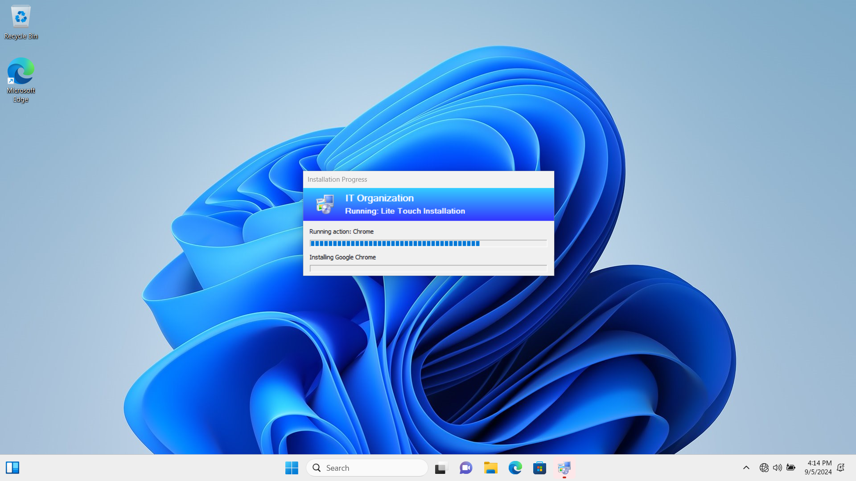

**6. Acrobat Reader is installing.**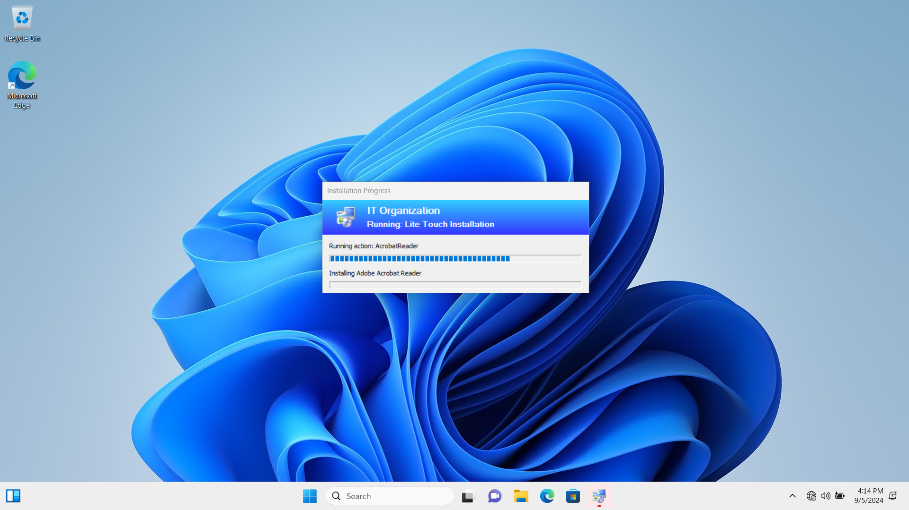

**7. VLC is installing.**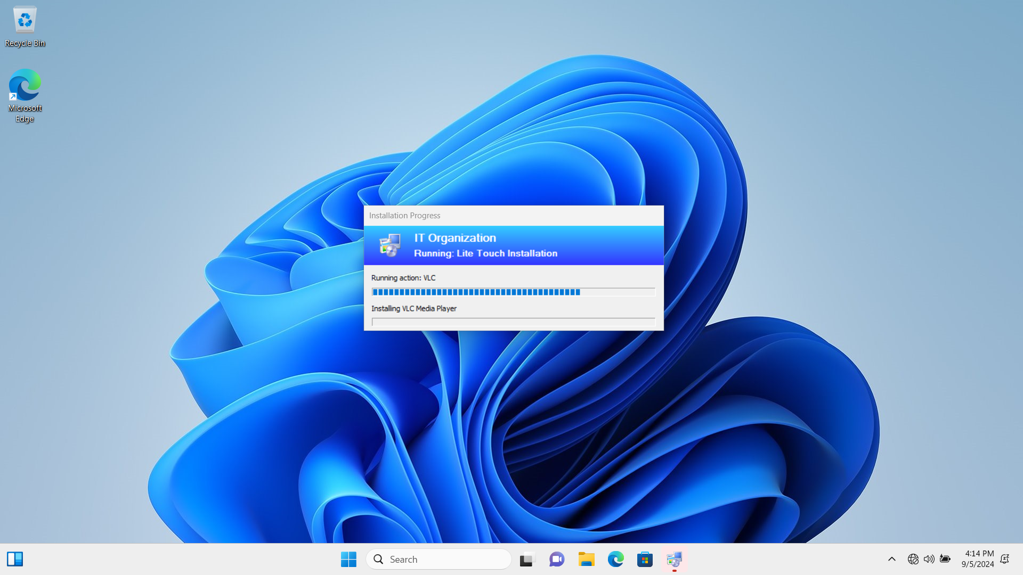

**8. Google Chrome, Acrobat Reader, and VLC are installed automatically, and we can find the icons of them on Desktop.**

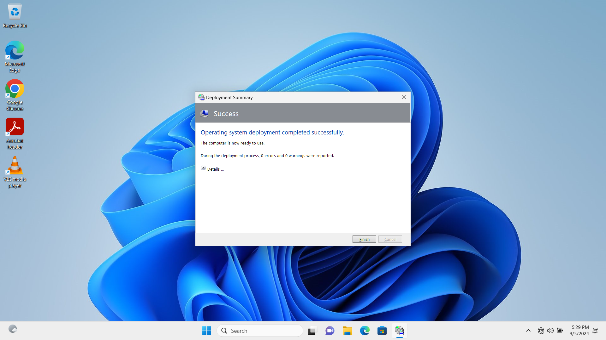

## Task 5: Version Control with GitHub Repository

**1. Create a new repository:**

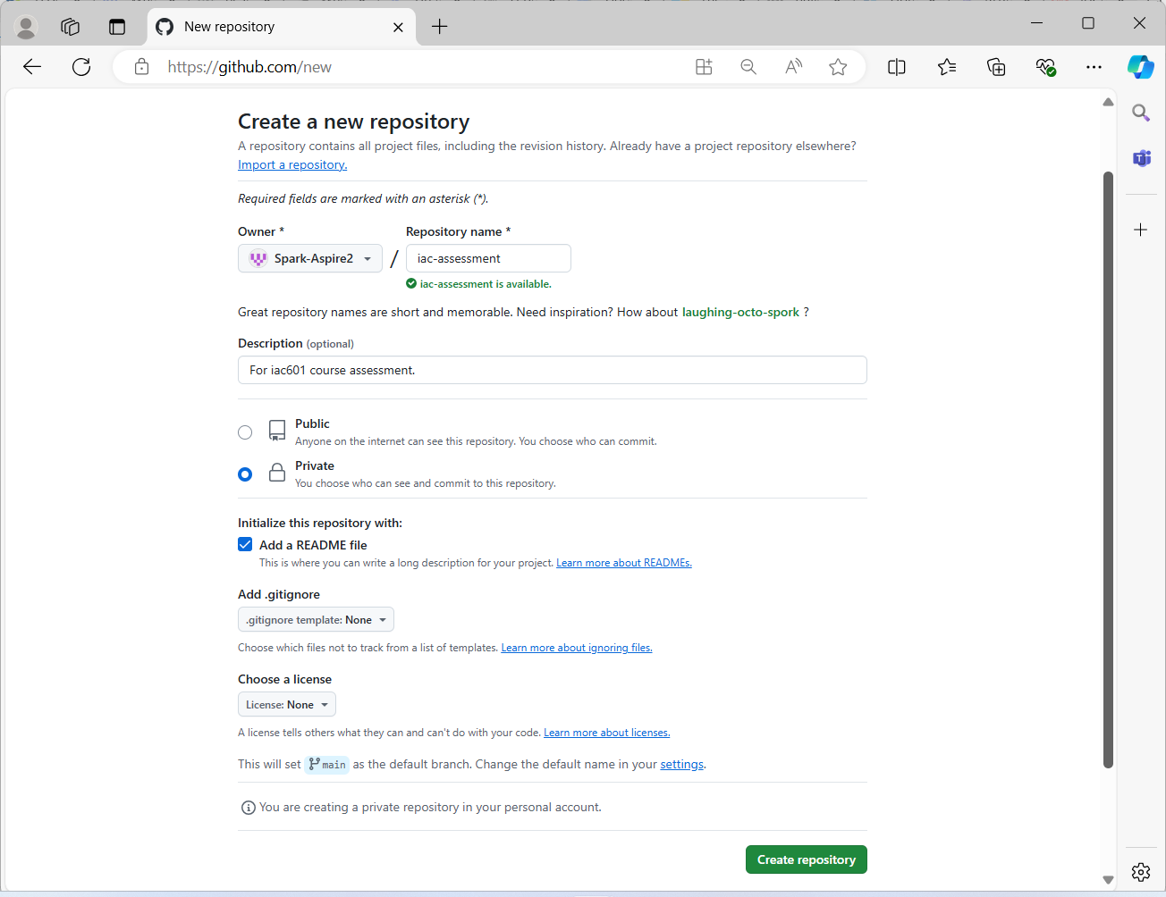

**2. Clone the Github repository to the local machine:**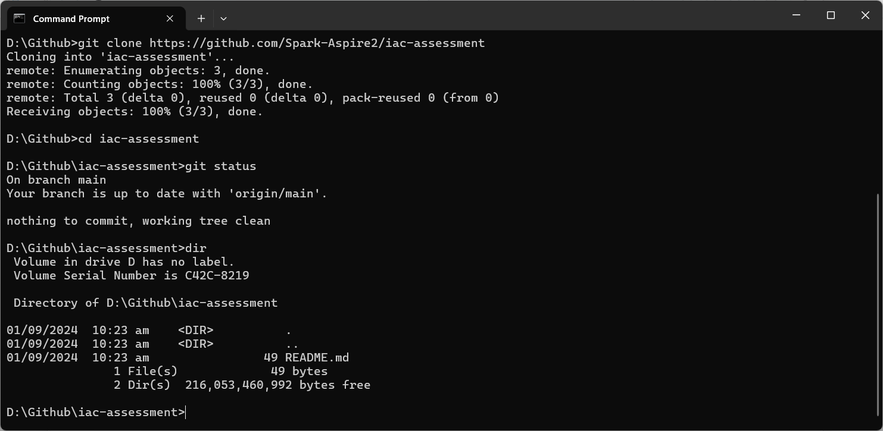

**3. Upload the latest documentation and PowerShell scripts to Github repository:**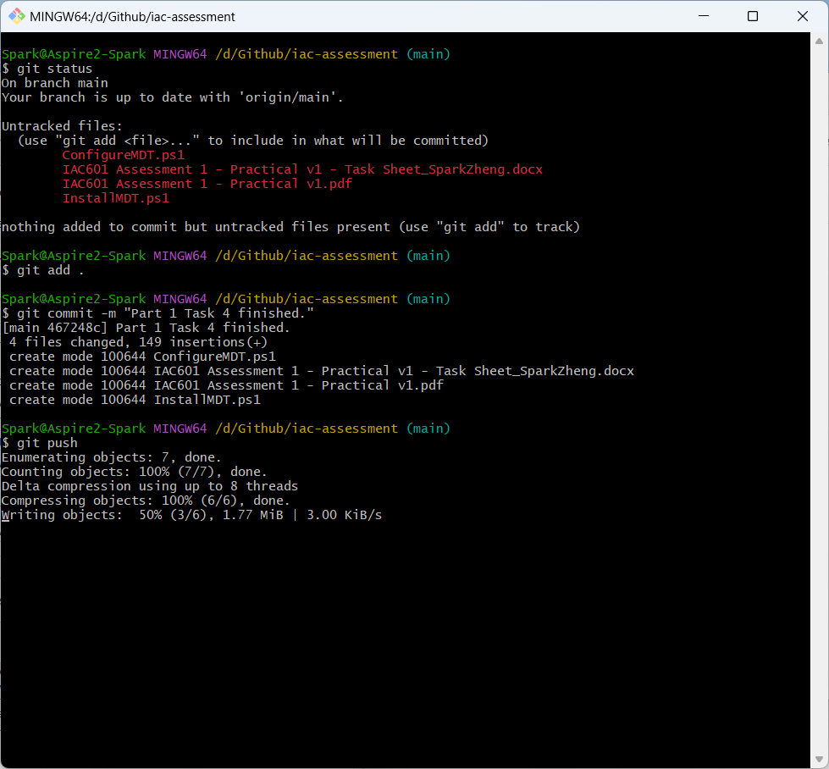

**4. Check results on the website of GitHub:**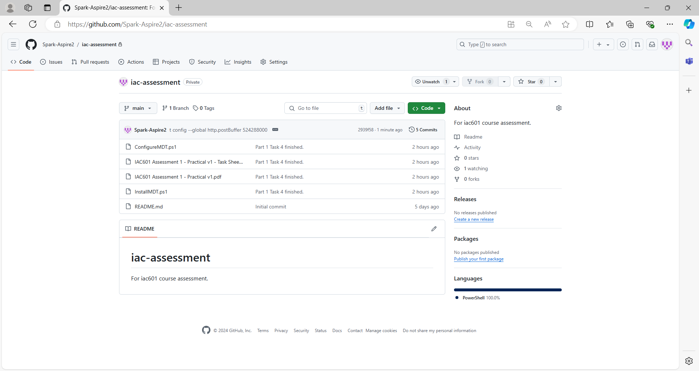

# Part 2

## Task 1: Planning and Design of Cloud Infrastructure

**1. Resource needed by Media Labs to make a pilot test:**

* Azure Virtual Machine (VM):

A Windows Server 2022 VM configured with a public IP for RDP access and associated with a network interface, network security group, and virtual network.

* Azure MySQL Database:

Deployed within the same resource group, using a DNS zone and subnet within the virtual network. Backup retention is configured for 7 days.

**Resource list includes:**

* 1 resource group
* 1 virtual network
* 2 subnets, one for hosting Windows Server 2022, the other for hosting MySQL Server
* 1 public IP address
* 1 network interface card
* 1 dns zone
* 1 network security group to limit RDP access
* 1 virtual machine, for Windows Server 2022
* 1 mysql flexible server

**2. Cloud infrastructure diagram:**

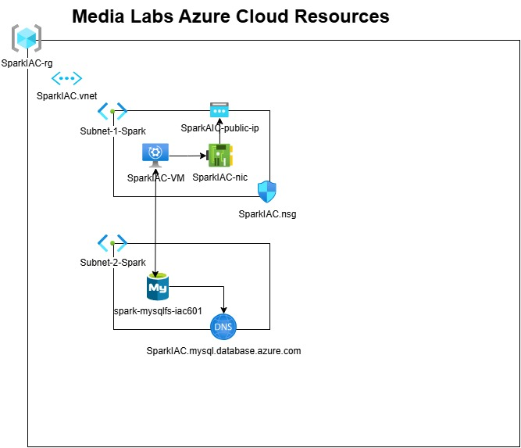

## Task 2: Analysis and Evaluation of Legal and Regulatory Requirements

There are several primary legal and regulatory requirements in New Zealand, including Privacy Act 2020(Privacy Act 2020. 2024), Copyright Act 1994(Copyright Act 1994. 2023), Fair Trading Act 1986(Fair Trading Act 1986. 2024), Health Information Privacy Code 2020(Health Information Privacy Code 2020. 2022), and New Zealand Information Security Manual (New Zealand Information Security Manual. 2024), etc.

To use terraform scripts to deploy Azure Windows Server 2022 and MySQL flexible server automatically involves those legal and regulatory requirements listed above. These requirements ensure that the deployment process is compliance with software licenses, data protection, and security regulations.

1. **Software license compliance.** 
   * + - During the implementation, to ensure all software installed, including Windows Server 2022, MySQL Server, and MySQL workbench, is properly licensed for use by Media Labs under Copyright Act 1994 and Fair Trading Act 1986.
       - For Media Labs, licenses are confirmed before deployment. A record of all software licenses, proof of purchase and download links is maintained and the usage and installation of software on Azure Cloud virtual machines is documented to demonstrate compliance.
2. **Data protection and privacy.** 
   * + - Under Privacy Act 2020 and Health Information Privacy Code 2020, it includes ensuring that no personal data is unlawfully processed during the deployment, and appropriate measures are in place to secure any personal data that may be involved.
       - During deployment, all personal data is minimized, protected, and only used for the necessary purposes, and data is encrypted and is not leaked or improperly accessed. Terraform scripts are configured to anonymize to avoid storing any user-specific data in deployment logs or capturing user data during the deployment process.
3. **Security and compliance standards.** 
   * + - Under New Zealand Information Security Manual, deployment processes should include measures that align with these standards, like secure transmission of data and maintaining system integrity, protecting against cybersecurity with security patches and updates to prevent vulnerabilities, managing firewall rules, ensuring security policies are enforced, and managing system settings to prevent unauthorized changes.
       - During deployment, terraform scripts are configured to use security group/rules to limit the source IP addresses and ports which can access the virtual machine on Azure Cloud. Only RDP protocol and the IP address of my laptop are granted to access the virtual machine of Windows Server 2022 and then to access MySQL Server through it.

## Task 3: Scripts Design and Development

**1. Set Provider**

########### Provider #####################

provider "azurerm" {

  skip_provider_registration = true # This is only required when the User, Service Principal, or Identity running Terraform lacks the permissions to register Azure Resource Providers.

  features {}

}

**2. Create resource group**

########### Resource Group ###############

resource "azurerm_resource_group" "rg_block" {

  name     = var.rg_name

  location = var.location

}

**3. Create Vnet**

########### Virtual Network ###############

resource "azurerm_virtual_network" "vnet_1_block" {

  name                = var.vnet_1_name

  location            = azurerm_resource_group.rg_block.location

  resource_group_name = azurerm_resource_group.rg_block.name

  address_space       = var.vnet_1_cidr

  tags = {

    environment = "test"

  }

}

1. **Create 2 subnets**

########### Virtual Network 1 - Subnet 1 ###########

resource "azurerm_subnet" "subnet_1_block" {

  name                 = "${var.vnet_1_name}-${var.subnet_1_name}"

  resource_group_name  = azurerm_resource_group.rg_block.name

  virtual_network_name = azurerm_virtual_network.vnet_1_block.name

  address_prefixes     = var.subnet_1_cidr

}

resource "azurerm_subnet" "subnet_2_block" {

  name                 = "${var.vnet_1_name}-${var.subnet_2_name}"

  resource_group_name  = azurerm_resource_group.rg_block.name

  virtual_network_name = azurerm_virtual_network.vnet_1_block.name

  address_prefixes     = var.subnet_2_cidr

  service_endpoints    = ["Microsoft.Storage"]

  delegation {

    name = "mysql_fs"

    service_delegation {

      name = "Microsoft.DBforMySQL/flexibleServers"

      actions = [

        "Microsoft.Network/virtualNetworks/subnets/join/action",

      ]

    }

  }

}

**5. Create public IP address**

### Public  IP Address ###############

resource "azurerm_public_ip" "public_ip_1" {

  name                = var.public_ip_1_name

  resource_group_name = azurerm_resource_group.rg_block.name

  location            = azurerm_resource_group.rg_block.location

  allocation_method   = "Dynamic"

}

**6. Create network adapter**

########### Network Interface ###############

resource "azurerm_network_interface" "main_nic_1" {

  name                = var.network_interface_1_name

  location            = azurerm_resource_group.rg_block.location

  resource_group_name = azurerm_resource_group.rg_block.name

  ip_configuration {

    name                          = "nic-ip-configuration"

    subnet_id                     = azurerm_subnet.subnet_1_block.id

    private_ip_address_allocation = "Dynamic"

    public_ip_address_id          = azurerm_public_ip.public_ip_1.id

  }

}

**7. Create security rules**

########### Network Security Group ###############

resource "azurerm_network_security_group" "nsg_1_block" {

  name                = var.security_group_name

  location            = azurerm_resource_group.rg_block.location

  resource_group_name = azurerm_resource_group.rg_block.name

  # Only IP addesses of "118.92.0.0/16" are permit to access the VM.

  security_rule {

    name                       = "RDP"

    priority                   = 1000

    direction                  = "Inbound"

    access                     = "Allow"

    protocol                   = "Tcp"

    source_port_range          = "*"

    destination_port_range     = "3389"

    source_address_prefix      = "118.92.0.0/16"

    destination_address_prefix = "*"

  }

  tags = {

    environment = "test"

  }

}

resource "azurerm_network_interface_security_group_association" "nic_nsg_association" {

  network_interface_id      = azurerm_network_interface.main_nic_1.id

  network_security_group_id = azurerm_network_security_group.nsg_1_block.id

}

**8. Create DNS for MySQL database**

### Private DNS Zone ###############

resource "azurerm_private_dns_zone" "mysql_dns" {

  name                = var.mysql_dns_name

  resource_group_name = azurerm_resource_group.rg_block.name

}

### Private DNS Zone Linked with VNET ###############

resource "azurerm_private_dns_zone_virtual_network_link" "dns_network_link" {

  name                  = var.dns_network_link_name

  private_dns_zone_name = azurerm_private_dns_zone.mysql_dns.name

  virtual_network_id    = azurerm_virtual_network.vnet_1_block.id

  resource_group_name   = azurerm_resource_group.rg_block.name

}

**9. Create MySQL flexible server**

### Azure MySQL Database ###############

resource "azurerm_mysql_flexible_server" "media_labs_mysql" {

  name                   = var.mysql_server_name

  location               = azurerm_resource_group.rg_block.location

  resource_group_name    = azurerm_resource_group.rg_block.name

  administrator_login    = var.mysql_root

  administrator_password = var.mysql_password

  backup_retention_days  = 7

  delegated_subnet_id    = azurerm_subnet.subnet_2_block.id

  private_dns_zone_id    = azurerm_private_dns_zone.mysql_dns.id

  sku_name   = "GP_Standard_D2ds_v4"

  depends_on = [azurerm_private_dns_zone_virtual_network_link.dns_network_link]

}

**10. Create a virtual machine of Windows Server 2022**

########### Virtual Machine Windows Server 2019 ###############

resource "azurerm_windows_virtual_machine" "vm_1_block" {

  name                  = var.virtual_machine_1_name

  location              = azurerm_resource_group.rg_block.location

  resource_group_name   = azurerm_resource_group.rg_block.name

  network_interface_ids = [azurerm_network_interface.main_nic_1.id]

  size                  = "Standard_B1s"

  admin_username = var.admin_username

  admin_password = var.admin_password

  computer_name  = var.virtual_machine_1_name

  timezone       = var.time_zone

  os_disk {

    caching              = "ReadWrite"

    storage_account_type = "Standard_LRS"

  }

  source_image_reference {

    publisher = "MicrosoftWindowsServer"

    offer     = "WindowsServer"

    sku       = "2022-datacenter-azure-edition"

    version   = "latest"

  }

}

**11. Declaration of varibables**

### Variables Declaration ###############

variable "rg_name" {

  description = "resource group name"

  default     = "SparkIAC-rg"

}

variable "location" {

  description = "location of resource group"

  default     = "Australia East"

}

variable "vnet_1_name" {

  description = "name of network"

  default     = "SparkIAC.vnet"

}

variable "vnet_1_cidr" {

  description = "Network range"

  default     = ["10.10.0.0/16"]

}

variable "subnet_1_name" {

  description = "name of sub-network"

  default     = "Subnet-1-Spark"

}

variable "subnet_1_cidr" {

  description = "subnet range"

  default     = ["10.10.0.0/24"]

}

variable "subnet_2_name" {

  description = "name of sub-network"

  default     = "Subnet-2-Spark"

}

variable "subnet_2_cidr" {

  description = "subnet range"

  default     = ["10.10.1.0/24"]

}

variable "admin_username" {

  default = "spark"

}

variable "admin_password" {

}

variable "public_ip_1_name" {

  default = "SparkIAC-public-ip"

}

variable "network_interface_1_name" {

  default = "SparkIAC-nic"

}

variable "security_group_name" {

  default = "SparkIAC-nsg"

}

variable "virtual_machine_1_name" {

  default = "SparkIAC-vm"

}

variable "time_zone" {

  default = "New Zealand Standard Time"

}

variable "mysql_root" {

  default = "spark"

}

variable "mysql_password" {

}

variable "mysql_dns_name" {

  default = "SparkIAC.mysql.database.azure.com"

}

variable "dns_network_link_name" {

  default = "dns-network-link"

}

variable "mysql_server_name" {

  default = "Spark-mysqlfs-iac601"

}

**12. Assign values to variables**

### Default values asigned to variables ###############

rg_name                  = "SparkIAC-rg"

location                 = "Australia East"

vnet_1_name              = "SparkIAC.vnet"

subnet_1_name            = "Subnet-1-Spark"

subnet_2_name            = "Subnet-2-Spark"

public_ip_1_name         = "SparkIAC-public-ip"

network_interface_1_name = "SparkIAC-nic"

virtual_machine_1_name   = "SparkIAC-vm"

admin_username           = "spark"

admin_password           = "TestP@ssword01"

time_zone                = "New Zealand Standard Time"

mysql_server_name        = "spark-mysqlfs-iac601"

mysql_root               = "spark"

mysql_password           = "TestP@ssword01"

mysql_dns_name           = "SparkIAC.mysql.database.azure.com"

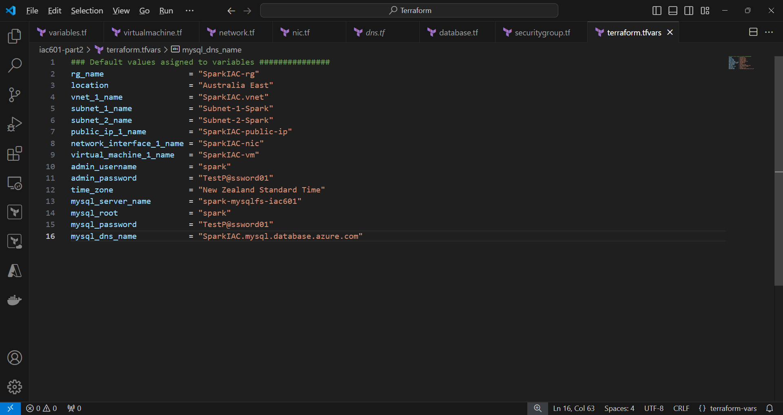

## Task 4: Deployment Services to the Azure Platform and Testing

**1. Terraform init.**

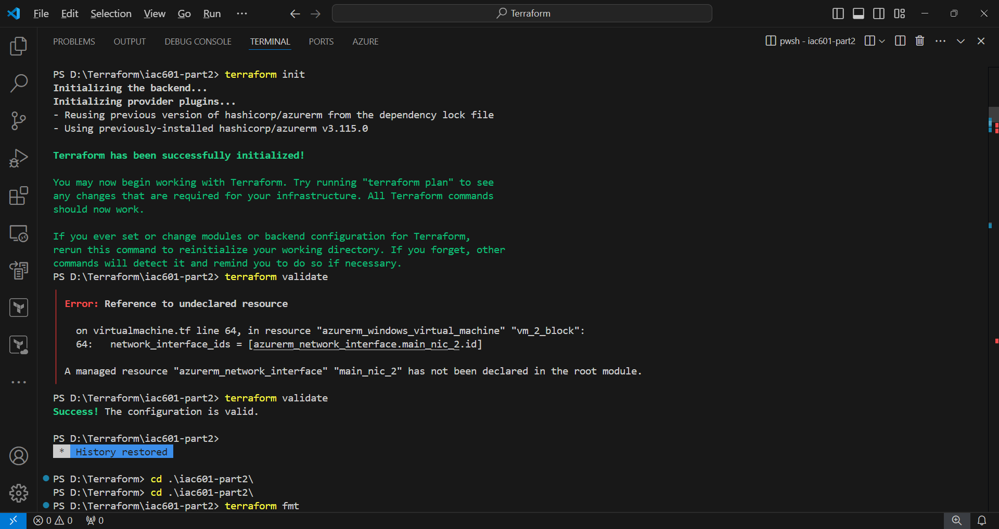

**2. Terraform validation**

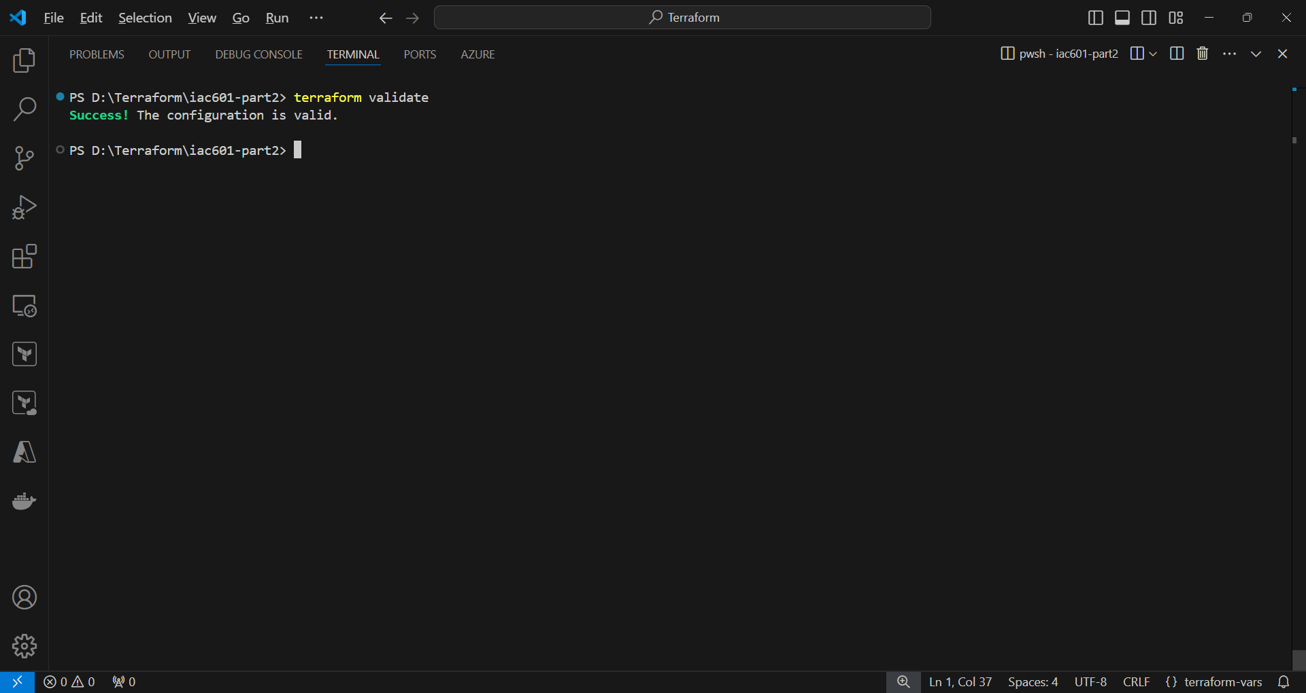

**3. Terraform plan**

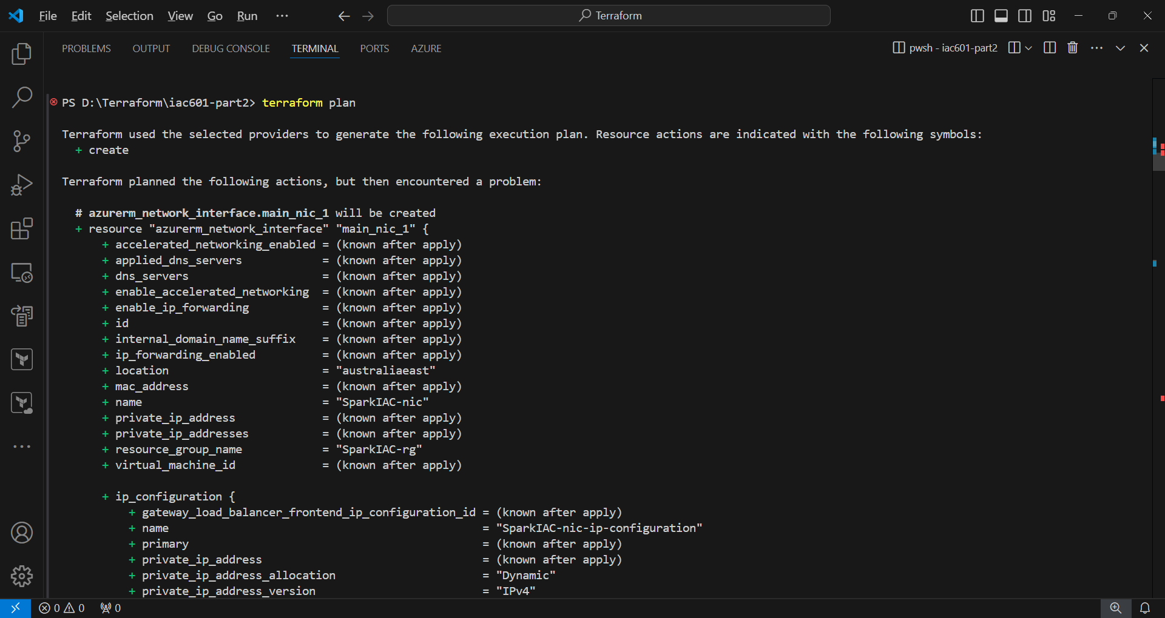

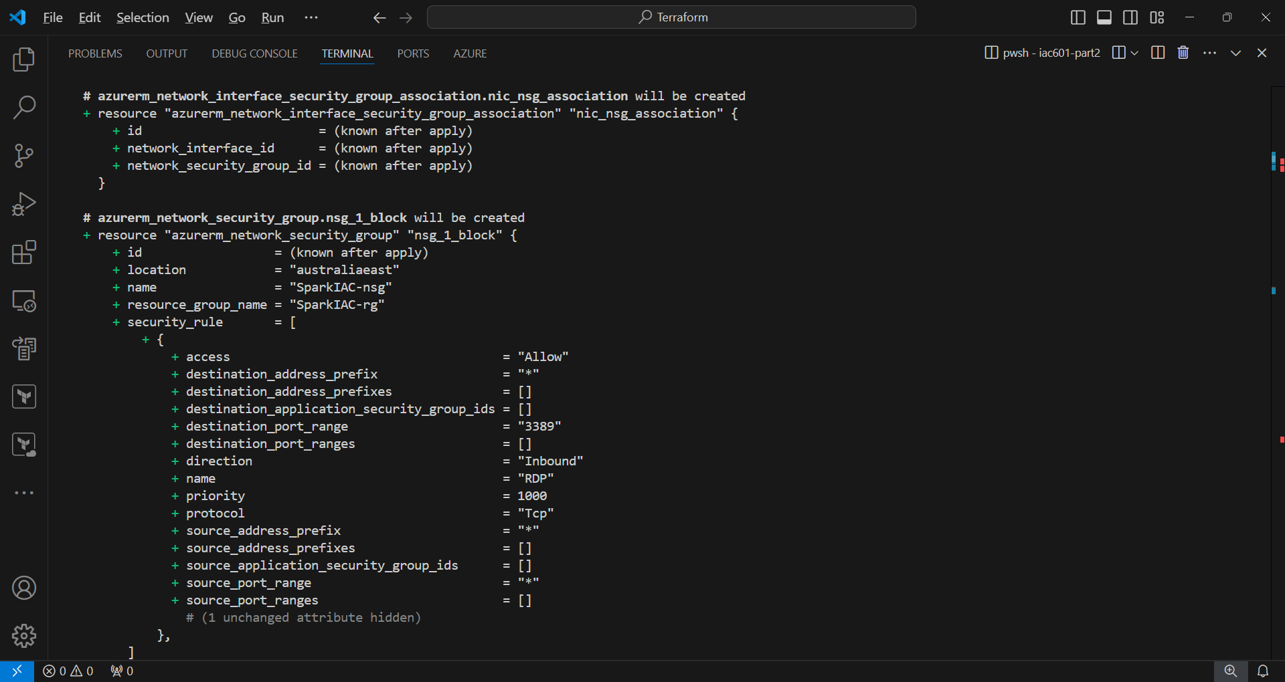

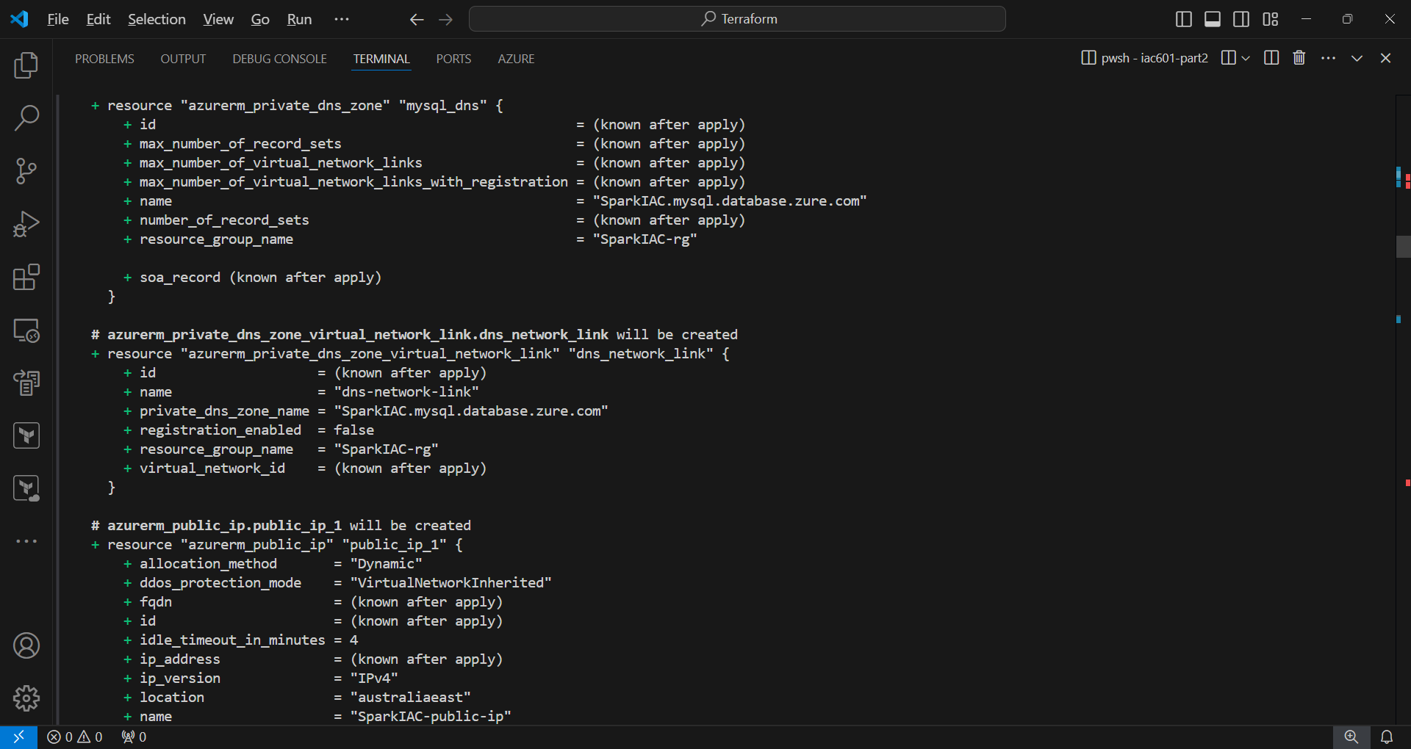

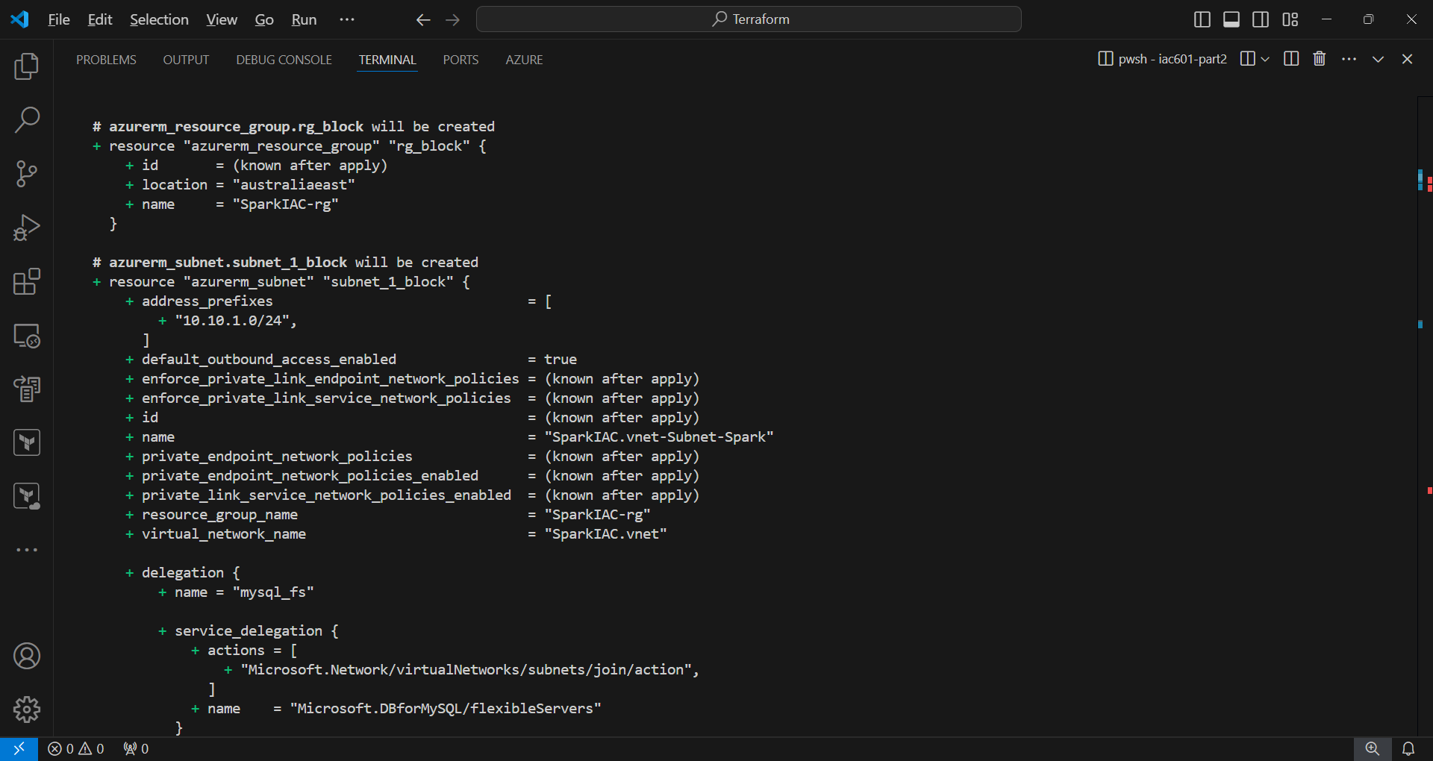

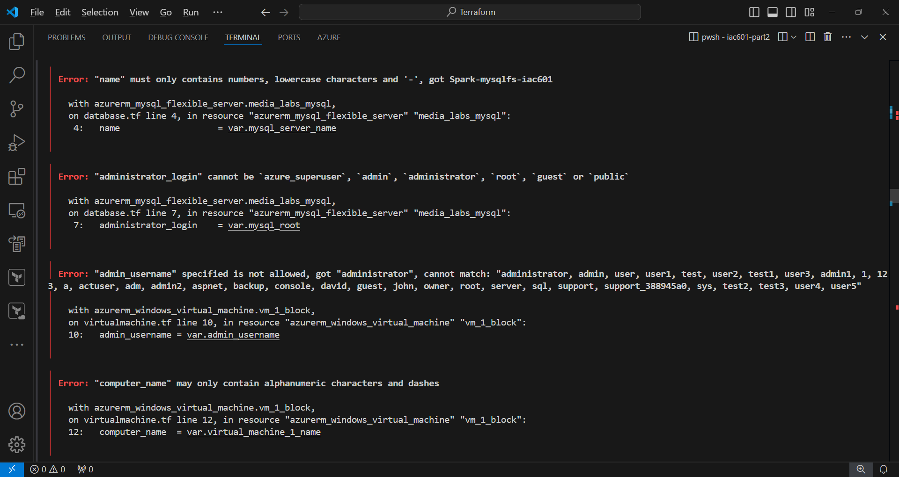

There are several errors during terraform plan.

* Virtual machine name cannot be set to “SparkIAC.vm”, so it is modified to “SparkIAC-vm”.
* For MySQL server name, only lowercase char could be used, so it is assigned with “spark-mysqlfs-iac601”

After modification, the script passed the terraform plan finally.

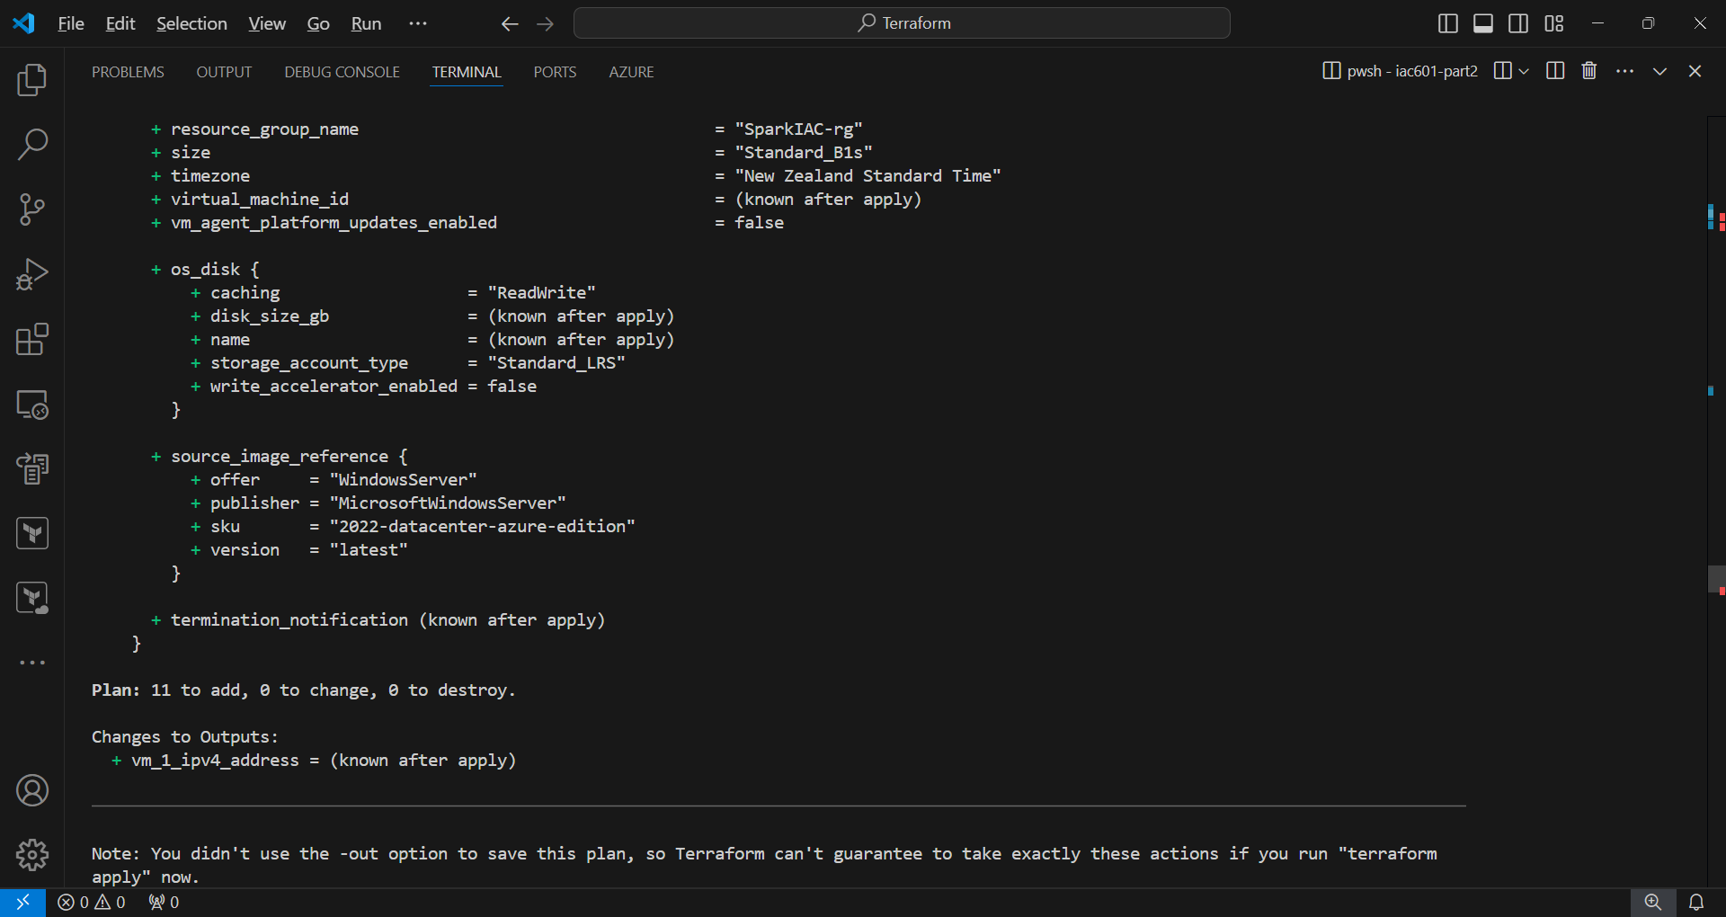

**5. Terraform apply**

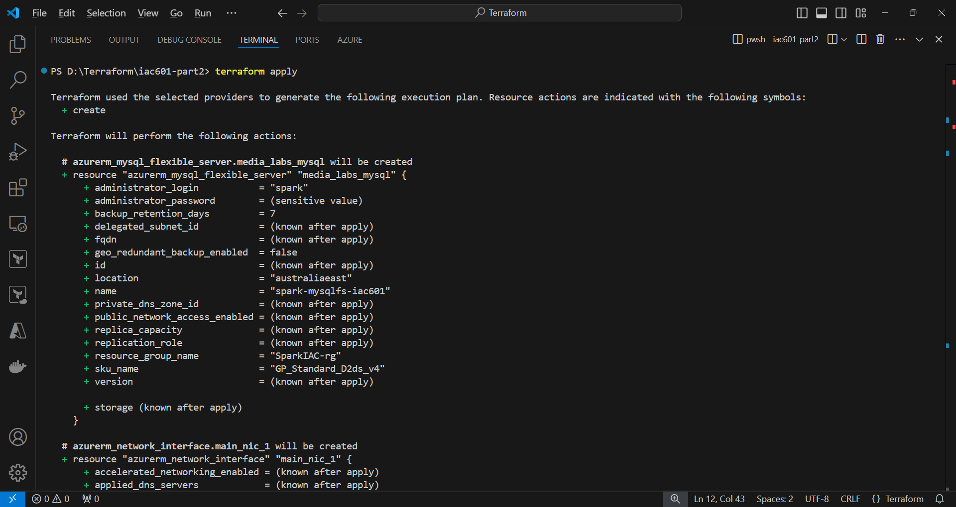

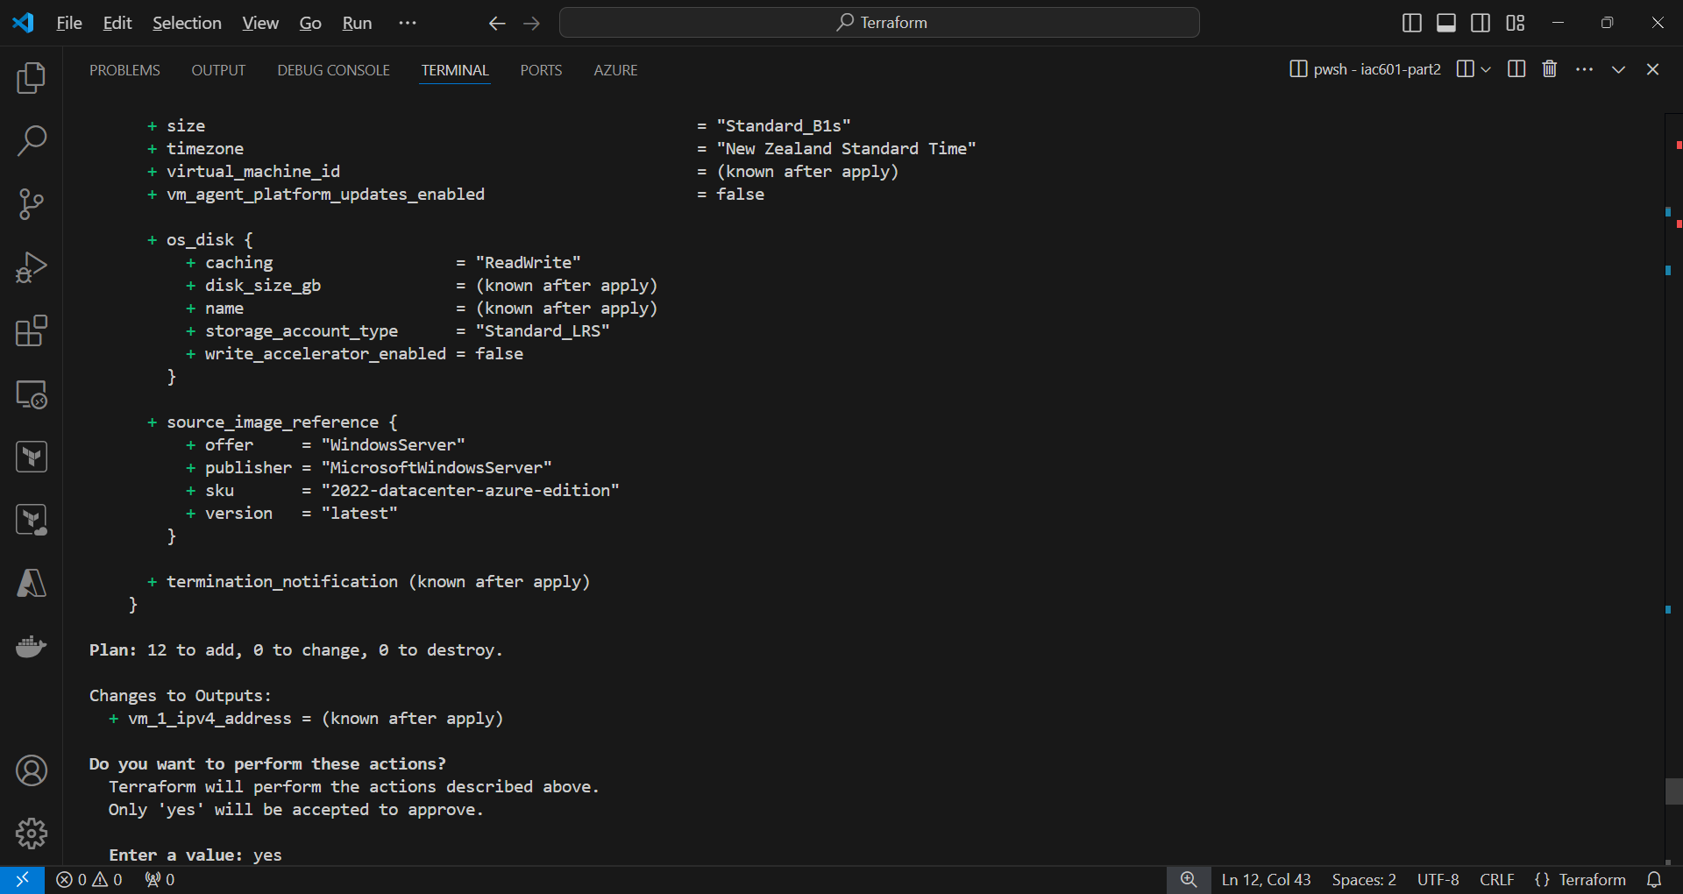

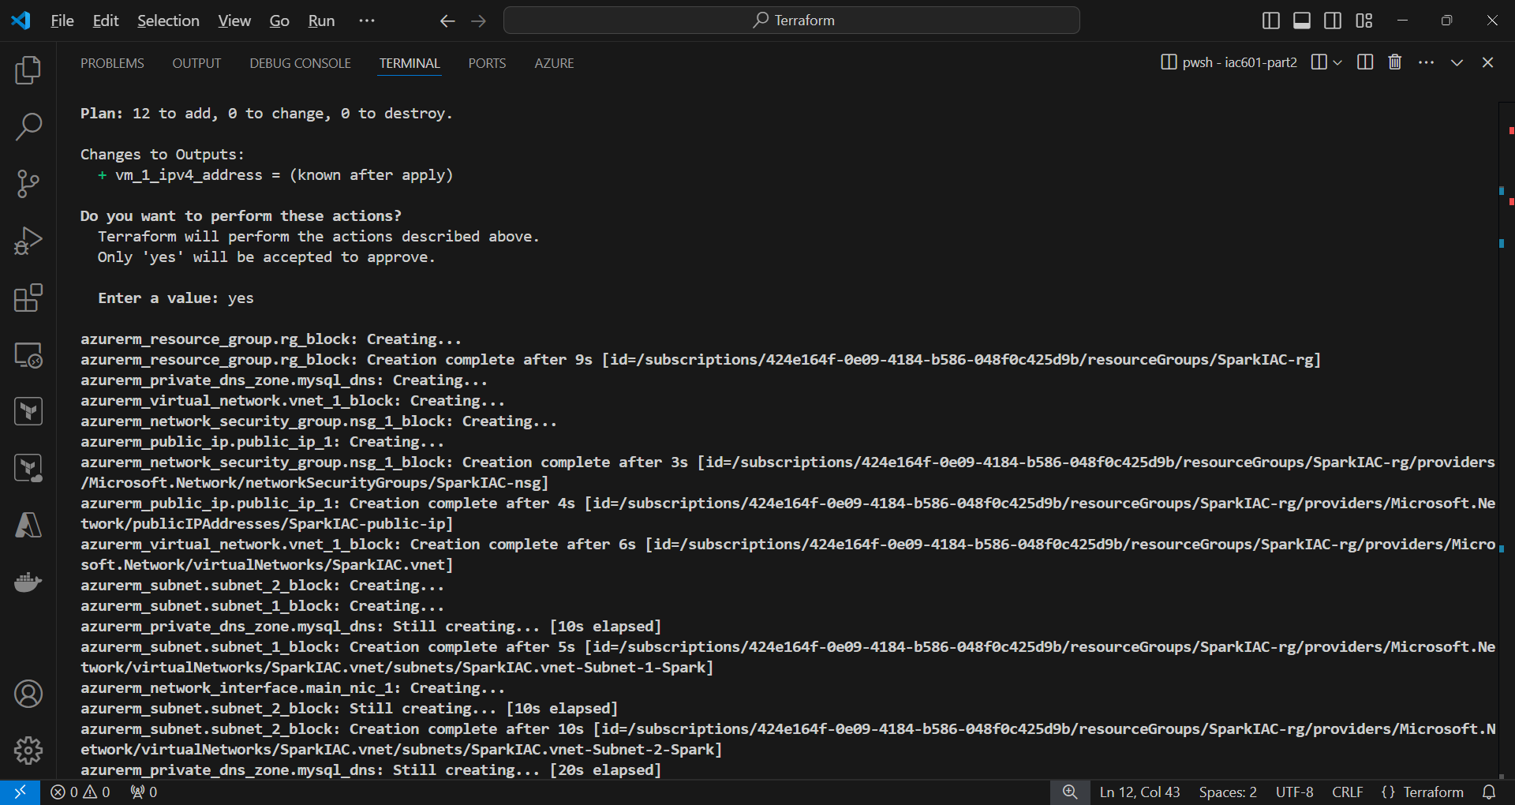

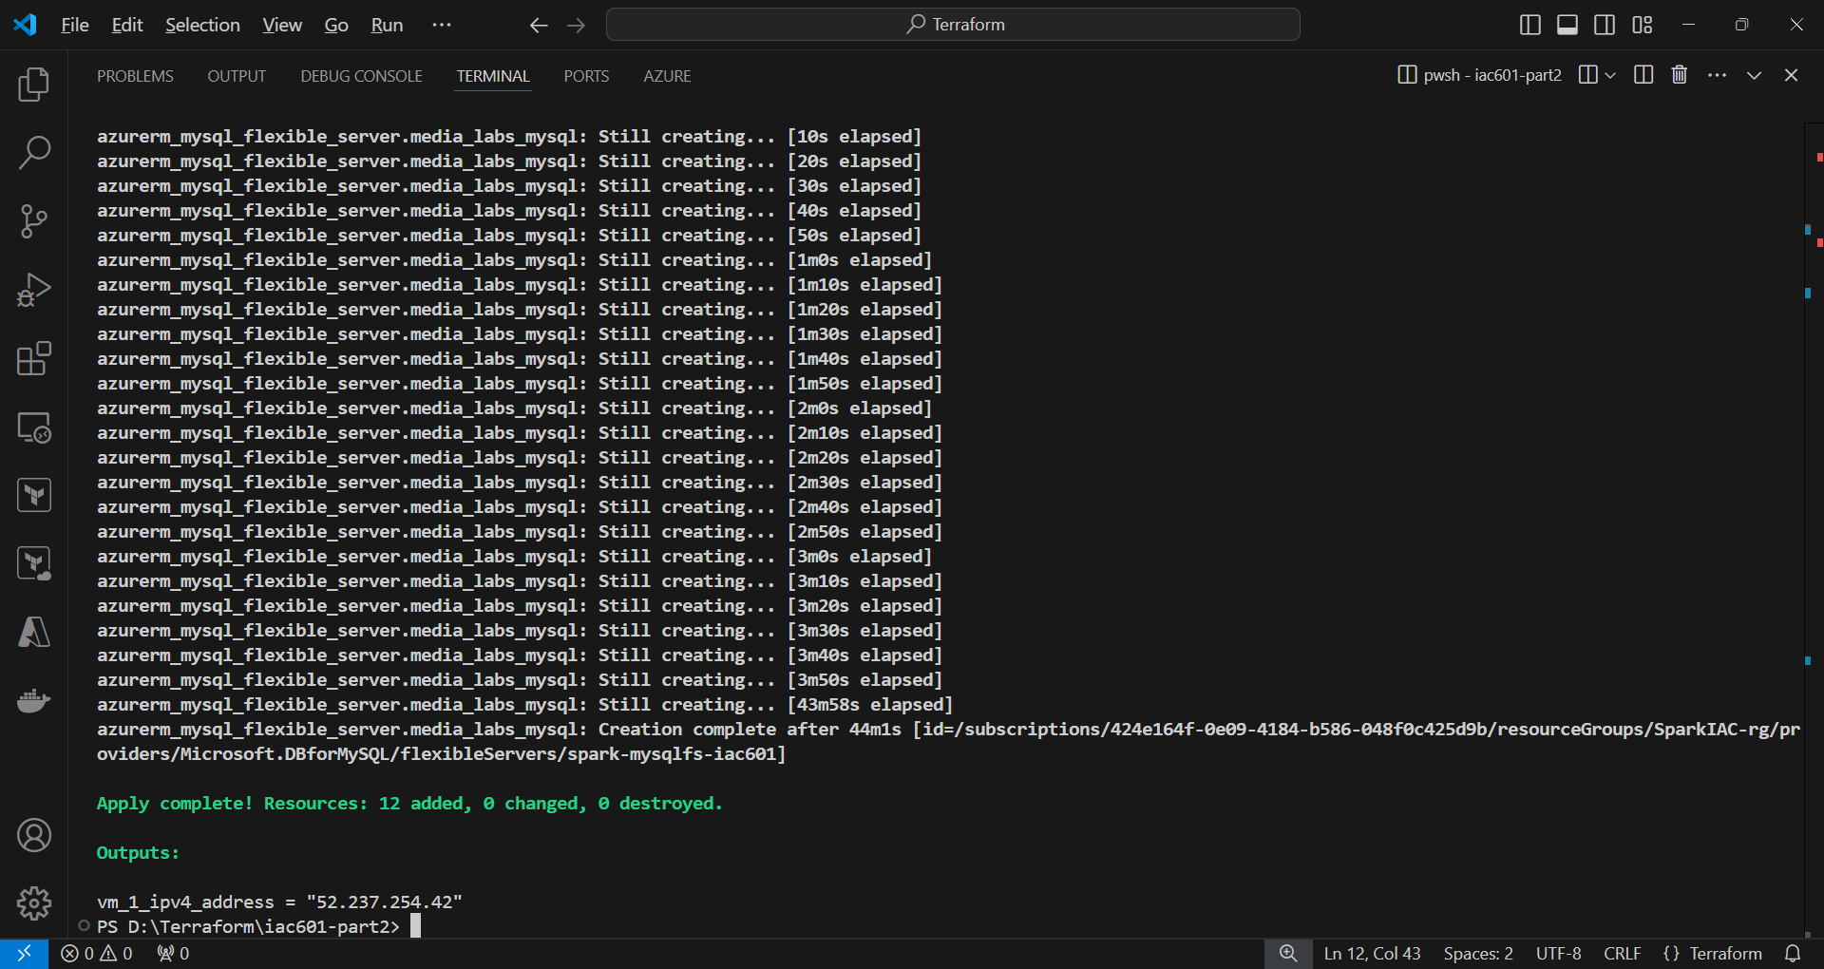

**6. Connect to the virtual machine of Windows Server 2022**

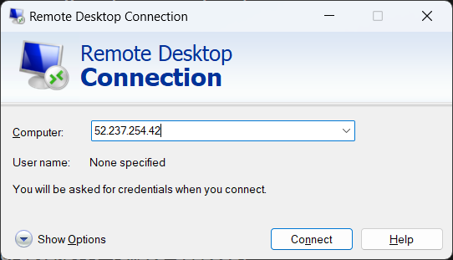

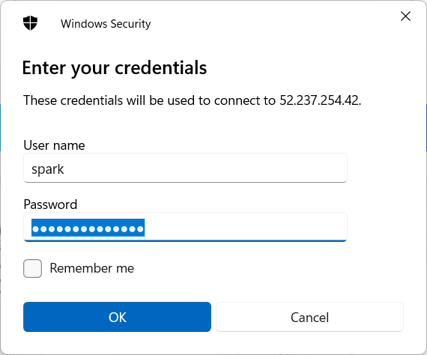

**7. Launch MySQL Workbench**

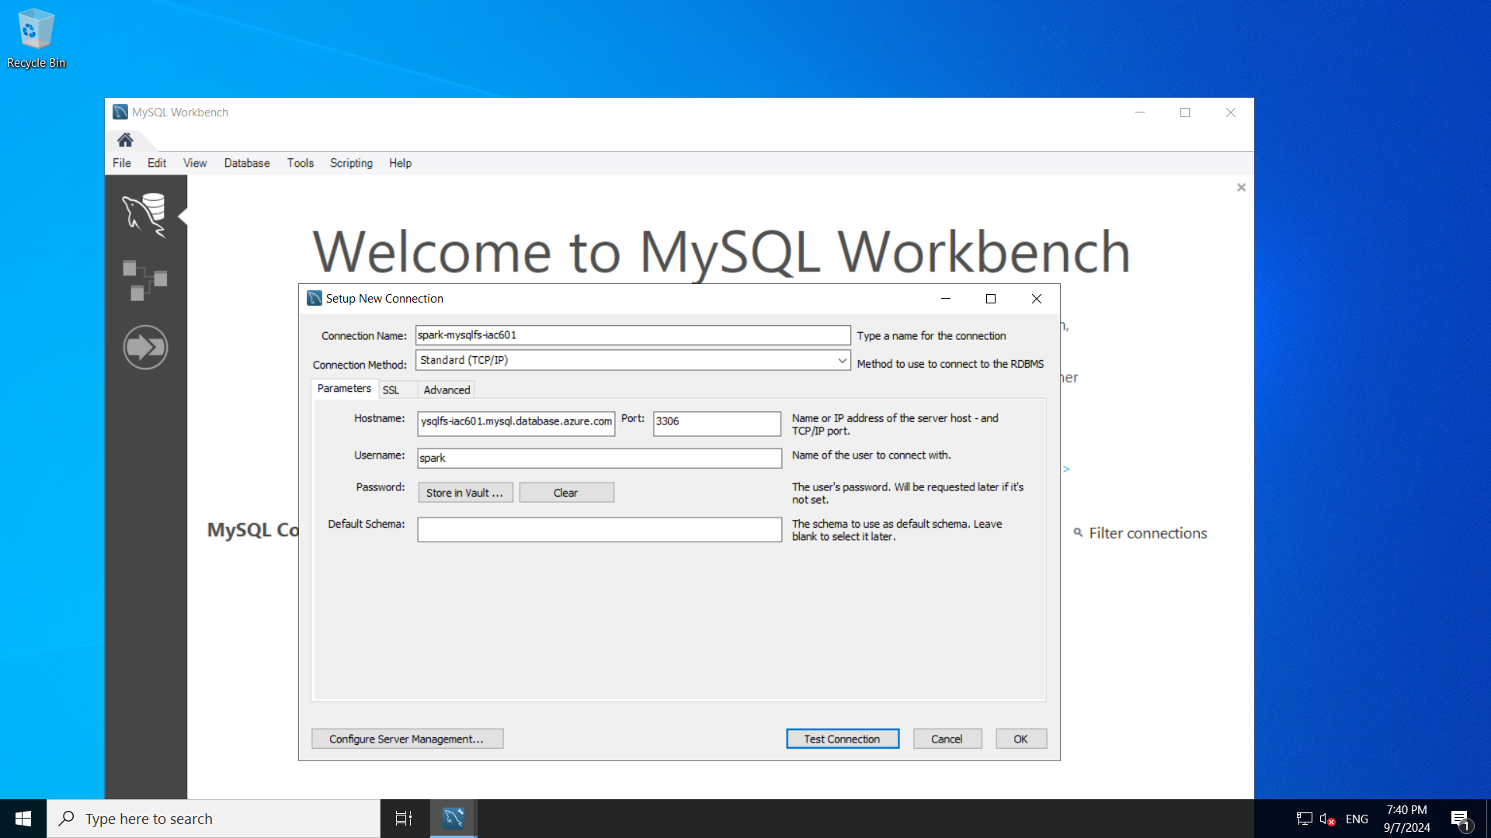

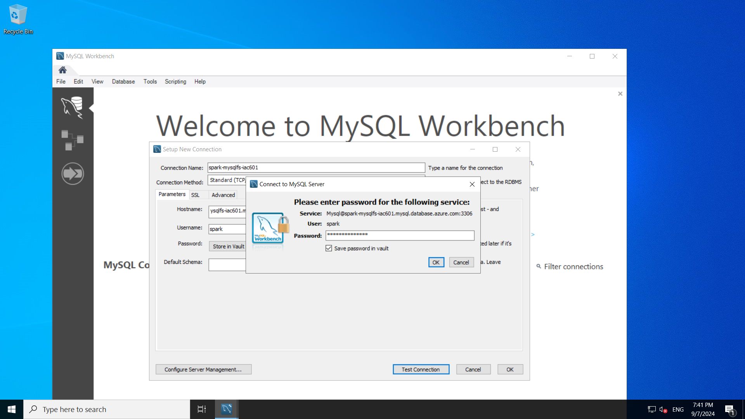

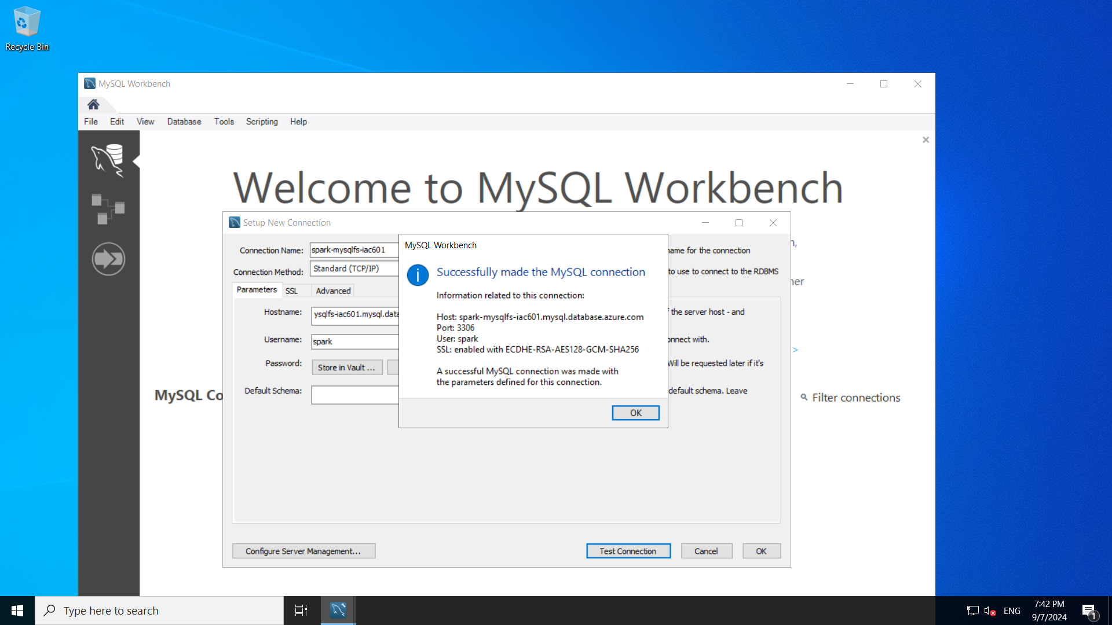

**8. Connect to MySQL Server**

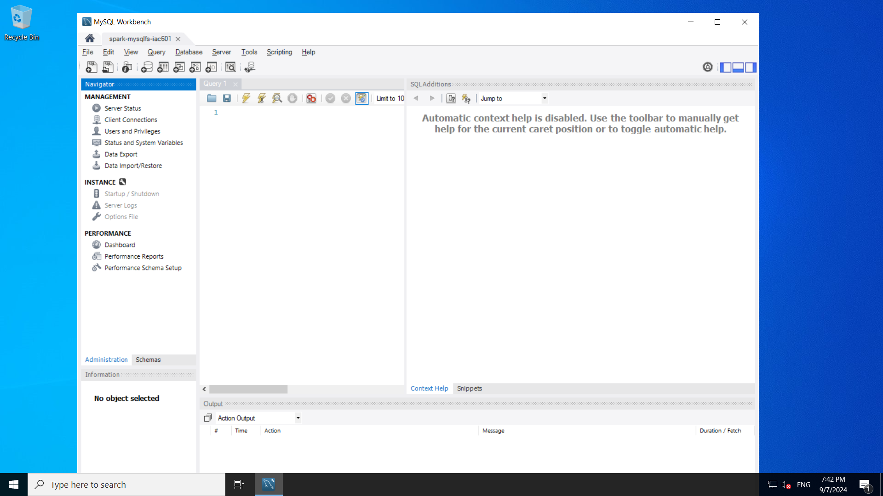

1. **Create a database name MediaLabs.**

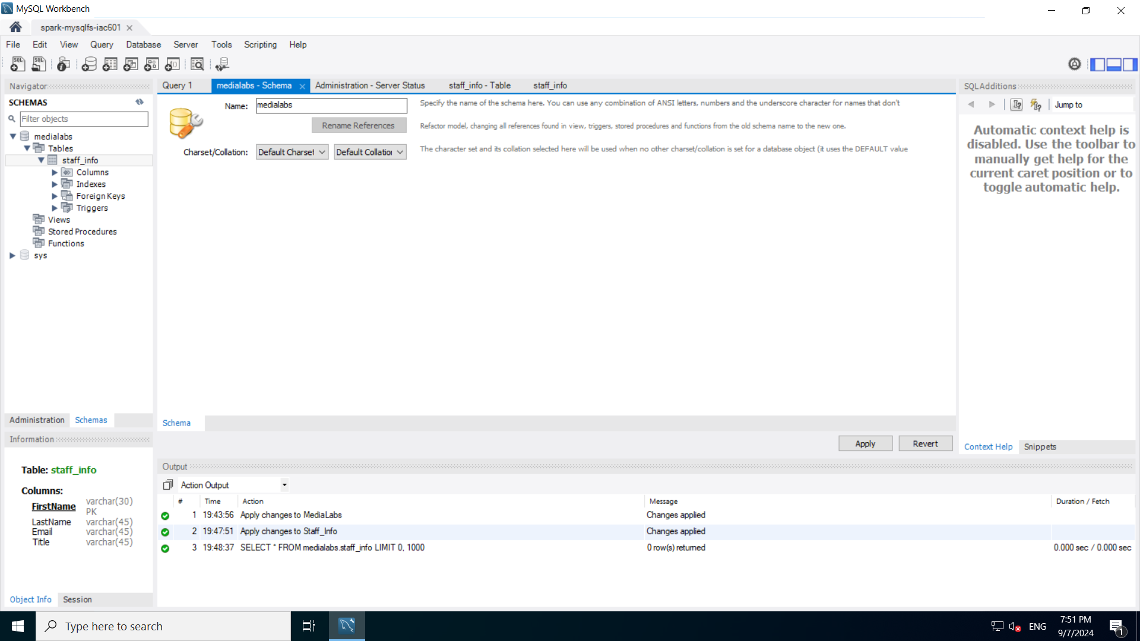

1. **Create a table named Staff_Info**

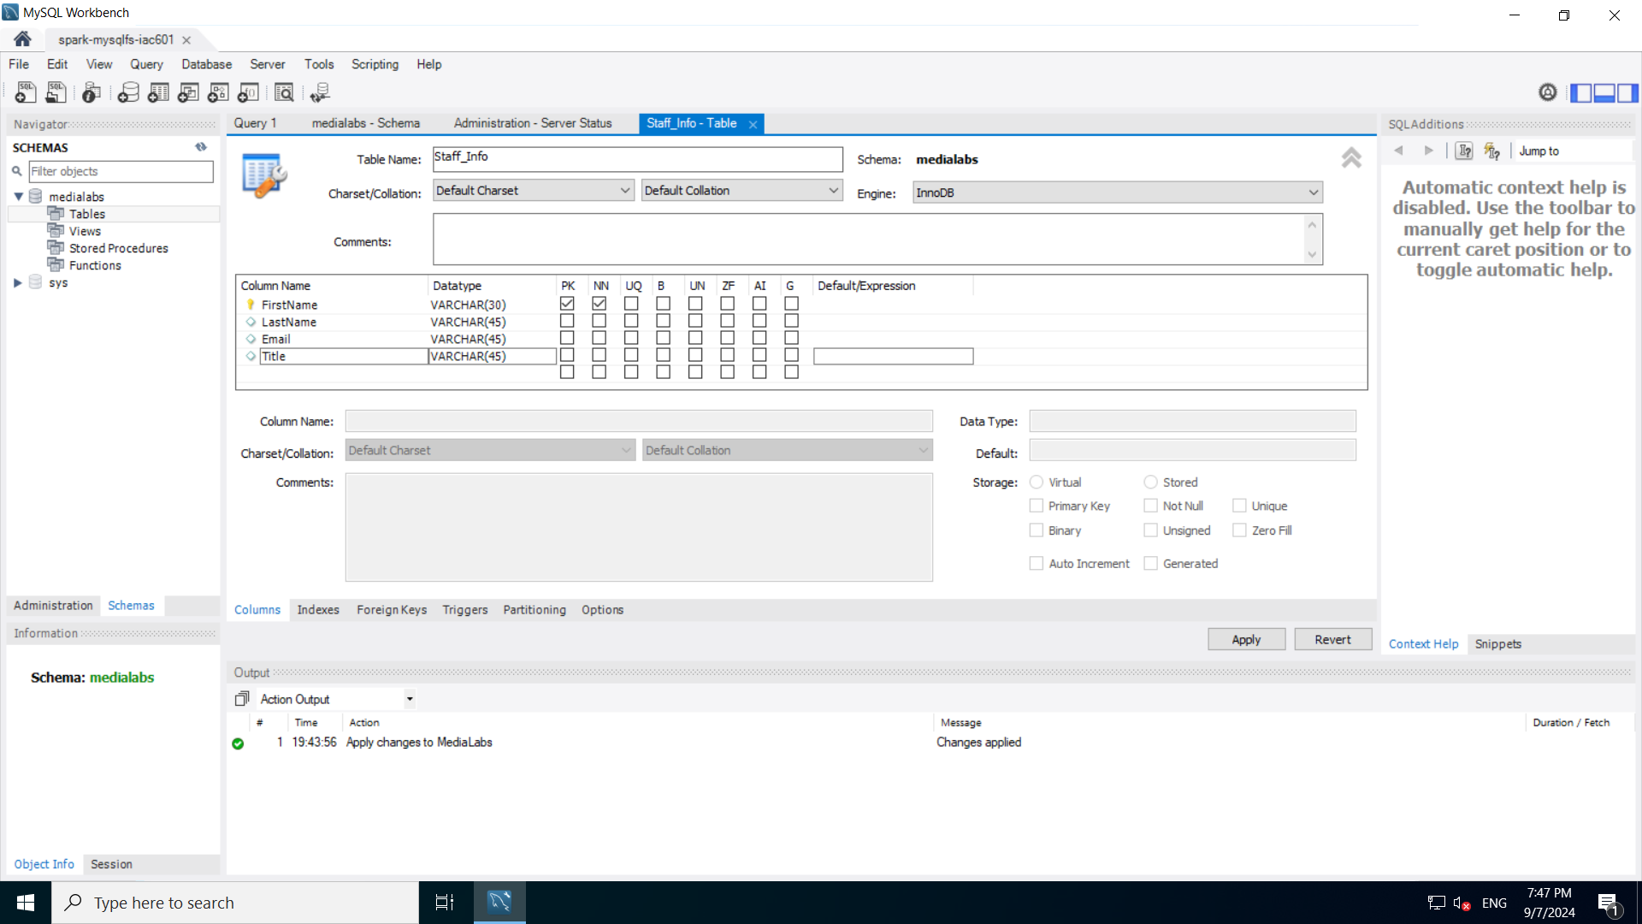



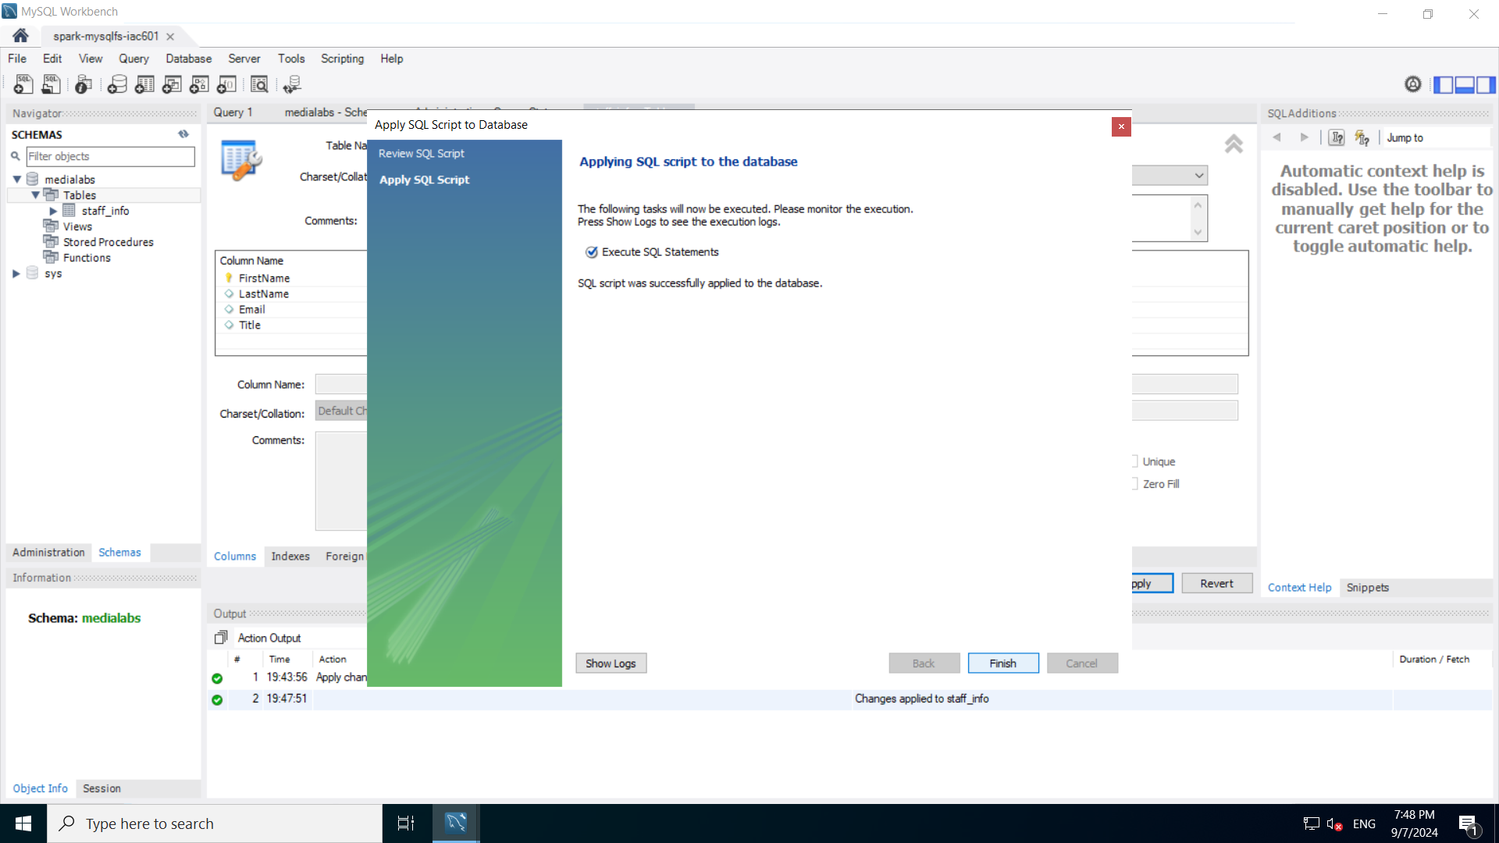

1. **Add records into the table.**

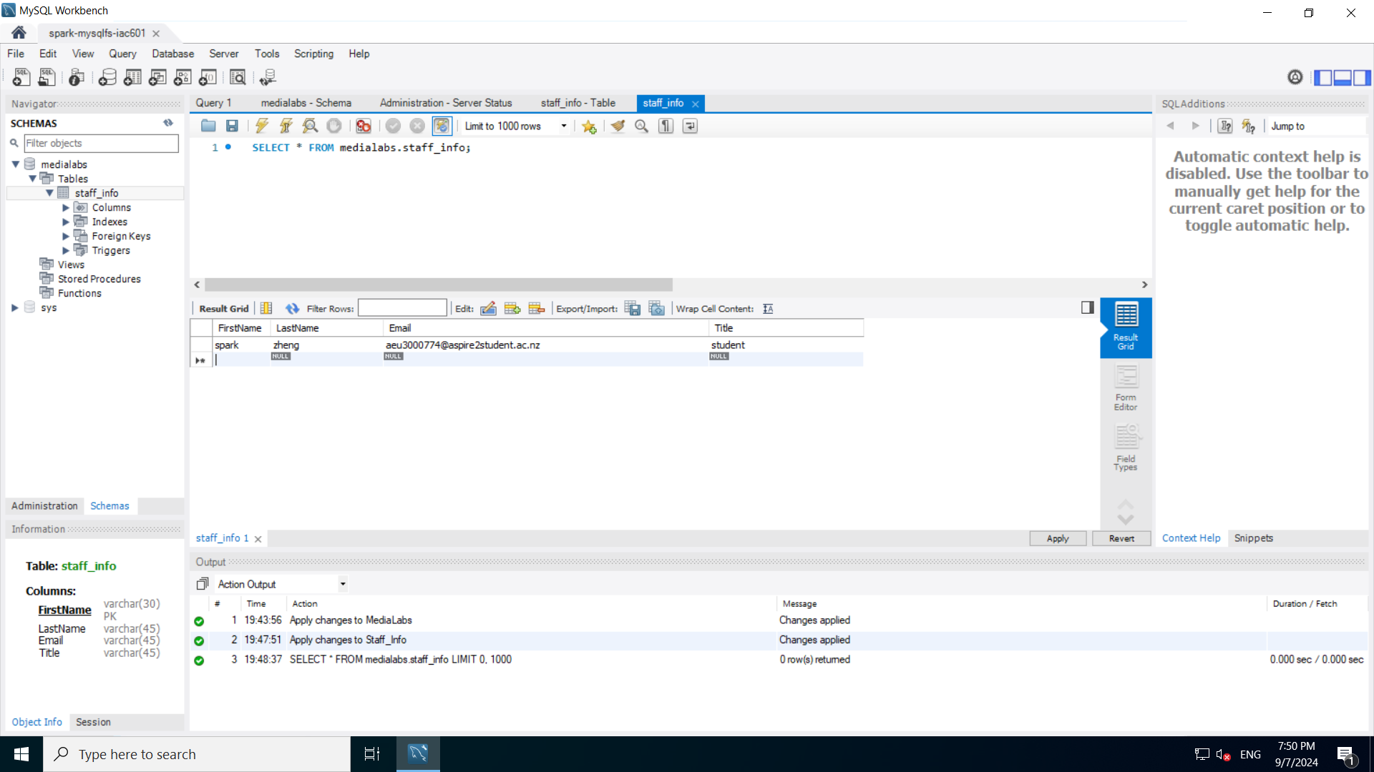

1. **Terraform destroy**

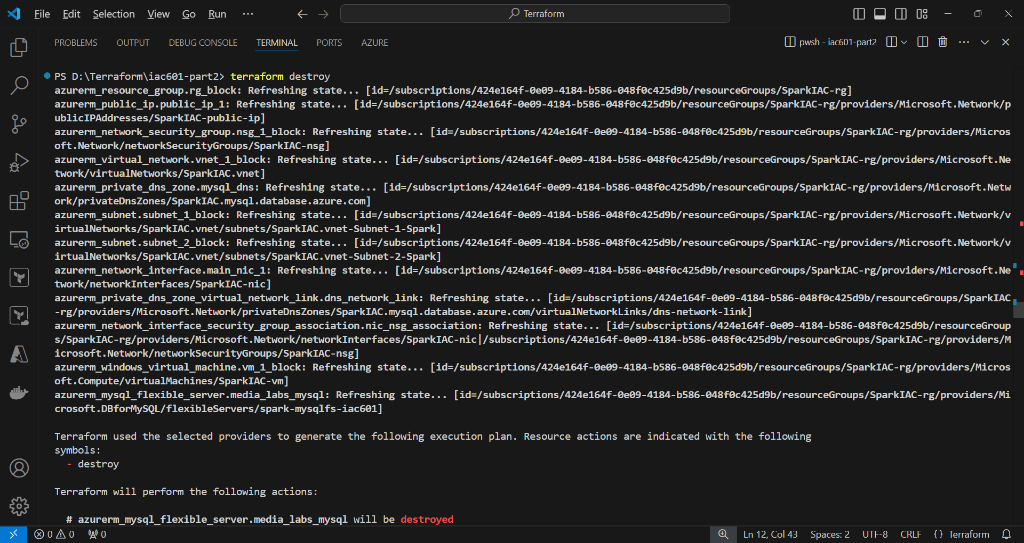

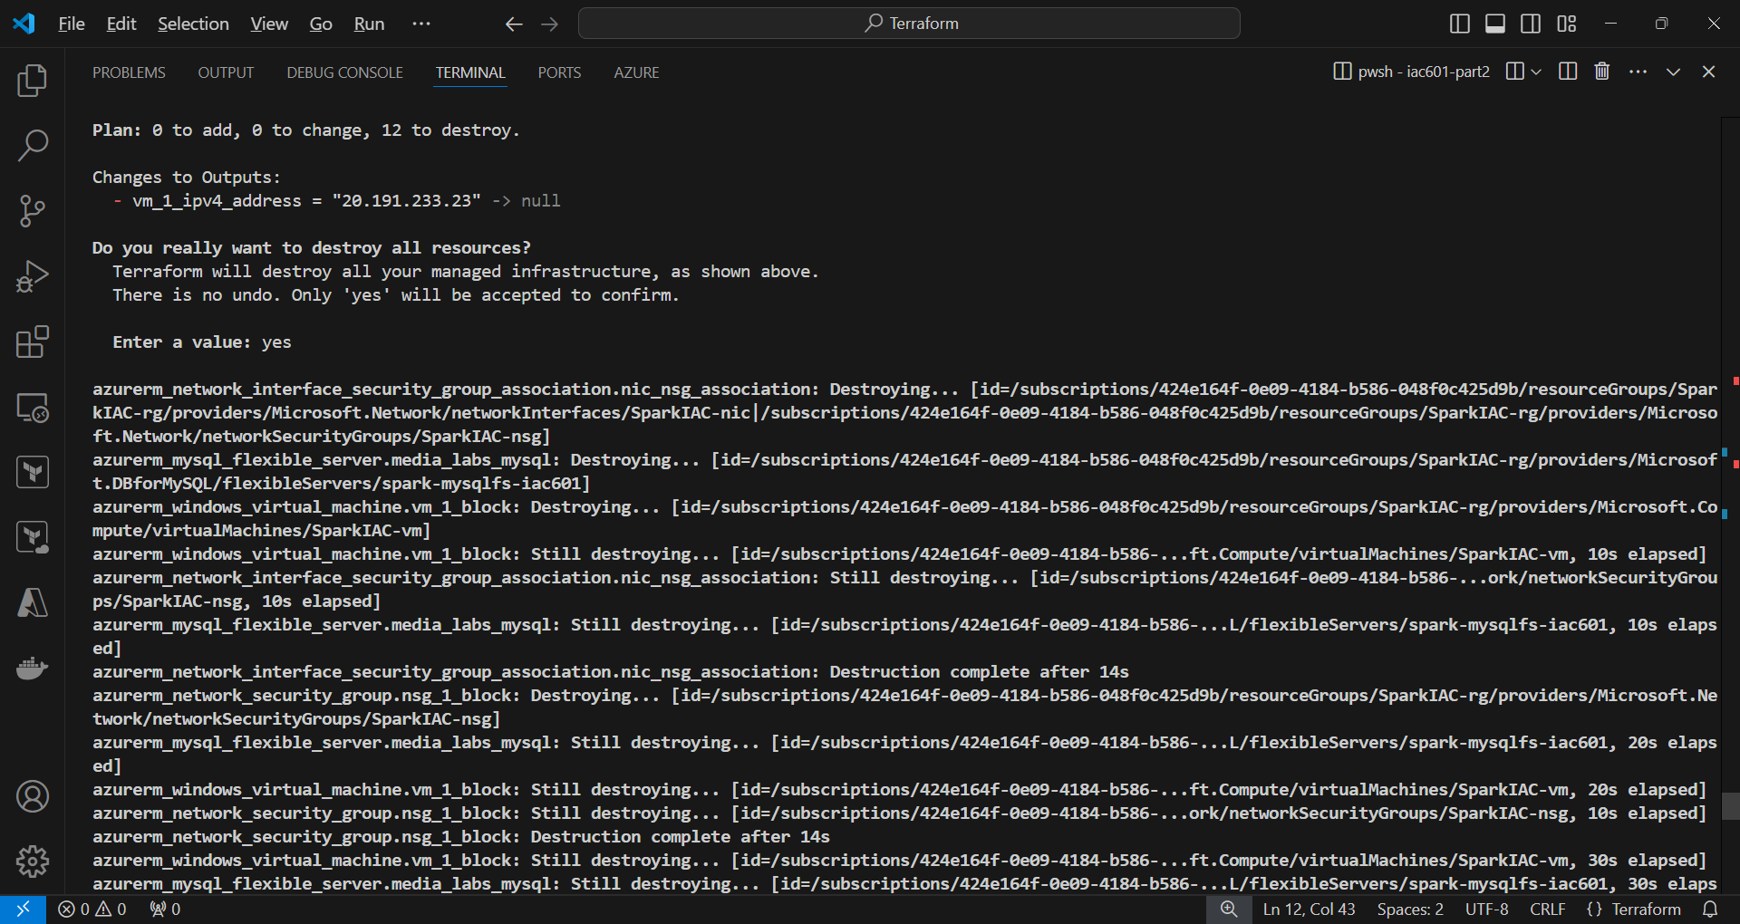

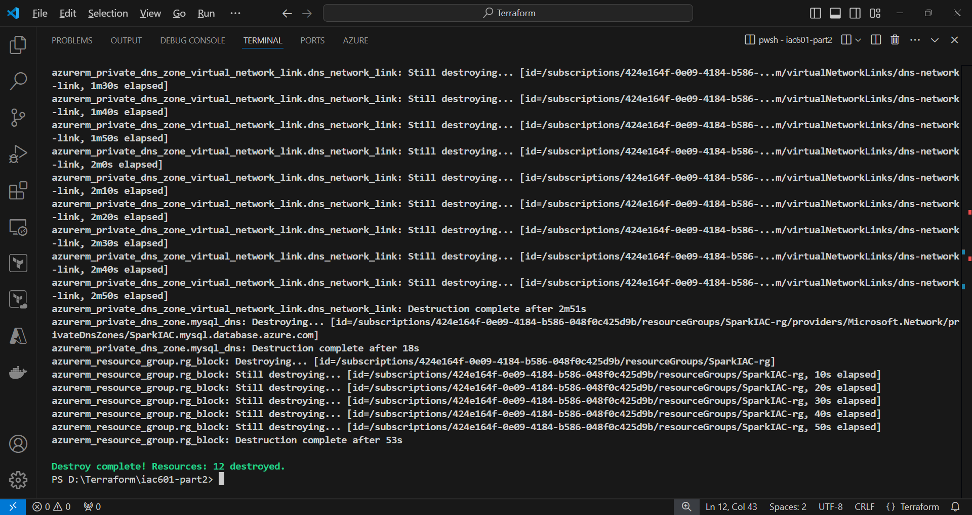

## Task 5: GitHub Repository

**1. add script files to local repository**

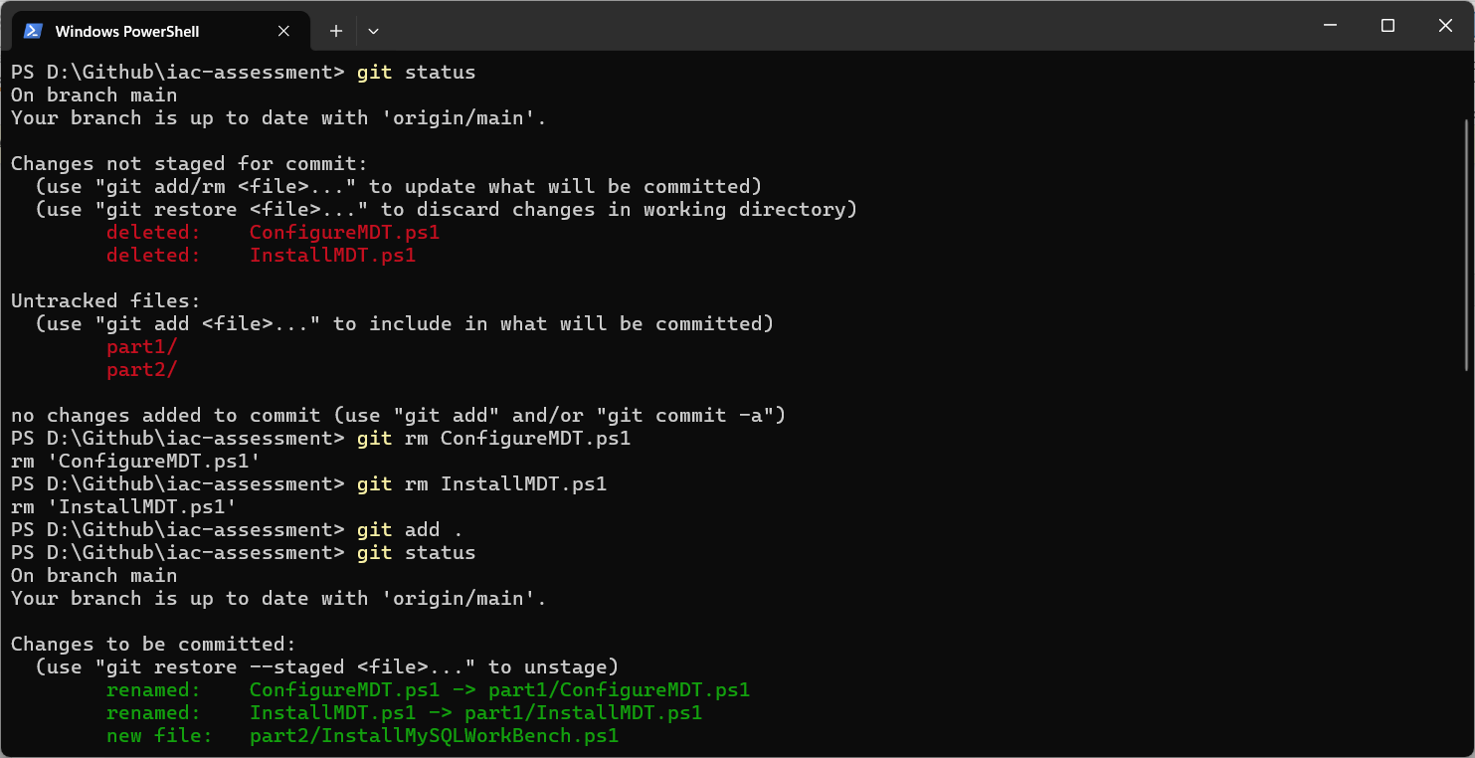

**2. commit files added to local repository**

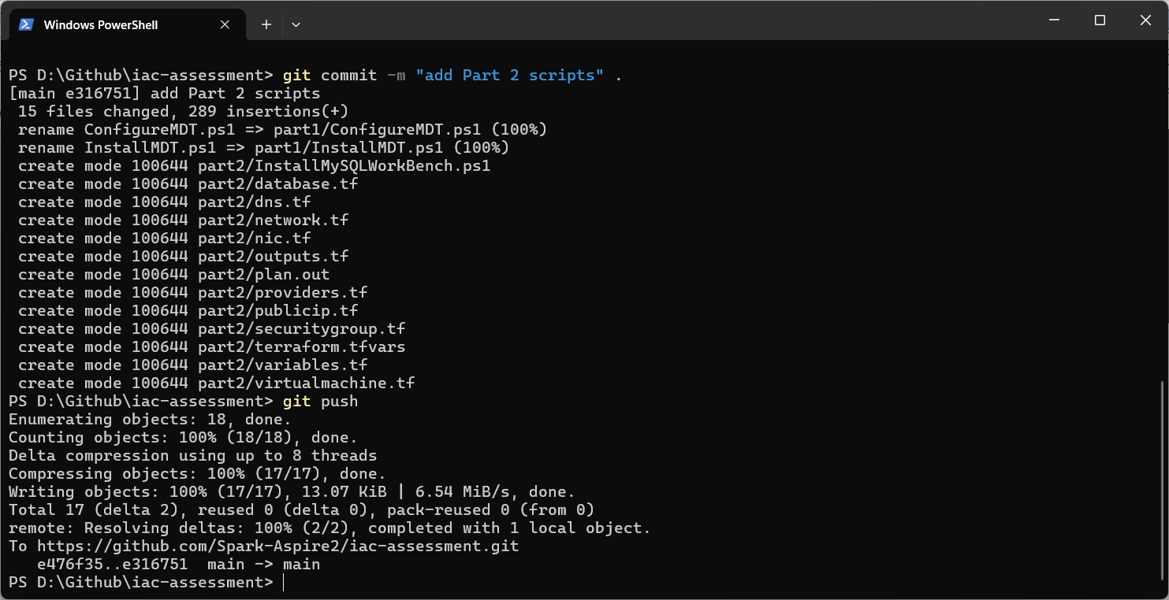

**3. Push local repository to Github**



**4. Check result on Github website**

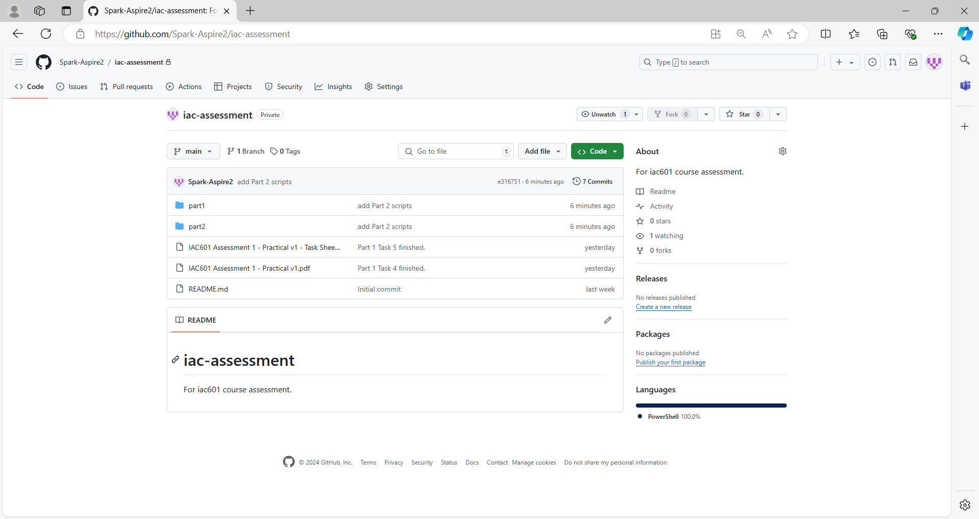

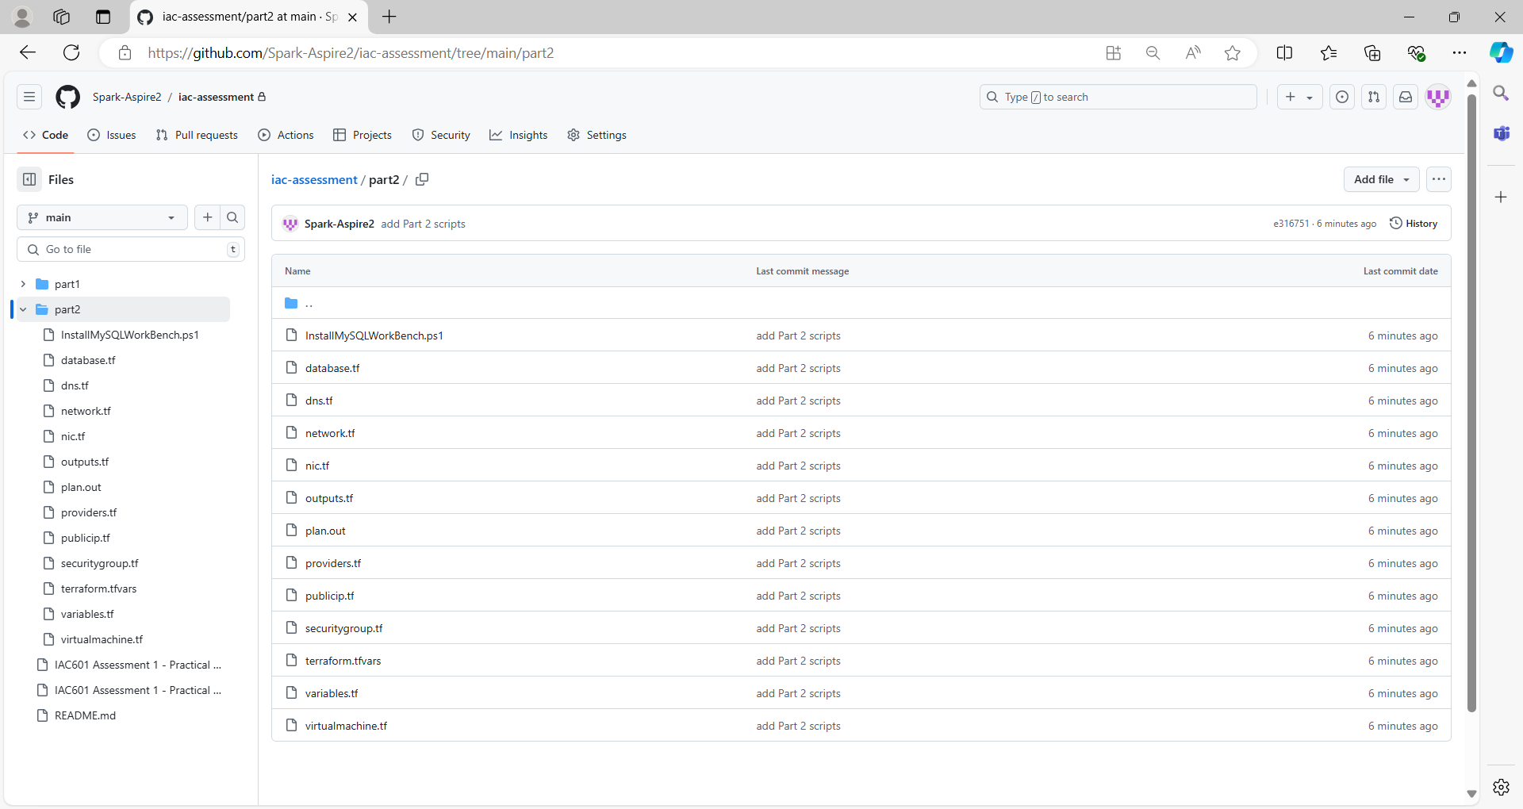

## References

1. Privacy Act 2020. (2024, July 1). https://www.legislation.govt.nz/act/public/2020/0031/latest/LMS23223.html
2. Copyright Act 1994. (2023, May 31). https://www.legislation.govt.nz/act/public/1994/0143/latest/DLM345634.html
3. Fair Trading Act 1986. (2024, July 10). https://www.legislation.govt.nz/act/public/1986/0121/latest/DLM96439.html
4. Health Information Privacy Code 2020. (2022, July 1). https://privacy.org.nz/privacy-act-2020/codes-of-practice/hipc2020/
5. New Zealand Information Security Manual. (2024, September). https://nzism.gcsb.govt.nz/ism-document